Please note that this information is embargoed until March 5, 2021, 9 AM CET / 3 AM ET

Take perfect monitoring sound to the streets
Sennheiser launches IE 100 PRO and IE 100 PRO Wireless, rounding off its portfolio of in-ear monitoring solutions

Old Lyme, Connecticut, March 5, 2021 – If music is your profession and your passion, then Sennheiser’s new IE 100 PRO Wireless in-ears are for you: They let you take the top-grade monitor sound you demand from the stage right onto the street thanks to the inclusion of a Bluetooth® connector that can be swapped with the cable when preferred. Listen to playlists, make calls or watch videos, while the AptX™ Low Latency codec ensures that sound and image are in perfect sync. The Bluetooth connector features a built-in microphone, remote for call and music control and a battery life of up to ten hours. Naturally, the IE 100 PRO is also available individually for stage work, where it surprises with some clever extras…

Ngoc Anh Nguyen is a performer, songwriter and producer who relies on the IE 100 PRO Wireless in-ears in her professional and private life

Precise monitoring and enjoyment of music too
When making music, more control means a better performance: As successor to the IE 40 PRO, the IE 100 PRO in-ears offer a natural, warm and utterly precise monitoring sound that allows you to fine-tune your performance with ease.

Thanks to the included silicone and memory foam ear tips, the in-ears adapt perfectly to your ear canals, coming as close as possible to custom ear moulds. This snug, comfortable fit is supported by a low-profile mould.

A reinforced ear-hook and detachable cable with patent-pending, break-proof connector give you the reliability you need during your performance. The package is rounded off by a cleaning tool and a soft pouch.

The in-ears are available in black, clear and red.

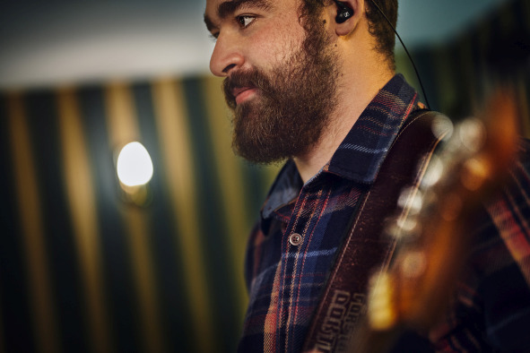 | 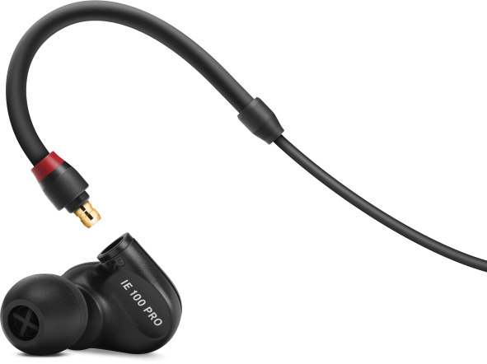
The IE 100 PRO features a low-profile mould and a reinforced ear-hook

“When you choose the IE 100 PRO Wireless, you get an outstanding two-in-one solution,” says product manager Gunnar Dirks. “In addition to the standard accessories, the IE 100 PRO Wireless includes the IE PRO BT Connector - simply unplug the standard cable, attach the lightweight semi-wireless cable instead and enjoy great audio with all the freedom of a Bluetooth connection!” A USB-C cable, which fully recharges the Bluetooth connector in 1.5 hrs is included, too.

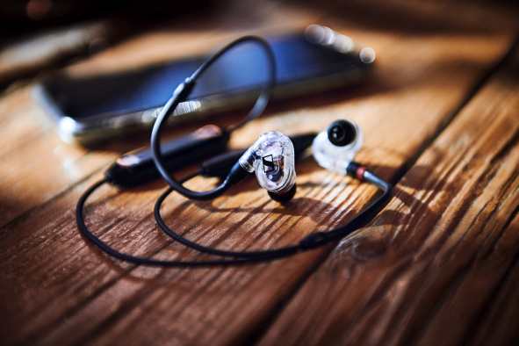 | With the IE PRO BT Connector hooked up instead of the cable, the IE 100 PRO becomes your every-day companion  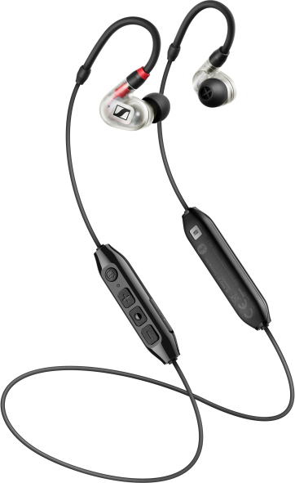

And now for the clever extras…
While the IE 100 PRO retains the same transducer and frequency response of its predecessor, it is now fitted with the same connector type and clever stage-proof internal cable duct as the IE 400 PRO and IE 500 PRO.

“Using one connector platform allows users to simply select their favourite cable regardless of the model they own,” says Gunnar Dirks. “For example, IE 500 PRO users can simply get themselves an IE PRO BT Connector to use their professional in-ears for wireless music enjoyment. Moreover, with the IE PRO Mono Cable, we’re adding a new solution for broadcasting.”

All cables for the IE PRO series are now fully interchangeable between models. Pictured is the new, low-noise IE PRO Mono Cable for broadcast applications | 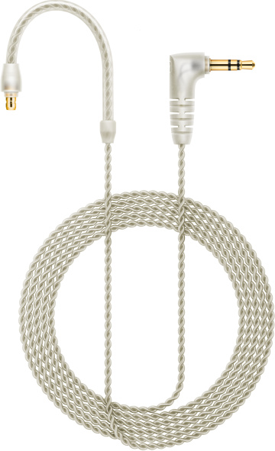

The new IE PRO Mono Cable is a twisted cable that offers excellent suppression of structure-borne noise. It can be used with the right or left earpiece, which gives a single-sided broadcast solution for live moderation, correspondents and ENG applications. With a stereo signal, the left signal will be transmitted.

The professional choice

PRO in-ears at a glance
Model | MSRP | Colours and accessories
IE 100 PRO | $119 USD  $159 CAD | Available in clear, red and black. Straight cable with ear-hook. Comes with silicone ear tips (S, M, L), memory foam ear tips (M), cleaning tool and pouch.
IE 100 PRO Wireless | $179 USD  $229 CAD | Available in clear, red and black. Straight cable with ear-hook. Accessories as with IE 100 PRO but with additional IE PRO BT Connector and USB-C charging cable.
IE 400 PRO | $349.95 USD  $439.95 CAD | Available in clear and smoky black. Straight cable with ear-hook. Comes with silicone ear tips (S, M, L), memory foam ear tips (S, M, L), cleaning tool and hard case.
IE 500 PRO | $599.95 USD  $749.95 CAD | Available in clear and smoky black. Features a special twisted cable with ear-hook that provides excellent suppression of structure-borne noise. Accessories as with IE 400 PRO.

Cables at a glance, available separately as accessories
Cable | MSRP | Notes
IE PRO Straight Cable Black | $49.95 USD  $59.95 CAD | Included with IE PRO 100, IE 100 PRO Wireless, and IE 400 PRO
IE PRO Twisted Cable Clear | $79.95 USD  $99.95 CAD | Included with IE 500 PRO
IE PRO Mono Cable | $59 USD  $69 CAD
IE PRO BT Connector | $119 USD  $159 CAD | Included with IE 100 PRO Wireless

For your social media channels:
Recommended by artists: Sennheiser’s new IE 100 PRO Wireless in-ears take monitoring sound to the streets. #IE100PRO #Sennheiser #IEM

Technical data
IE 100 PRO (with straight IE 100 PRO cable)
Frequency response: 20 Hz to 18 kHz
Sound pressure level (SPL): 115 dB (1 kHz / 1 VRMS)
THD: < 0.1% (1 kHz, 94 dB)
Impedance: 20 ohms

IE PRO BT Connector
Weight: 14g
USB Standard: Type C
Battery time: up to 10 hrs, SBC
Supported profiles: A2DP, AVRCP, HSP, HFP
Bluetooth version: 5.0
Codecs: SBC, AAC, AptX™, AptX™ Low Latency

Useful links
Learn more about Sennheiser’s IE PRO in-ears
Ngoc Anh Nguyen talks about what music means to her
IE 100 PRO/IE 100 PRO Wireless product information
IE PRO BT Connector product information

Download high-resolution product photos
Download high-resolution application photos

About Sennheiser
Shaping the future of audio and creating unique sound experiences for customers – this aim unites Sennheiser employees and partners worldwide. Founded in 1945, Sennheiser is one of the world’s leading manufacturers of headphones, loudspeakers, microphones and wireless transmission systems. Since 2013, Sennheiser has been managed by Daniel Sennheiser and Dr. Andreas Sennheiser, the third generation of the family to run the company. In 2019, the Sennheiser Group generated turnover totaling €756.7 million. www.sennheiser.com

Global Press Contact

Stephanie Schmidt
Stephanie.schmidt@sennheiser.com
+49 (5130) 600 – 1275

