BASSBOSS Ready to Rumble at Mobile Beat Las Vegas 2018

DJs and attendees will take in the premium offerings from BASSBOSS through its popular ‘Demolition Room’
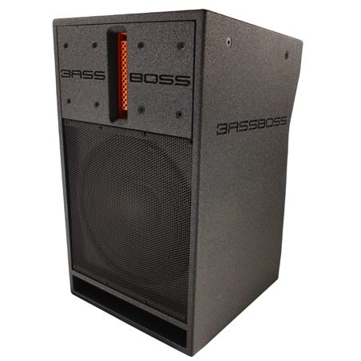
Las Vegas, NV, February 22, 2018 — Loudspeaker manufacturer BASSBOSS has announced that it will showcase its industry-leading powered Subwoofers, Tops and MicroMains at this year’s Mobile Beat Las Vegas conference, which will be held at the Tropicana Las Vegas from March 12–15, 2018. The company will highlight the power and performance of its DJ112 and DV12 Powered MicroMains, AT212 Powered Tops, and ZV28, DJ18S and VS21 Powered Subwoofers throughout the conference and during its popular “Demolition Room” Experience, which will feature equipment from Denon DJ’s Prime Series. Delivering remarkable output-to-size ratio and fast plug-and-play setup, BASSBOSS loudspeakers enable DJs who travel with their own sound reinforcement to deliver impressive results.

“We are looking forward to attending this year’s Mobile Beat Las Vegas,” says David Lee, BASSBOSS president. “We’re always hungry for opportunities to showcase our products for the industry’s most discerning mobile DJs. As anyone who has witnessed a BASSBOSS ‘Demolition Room’ Experience before knows, our products make a big statement that’s sure to turn some heads and loosen a few lighting fixtures. But in addition to an impressive show of force, they also excel in clarity, ease of use, and portability, making them an ideal solution for DJs on the move.”

Small, But Authoritative – DJ112 and DV12 MicroMains
BASSBOSS’s DJ112 Powered MicroMains provide DJs with incredible performance when paired with BASSBOSS subwoofers. The DJ112’s ultra-small size belies its powerful output, delivering enough mid and high range to keep up with a pair of double 18” subwoofers. It also excels as a DJ monitor, with punchy performance and plenty of distortion-free headroom.

The DV12 delivers an authoritative 3,000 Watts of output in a lean 49 lb. package, with 120° horizontal dispersion, extended projection, and ultra-high fidelity. Satellite Mode provides even greater mid and high range output while relinquishing low end duties to a subwoofer, while Full-Range Mode delivers frequency response down to an impressive 45 Hz. (-3dB) The remarkable output from such a small, lightweight and rugged enclosure means the DV12 can deliver better results at bigger shows with less effort.
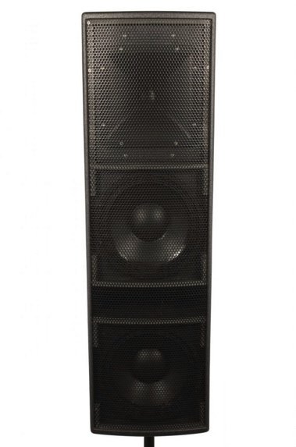
Top of the Tops – AT212-3K Powered Top
The AT212-3K allows you to bring less and do more for even the most demanding applications. Its tall, slim design allows its high frequency horn to stand above crowds when stacked atop BASSSBOSS subwoofers for a complete 3-way active full range system. 3,000 Watts of power provide impressive output capabilities. Built-in processing ensures linear frequency response and phase-coherent sound reproduction with characteristic BASSBOSS plug-and-play ease. At 89 lbs, the AT212-3K makes setup and breakdown manageable even for a DJ working alone.

Bass Is King – ZV28, DJ18S and VS21 “Rum Punch” Powered Subwoofers
Low end is the key to BASSBOSS’s impressive “Demolition Room” Experience, where the feeling of moving air is enough to get any DJ’s heart racing. The ZV28 Powered Sub is unlike any other double 18” on the market, with bass frequencies diving down the limits of human hearing to 21 Hz at earth-shaking levels of continuous output. Not only does it handle notes that other subwoofers simply cannot play, it reproduces deep frequencies with ease and articulation.

Bring More Bass, Not More Boxes.
The DJ18S offers deeper bass and is more powerful than other single 18” subwoofers. Only 110 lbs, its built-in amplifier delivers 2400 Watts of continuous RMS power and features comprehensive DSP. Such a powerful amp unburdens the DJ18S of the risks of overheating, clipping, and roll-off of deep frequencies that affect other subwoofers, allowing it to replace several competing boxes that simply can’t keep up. The result is a massive sound in a road-ready enclosure that gives DJs the power to up their output while reducing their footprint.

The VS21 Rum Punch has got it all: punchy output with deep low-end, with versatility to handle everything from dance music to acoustic performances. That makes it a great solution for DJs who might share stage time with other musical acts. These powerful single 21” subs are easily combined into arrays of 4, 6 or 8 boxes with coupled horn sections for maximum impact. The VS21 Rum Punch has 2400 Watts of continuous RMS power on tap to ensure ample headroom and delivers flat frequency response down to 27 Hz. A vented, short-horn hybrid enclosure facilitates extended low frequency performance with increased upper frequency sensitivity for improved transient response.

To learn more about BASSBOSS, please visit them at www.bassboss.com.

For more information about Mobile Beat Las Vegas and registration, please visit: https://www.mobilebeatlasvegas.com/.
About BASSBOSS
BASSBOSS creates premium, ultra high-fidelity sound systems for the professional consumer, live sound and systems integration markets. The company was founded on the design and engineering expertise of David Lee, a pioneer in subwoofer design whose work has transformed the audio systems for hundreds of venues across North America. BASSBOSS systems are easily integrated, compact and power-efficient. Each cabinet is highly optimized with dedicated, comprehensive amplification and processing. For more information on BASSBOSS, please visit www.bassboss.com

Press contact:
Jeff Touzeau
Public Relations
Hummingbird Media, Inc.
(914) 602-2913
jeff@hummingbirdmedia.com

