AESNY 2022: Neumann, DearReality and Merging Technologies present high-quality and innovative solutions for all phases of the recording process including immersive applications

Old Lyme, October 6, 2022 – Sennheiser Group (Booth 329 / Demo Room 3D01) will be presenting its recording tools on October 19th & 20th during the 153rd AESNY Convention at the Javits Center. Highlights on display from Neumann.Berlin include KH line monitors with the recently released KH 150, NDH 30 open-back headphones, and the highly anticipated reissue of the legendary M 49. Meantime, Dear Reality will showcase its spatializer, monitoring and mixing plugins.

Neumann will feature various demonstrations over the course of the exhibition. Experience how Neumann microphones, loudspeakers, electronics and software are able to form premium systems, where each component complements and improves the sound quality of conventional and immersive productions.

Immersive Demonstration Room 3D01
The Sennheiser demo room will be outfitted with a full 7.1.4 immersive system, including several stereo pairs of monitors for demonstrating the new AMBEO 2-Channel Spatial Audio. Here, Neumann will host 9 different presentations featuring Grammy award-winning engineer/producers discussing their most recent immersive mixes on the Neumann immersive KH monitor system. Additionally, there will be product presentations on KH monitors, Dear Reality software and plugins, and Merging Technologies interfaces.

DSP-Powered Studio Monitor KH 150
While having a compact format, the KH 150 surprises with outstanding clarity, even at high volume, and extended low-end. Recommended for all applications from broadcast to music production, including styles that require a powerful, deep low-end and/or elevated listening levels such as urban music, EDM, and film scoring. Other monitors featured will include the KH 80, KH 120, and KH 750.

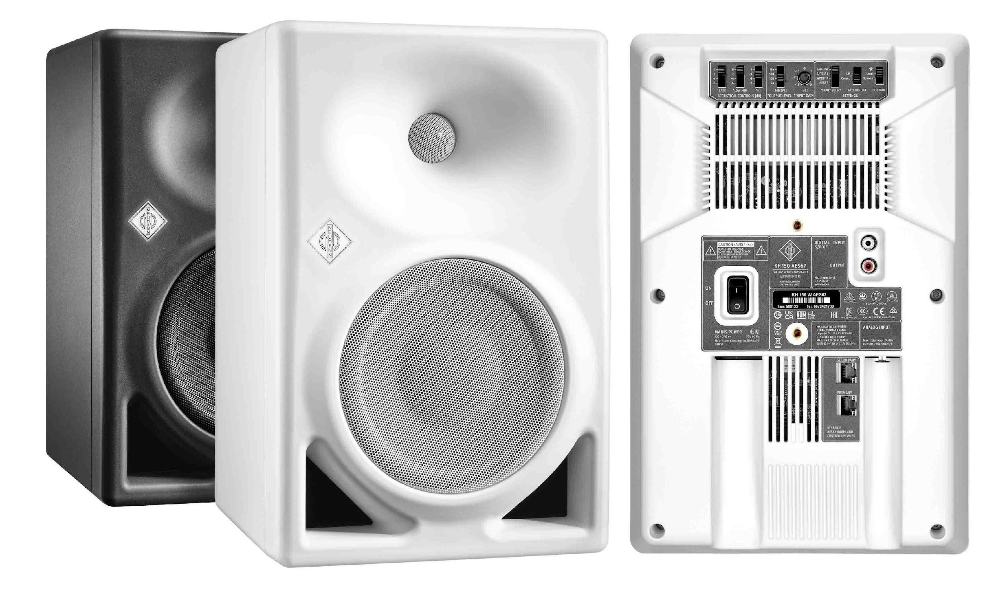 | The Neumann KH 150 with AES67 option

NDH 30 open-back headphone
Following the success of the award-winning NDH 20, released in 2019, the NDH 30 is a reference-class studio headphone for the most demanding mixing and mastering applications in both stereo and immersive formats. Attendees will be able to do a side-by-side comparison of the NDH 20 and NDH 30.

The new Neumann NDH 30 open studio headphone | 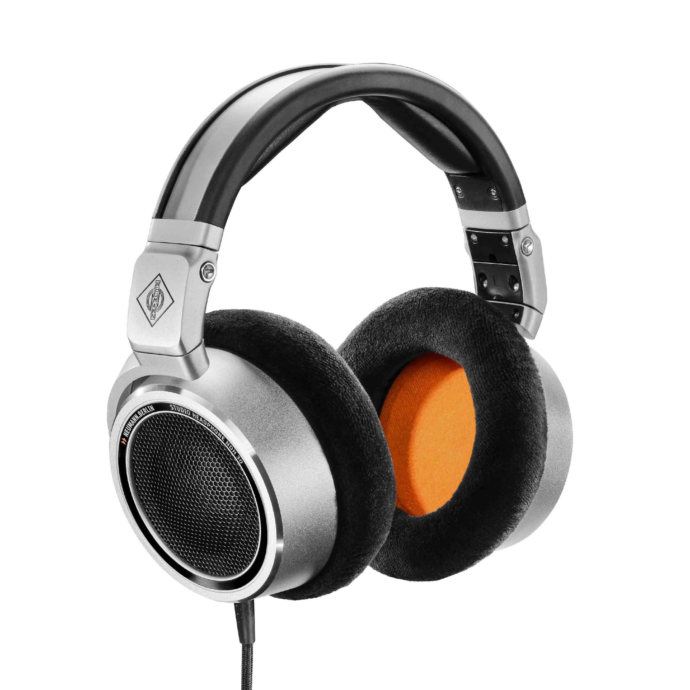

Neumann M 49 V
Microphone connoisseurs around the world have awaited a reissue of the legendary M 49 for decades. The M 49 V is a reissue according to original specifications and design documents from the Neumann archive with the classic K 49 large-diaphragm capsule that has been manufactured by Neumann unchanged since the 1950s. The M 49 V will be available for attendees to demo at the booth as well as U 87 Ai, U 67, TLM 49 and M 149 Tube microphones.

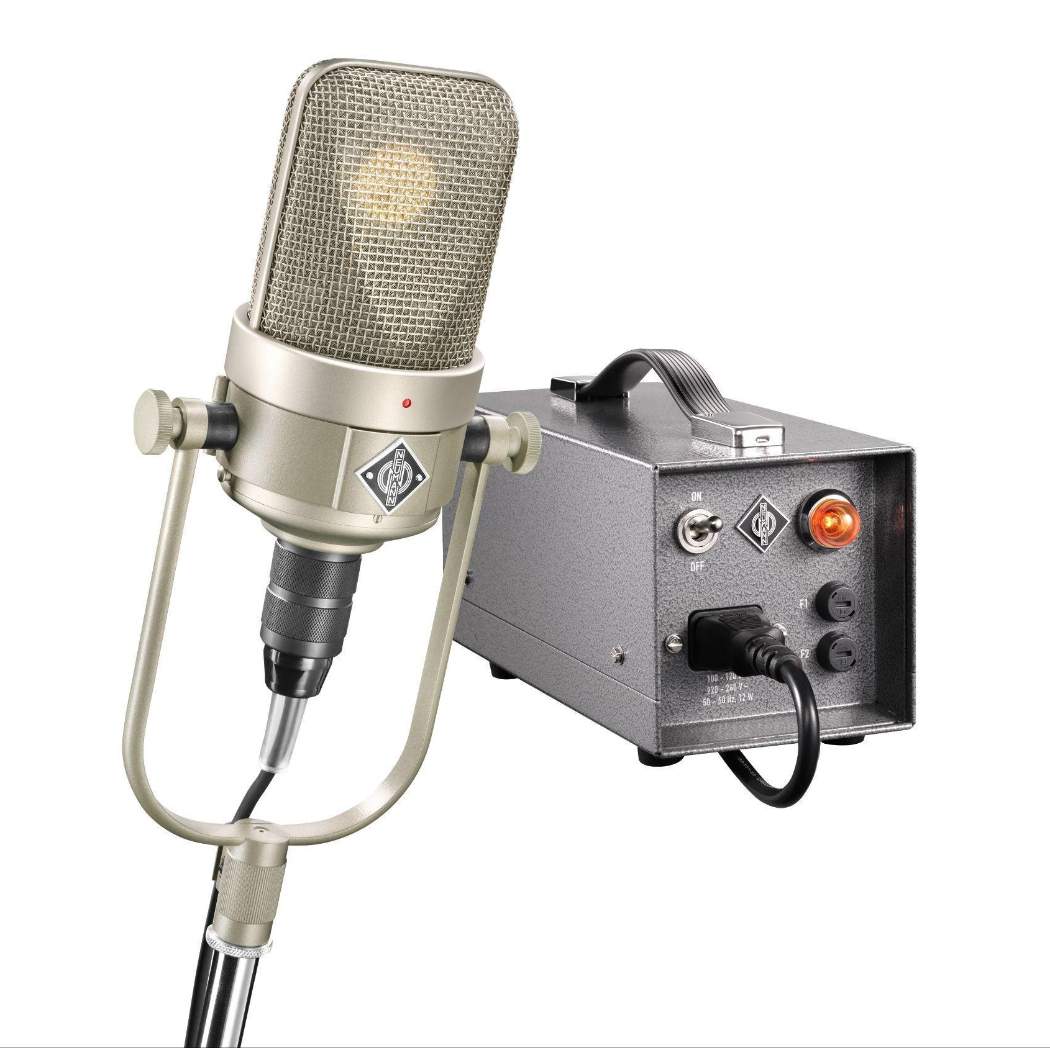 | The new Neumann M 49 V

Innovative software solutions for next-level stereo and immersive audio productions
Dear Reality showcases headphone monitoring plugins, advanced spatialization solutions, and provides a first glimpse of the upcoming reverb plugin for professional stereo audio production.

Virtual stereo and immersive mix rooms
The dearVR MIX and dearVR MONITOR headphone monitoring plugins turn any professional studio headphones into ideal mixing environments that place the user in the sweet spot of carefully designed stereo and immersive mix rooms. dearVR MONITOR offers 26 multichannel loudspeaker formats such as 7.1.4 or 9.1.6. Both plugins feature Dear Reality’s Spatial Headphone Compensation (SHC) technology, which adapts selected studio headphones to the virtual mixing room, enabling a stable simulation of a perfect acoustic environment with the highest degree of out-of-head localization.

Provides a reliable stereo mix room anywhere: Dear Reality’s dearVR MIX plugin | 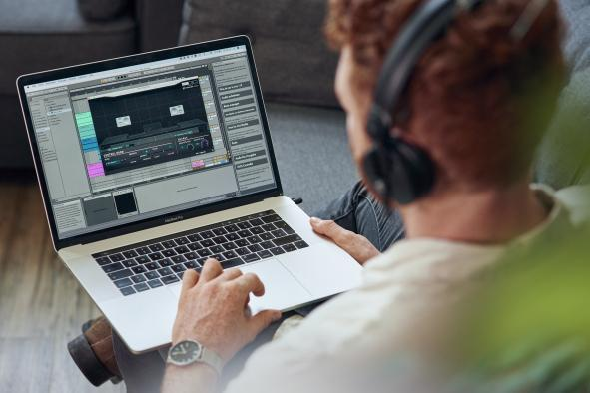

Enhanced immersive spatialization
With dearVR PRO, the state-of-the-art binaural, Ambisonics, and multi-channel spatializer, sound engineers have a full 360° immersive panner at their fingertips, placing the listener at the center of sound in 46 vivid virtual acoustic environments. Both spatializer plugins, dearVR PRO and the entry-level variant dearVR MUSIC, now include the patented Sennheiser AMBEO Clarity algorithm for next-level binaural productions with less audible frequency coloration.

The new Clarity feature lets users set the perfect balance between externalization and colorization | 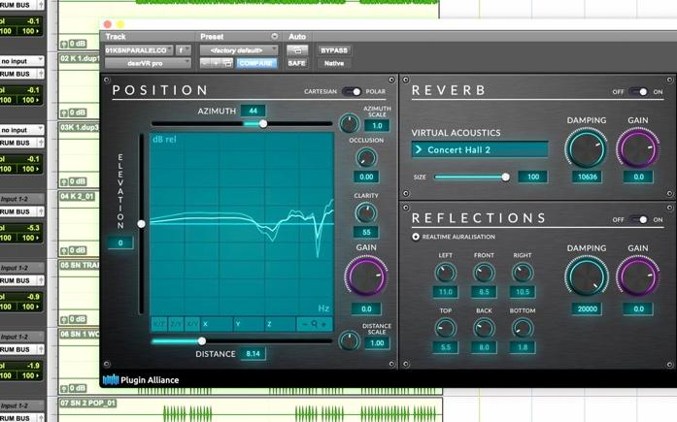

Neumann and Merging Technologies join forces
Merging Technologies, one of the world’s leading suppliers of AD/DA solutions and digital audio workstations, has joined the Sennheiser Group and the first joint product between Neumann.Berlin and Merging Technologies will be a Neumann audio interface that enables the perfect integration of Neumann products into a digital infrastructure.

About the Sennheiser Group
Building the future of audio and creating unique sound experiences for our customers – this is the aspiration that unites the employees of the Sennheiser Group worldwide. The independent family-owned company Sennheiser was founded in 1945. Today, it is managed in the third generation by Dr. Andreas Sennheiser and Daniel Sennheiser, and is one of the leading manufacturers in the field of professional audio technology. Within the Sennheiser Group are Georg Neumann GmbH (Berlin, Germany), manufacturer of studio-grade audio equipment; Dear Reality GmbH (Düsseldorf, Germany), known for its binaural, Ambisonics, and multichannel encoders with realistic room virtualization; and Merging Technologies SA (Puidoux, Switzerland), specialist in high-resolution digital audio recording systems.
sennheiser.com | neumann.com | dear-reality.com | merging.com

Local Press Contacts
Ashley Kinchen Jeff Touzeau
ashley@hummingbirdmedia.com jeff@hummingbirdmedia.com
+1 504 616-1683 +1 914 602 2913

