Make every song a love song
Sennheiser’s Valentine’s Day Gift Guide

London, 6 February 2020 – Showing that special someone in your life just what they mean to you can be tough, so why not use music as the medium this Valentine’s Day? Go above and beyond the usual gift of chocolates and flowers and give something that can be enjoyed long after the occasion is over: a pair of headphones from Sennheiser’s brilliant wireless range and a playlist of your favorite love songs.

For the stylish music lover
MOMENTUM WIRELESS
+ Smart features such as Auto On/Off and Smart Pause ensure you never miss a beat of your favorite love song
+ Superior sound: reproduces the balanced depth and precision of a studio recording
+ Three Active Noise Cancellation modes and Transparent Hearing function
+ A touch of stylish indulgence: genuine, soft
leather on the earpads and headband
+ One-touch access to voice assistants
+ Almost impossible to misplace thanks to
the integrated Tile Bluetooth tracker
MSRP: £349
https://en-uk.sennheiser.com/momentumwireless

An audio companion for all day, every day
HD 350BT
+ Great wireless sound with deep dynamic bass
+ Intuitive controls including voice assistant
button for Siri and Google Assistant
+ Impressive 30-hour battery life
+ Available in a choice of white or black
MSRP: £89.99
https://en-uk.sennheiser.com/hd-350-bt

For those always on the road
PXC 550-II WIRELESS
+ Created for a smart travel experience
+ Undisturbed, superior wireless sound in any environment with adaptive noise cancellation
+ Intuitive operation via touch pad
+ One-touch access to voice assistants
+ Travels the world on a single charge: up to
20 hours with BT and ANC switched on, and
up to 30 with ANC and a wired connection
MSRP: £299
https://en-uk.sennheiser.com/pxc-550-ii

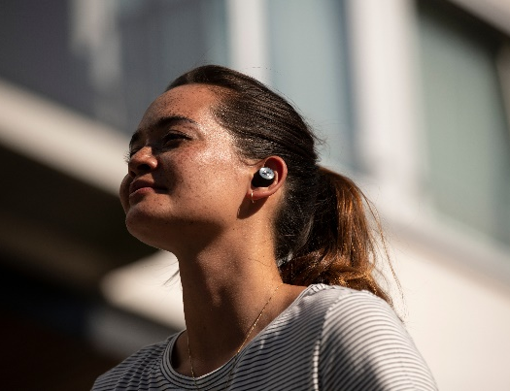
Something they’ll adore
MOMENTUM TRUE WIRELESS
+ Exceptional sound performance
+ Transparent Hearing feature for optional improved situational awareness
+ Intuitive touch interface and direct access to smart assistants
+ Pure design featuring metallic details
and a stylish fabric-wrapped case
+ 4-hour battery life and up to 8 additional
hours via the charging case
MSRP: £279.99
https://en-uk.sennheiser.com/truewireless-details

About Sennheiser
Shaping the future of audio and creating unique sound experiences for customers – this aim unites Sennheiser employees and partners worldwide. Founded in 1945, Sennheiser is one of the world’s leading manufacturers of headphones, loudspeakers, microphones and wireless transmission systems. Since 2013, Sennheiser has been managed by Daniel Sennheiser and Dr. Andreas Sennheiser, the third generation of the family to run the company. In 2018, the Sennheiser Group generated turnover totaling €710.7 million. www.sennheiser.com

North and East Europe Press Contact
Sennheiser electronic GmbH & Co. KG
Maik Robbe
Communications Manager UK & Nordics
maik.robbe@sennheiser.com

