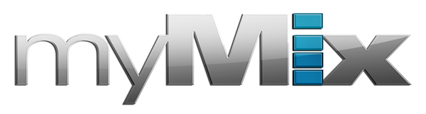

Simplicity is Key: Skyland Studios Employs myMix
as Easy Recording Solution for Wide Range of Artists

The primarily album-format production studio chooses myMix as its go-to recording interface
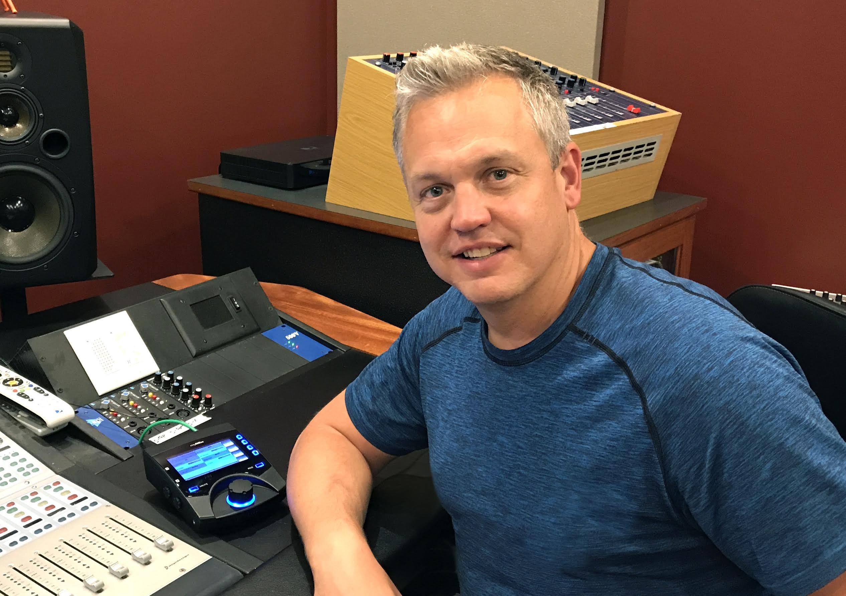
Lakeville, Minnesota, October xx, 2017 — myMix, a network-based audio mixing and recording system which features easy operation while meeting the highest audio demands, has been chosen by Skyland Studios outside of Minneapolis, for its easy operation and simple set up, making it an ideal recording solution for a wide range of artists.

“It’s just so easy,” said Darren Rust, who has owned Skyland Studios for 11 years. “When your average Joe steps into the studio and sees a device sitting in front of him with buttons, knobs and faders all over the place, it can get a little daunting. But, when you see the myMix, you see only one knob and a screen. When I have someone new come in to record, it takes no time at all for them to learn how to use it. Artists who have an average understanding of recording can be using it within 30 seconds.”

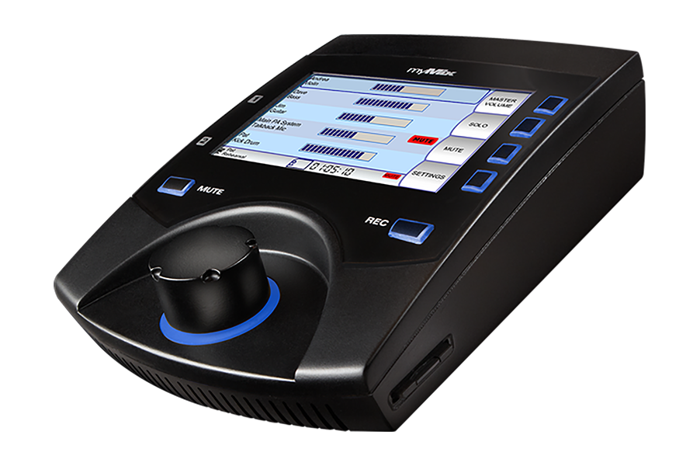
The easy-to-set-up and easy-to-operate myMix is a staple for Skyland Studios’ artists, which Rust said are mostly vocalists and occasionally multi-piece bands, and affords an opportunity to run tracking without involving a studio engineer.

“I’m the sole proprietor — the only guy running this recording studio with no assistants or help,” Rust said. “So I need to have a workflow that is smooth, and the myMix allows that. It allows people to take care of business when they are tracking so that I can do what I need to do in the control room. That’s absolutely essential.” Rust says the fact that anyone — even those with a limited recording background — can use the myMix makes it a 'must-have' for his studio.
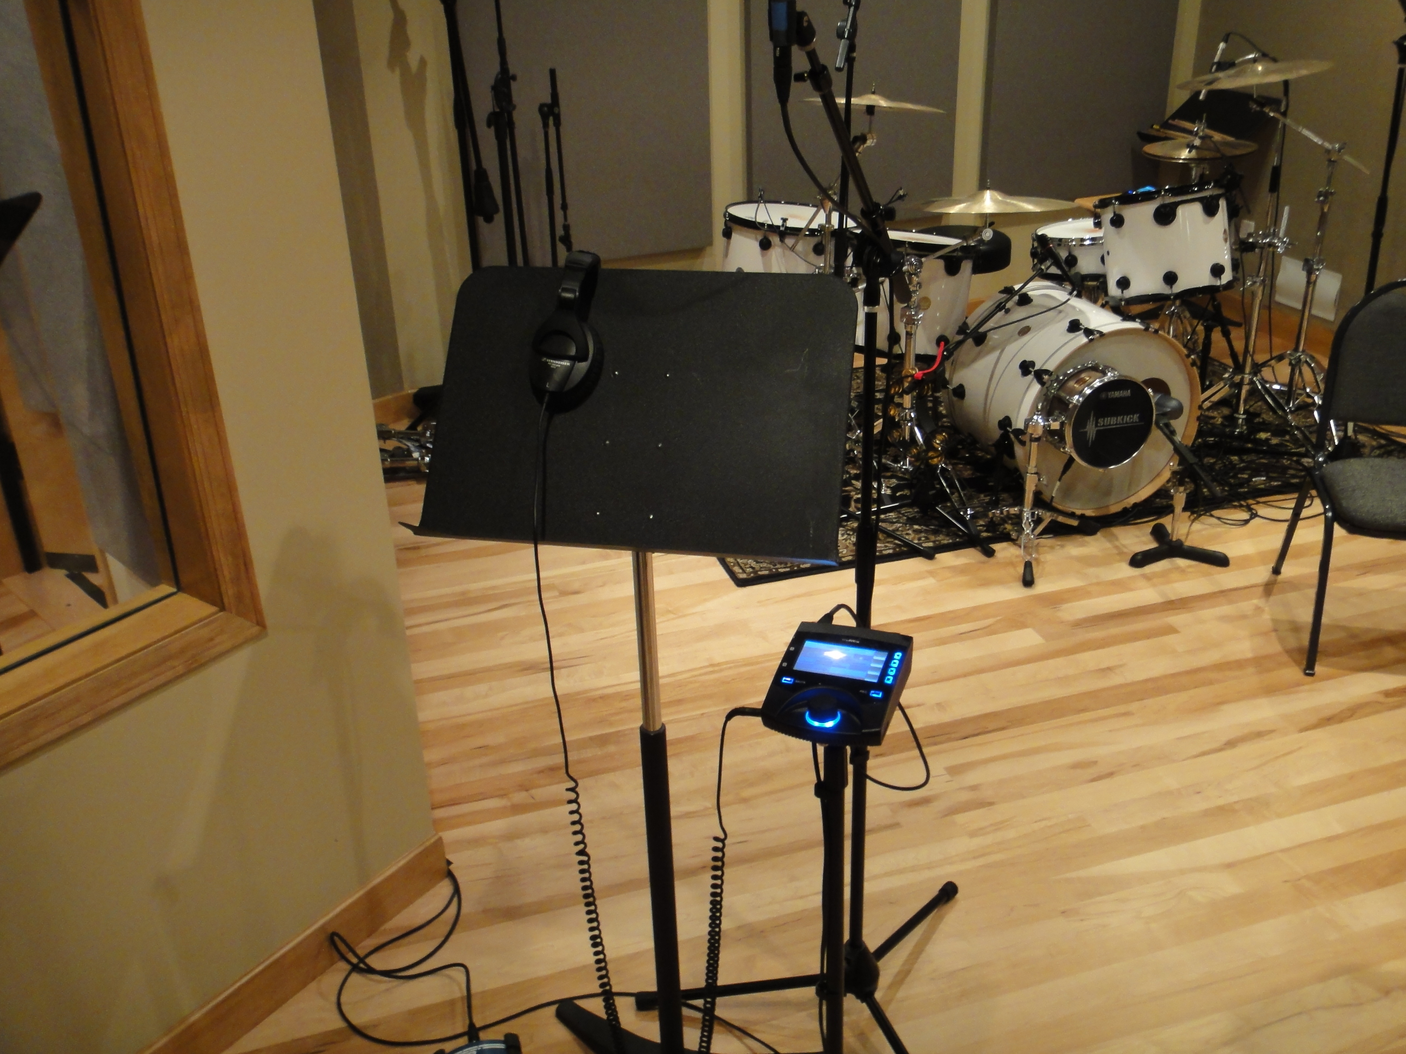
“myMix really hit a home run in creating a unit that is so simple to operate that even those with a limited technical background could quickly understand the menu and functions,” Rust said. “I’ve had artists of all kinds here — young and old — and nobody has ever had issue with how to run these units. It is all seamless."

Breakdown of Skyland’s Setup
Skyland Studios focuses mostly on album production and uses the myMix primarily during playback for recording. “I typically send a stereo mix of the music the artist is going to sing to, or, if I’m working on a three- to four-piece session, I have multiple stems going to all the different players. I can then give them individual control over their respective instruments,” Rust said.

Rust uses the digital interface and sets up extra busses out of ProTools that split out and go directly into the myMix. “All those channels can be split out into whatever I want — it’s pretty diverse,” Rust said. “I have busses set up in ProTools already named, so it’s very quick to set up a queue. The interface is convenient and me a ton of time.”

For more information, visit mymixaudio.com.

About myMix

Part of the Synthax family, the North American distributor for RME, myMix is a personal monitor mixing and recording system featuring local network inputs and can operate either self-contained or integrated with any analog or digital mixing consoles. Thanks to its ease of use, the myMix is ideal for on-stage performances, studio monitoring as well as installed applications such as houses of worship.

Media Contacts:
Jeff Touzeau
Public Relations
Hummingbird Media
+1 (914) 602 2913
jeff@hummingbirdmedia.com

Katie Kailus
Public Relations
Hummingbird Media
+1 (630) 319-5226
katie@hummingbirdmedia.com

