The Sound of the City: Wallace Detroit Guitars Founder to be Featured on INSP Network’s Award-Winning Series ‘Handcrafted America’

Critically-acclaimed TV show will focus on how Wallace is keeping Detroit’s history alive with handmade, limited edition guitars made from landmark buildings

Detroit, October 23, 2017— Wallace Detroit Guitars, manufacturer of handmade guitars created of wood from Detroit landmarks, announces that company founder Mark Wallace will be featured on the third season of INSP’s Handcrafted America. The episode will air on Friday, October 27th at 8:30 PM EST.
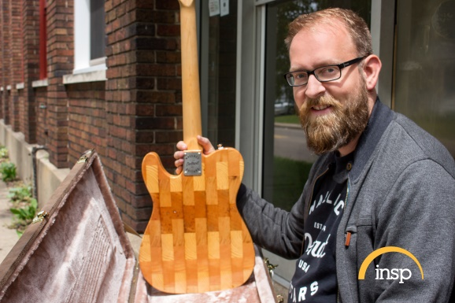
The segment also features soul/blues powerhouse Laith Al-Saadi playing on one of Wallace Detroit Guitars' instruments. Al-Saadi is widely known as having won a finale spot in NBC's "The Voice" in 2016, and he has since won over classic rock and blues fans around the world.

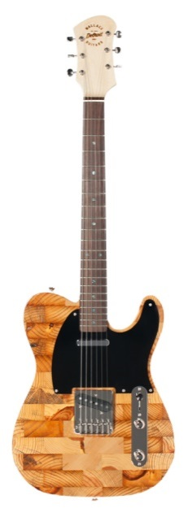
In every half-hour episode of Handcrafted America, Jill Wagner (Christmas in the Smokies, Teen Wolf, Wipeout) meets three gifted artisans and gets a behind-the-scenes look at how their products are created. Along the way, viewers learn about the history and cultural heritage that inspire and influence the design of their handcrafted products. Over the course of three seasons of Handcrafted America, the stories of more than 100 artisans will have been told.

Wallace and his company pay homage to their hometown of Detroit — a city known for rolling up its sleeves and working with its hands — by creating their instruments from the floorboards of the former Detroit Fire Department Headquarters, benches of The Brewster Wheeler Recreation Center and many other historically meaningful locations throughout the city. Handcrafted America focuses on American ingenuity and craftsmanship — making Wallace Detroit Guitars perfectly suited for the program.

“We are honored to be featured on Handcrafted America and to have our work highlighted alongside other talented artisans,” said Mark Wallace, founder of Wallace Detroit Guitars. “We hope this program will spotlight the craftsman spirit of Detroit, and how far we have come as a city of passionate creators and entrepreneurs.”

The episode of Handcrafted America that features Wallace Detroit Guitars will air on INSP on Friday, October 27th at 8:30PM EST. To find out where to watch in your area, click here (check your local listings for additional show times).
For more information, visit wallacedetroitguitars.com. For more information on Laith Al-Saadi, please visit https://laithalsaadi.com.
For more information on INSP’s Handcrafted America, visit handcraftedamericatv.com.
About Wallace Detroit Guitars
Founded by Mark Wallace in 2014, Wallace Detroit Guitars breathes new life into reclaimed wood from Detroit buildings by shaping it into some of finest American guitars on the market. Their instruments acknowledge not only Detroit’s architectural history, but also its proud tradition of both great craftsmanship and great music. With superior construction, premium components, and a great story, each guitar delivers a truly timeless playing experience.

About INSP
INSP is available nationwide to more than 81M households via Dish Network (channel 259), DirecTV (channel 364), Verizon FiOS (channel 286), AT&T U-verse (channel 564) and more than 2,800 cable systems. Click here to find INSP in your area. For positive entertainment that celebrates the American spirit and honors timeless values, it’s INSP.

Contact Information:
Jeff Touzeau
Public Relations
Hummingbird Media, Inc.
(914) 602-2913
jeff@hummingbirdmedia.com

