For immediate distribution

Temple University Taps Ferrofish A32 Converter for Televised Sports Broadcasts
Ease of use and reliability allow the University’s broadcast team to focus on the production and eliminate concern over audio faults

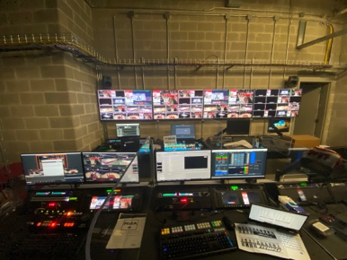
Philadelphia, May 19, 2021 — For its first in-house ESPN/American Athletics Conference broadcast in late 2020, Kevin Hession, Temple University’s director of video production and broadcast engineer, needed a versatile and reliable converting solution for analog audio sources — specifically for natural sound microphones during its men’s basketball and women’s basketball, volleyball and gymnastics productions. After partnering with Alpha Video out of Minneapolis, Hession and his team selected the Ferrofish A32 AD/DA converter.
Temple University's broadcast room

“We wanted as much functionality as possible to still be able to use analog audio when necessary,” Hession said, adding that the A32 converter is routed to a full patch bay. “We’re then able to patch those sources to the necessary destinations.”

Hession and the broadcast team then convert that to MADI and send it to a 64-channel digital mixing console. “The audio ecosystem we implemented makes audio routes incredibly simple,” he added. “The A32 gives us a ton of flexibility with that.”

Converting Audio with Ease
A universal solution for connecting, routing and converting, the A32 is a perfect solution for high-end multi-format converting for broadcasting.

Aside from its universal functionality, Hession said another key feature when selecting the A32 converter was its ease of use.
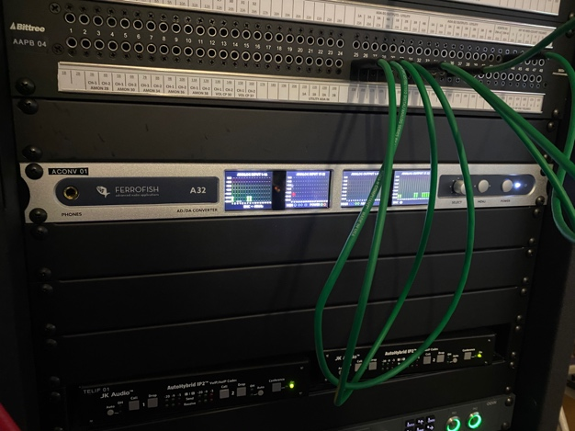
“By using the A32, it easily allows me to focus on the actual production rather than having to constantly troubleshoot any potential audio faults,” he said. “If we want another audio source, or even if our broadcast talent just wants a different analog source we’ve set up, it takes less than four clicks.”

Recently, Hession shared that his team had the honor of producing Hall of Fame Temple Men’s Basketball Head Coach John Chaney’s “Celebration of Life” service, which aired simultaneously on ESPN+ and YouTube — drawing thousands of viewers watching live from Temple’s Liacouras Center.
Temple University's Ferrofish A32

“An outside AV company came in to do any in-house audio, and all we had to do was connect their mixdown to the A32, and we had crystal clear audio,” he explained. “It was as simple as that.”

The Ferrofish A32 also is available in a Dante format.

For more information, visit ferrofish.com.

About Ferrofish
Known for its precision-engineered German technology, Ferrofish manufacturers high-quality, innovative advanced audio applications. From its class-leading A16 MK-II and A32 AD/DA converters to its Verto Series of intuitive Dante converters, Ferrofish is known for its premium conversion solutions that are ideal for a wide range of applications. For additional information, visit the company online at http://www.ferrofish.com.

About Synthax, Incorporated
Synthax Inc. is the exclusive USA distributor for RME digital audio solutions, Digigram broadcast audio systems, Appsys digital audio tools, Ferrofish advanced audio applications, myMix personal monitoring systems and ALVA cableware. We supply a nationwide network of dealers with these products for professional audio, broadcast, music industry, commercial audio, theater, military and government applications. For additional information, visit the company online at http://www.synthax.com.

Media Contacts:
Katie Kailus
Public Relations
Hummingbird Media
+1 (630) 319-5226
katie@hummingbirdmedia.com

Jeff Touzeau
Public Relations
Hummingbird Media
+1 (914) 602 2913
jeff@hummingbirdmedia.com

