Sky Studios Elstree Chooses Xytech’s Media Operations Platform for New Film & TV Facility

From flexible resource scheduling to effective quoting and crewing, Xytech’s Media Operations Platform brings complete operational control and helps streamline the studio’s internal processes

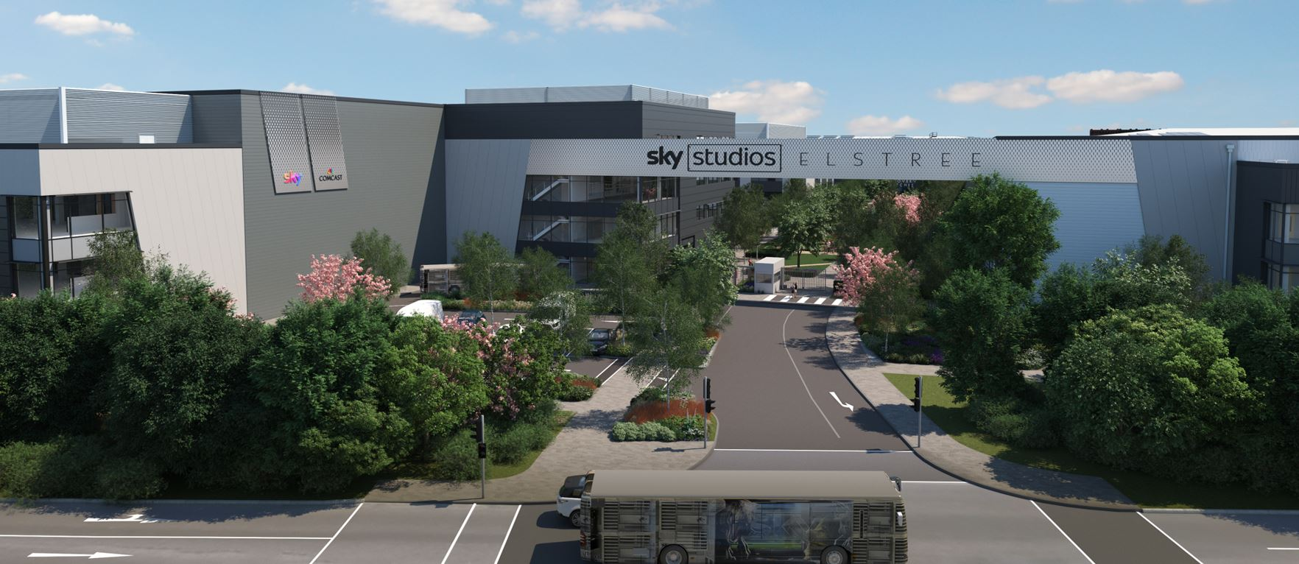

Borehamwood, UK, August 11, 2022 — First announced in 2019 and opening its doors fully later this year, Sky Studios Elstree is a joint project between Sky and NBCUniversal. The 27.5-acre, state-of-the-art complex located just north of London houses 13 sound stages, with leading media operations provider Xytech Systems offering total operational and financial control by streamlining the new film and TV studio’s internal processes across quoting, resource scheduling, cost management and reporting.

“Not long after Sky Studios Elstree was given the go-ahead in 2019, we started searching for a media operations solution that would meet the strict demands of our cutting-edge studios catering for high-end TV shows and films,” said Tom Avison, Director of Operations at Sky Studios Elstree. “Sky already had an excellent, long-standing relationship with Xytech Systems through its Transmission solutions installed at the Sky facilities in Italy, Germany and the UK. We also knew Xytech was already servicing other major studios across the UK, so we naturally approached them to see what they could offer us.”

Avison notes how from the early discussions and right through to the implementation and go-live phase, they found both the solution and the expertise offered by the Xytech team to be “highly flexible and responsive to the requirements of our operation and our ambition to use the system from quote to invoice and at every point in between.”

Xytech’s Media Operations Platform now manages the studio’s scheduling requirements, including studios, ancillary room and equipment bookings.

“Xytech software offers a multitude of features when it comes to handling the complex requirements of bookings,” explained Matt Waldock, Xytech’s VP and Director of Business Development, EMEA. “Our Media Operations Platform allows for quick and efficient quote and order creation. As bookings are added or changed, the system updates the display in real time, putting automated financial transparency directly into clients’ hands.”

It’s also recently been confirmed Universal Pictures’ “Wicked,” starring Ariana Grande and Cynthia Erivo, will be the first production to take up residence at Sky Studios Elstree.

“The creation of Sky Studios Elstree reflects the explosion the studio market is seeing in the UK now,” Waldock said. “Sky Studios Elstree choosing Xytech to manage its quote-to-invoice process around its resource requirements further confirms Xytech’s status as the leading vendor for small and large studios alike. The team at Sky Studios Elstree have been a pleasure to work with and we look forward to continuing our long-standing partnership.”

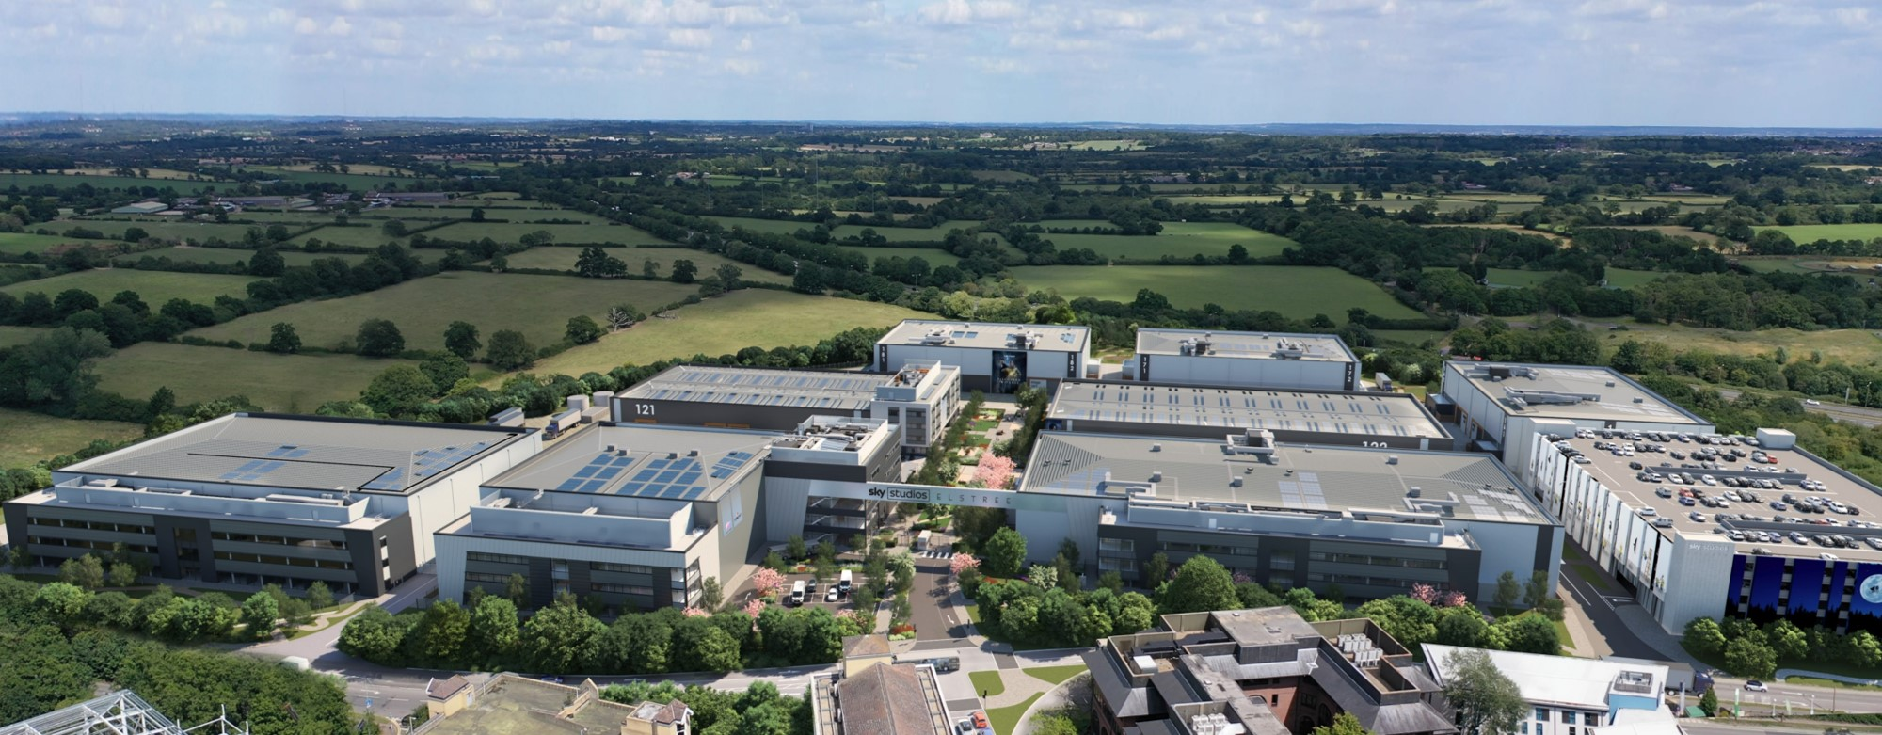

About Xytech
For over 30 years, the world’s premiere media companies have depended on Xytech to run their businesses. Xytech’s Media Operations Platform is the only end-to-end solution for the complete content lifecycle. Xytech provides scheduling, automation, asset management, billing and cost recovery for broadcasters, media services companies and transmission facilities in a comprehensive solution. In April 2021, Xytech acquired the ScheduALL brand of enterprise resource management software for broadcasters and media companies, providing end-users with an even more robust product roadmap and greater global service offerings. For more information, visit xytechsystems.com.

Media Contacts:
Katie Kailus
Hummingbird Media
630-319-5226
katie@hummingbirdmedia.com

Sarah James
Gasoline Media
+44 7702 421635
sarahj@gasolinemedia.com

Victoria Chernih
Gasoline Media
+44 7881 091687
victoria@gasolinemedia.com

