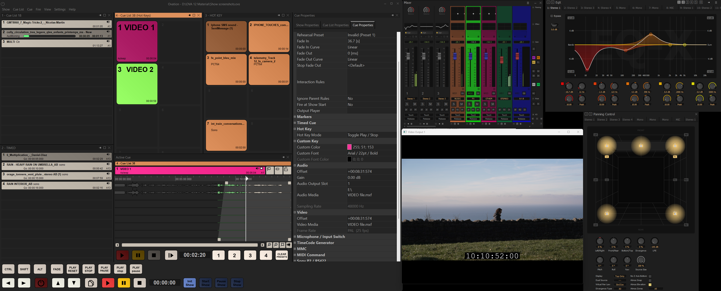

APRIL 2026

Merging Technologies Announces Ovation 12

A New Era for Live Show Control with Integrated Video, Advanced Synchronization, and Expanded Performance

Puidoux, Switzerland, April 2026 – Merging Technologies announces the upcoming release of Ovation 12, the latest major update to its industry leading audio playout system and show sequencer software. Scheduled for release on April 30, 2026, Ovation 12 represents a significant evolution of the platform, introducing native video playback, enhanced synchronization capabilities, and expanded I/O performance for today’s most demanding live and installation environments.
Trusted as the beating heart of theme parks, museums, broadcast facilities, and complex live productions worldwide, Ovation has earned its reputation for rock solid reliability, ultra-low latency performance, and unmatched flexibility. With Ovation 12, Merging Technologies responds directly to customer feedback by extending the platform beyond audio – without compromising its core strengths.

Native Video Playback, Seamlessly Integrated
With Ovation 12, video playback becomes an integral part of the show workflow.
Video files can now be dragged and dropped directly into playlists and handled like any other cue – even while a show is running. Audio fade-ins and timing can be precisely aligned to picture using Ovation’s active cue window, ensuring tight synchronization during rehearsals and live operation.
Ovation 12 supports all common video formats, with files easily trimmed directly within Ovation or prepared in Pyramix. Up to four video streams can be played simultaneously via standard computer graphics cards, delivering powerful visual integration without additional complexity.
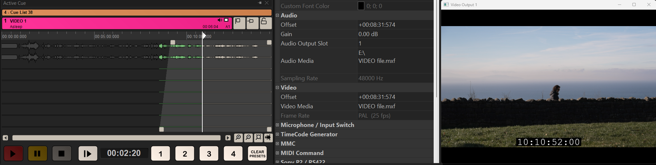

Advanced Timecode Control with Multiple LTC Outputs
Complex productions often rely on multiple third-party systems for lighting, video, special effects, and automation. Ovation 12 introduces native generation of multiple LTC outputs, enabling operators to drive several external sequencers simultaneously – each with its own independent timecode.
LTC can be routed to any audio output, generated at any frame rate, and sourced flexibly from show time, timed cue lists, or individual cues. Timecode readouts can be displayed anywhere on the operator’s screen, providing clear, real-time visibility in mission-critical environments.
This new capability eliminates workarounds and significantly simplifies synchronization in large scale, multi-system productions.
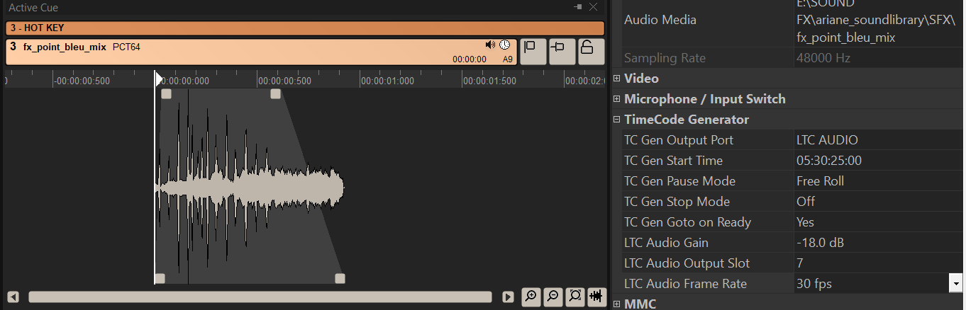

True Bidirectional Automation with Pyramix
Ovation and Pyramix have long formed a powerful ecosystem, allowing sound designers to create content in Pyramix and publish it to Ovation with a single operation. Ovation 12 deepens this integration with fully bidirectional automation exchange.
Automation data can now flow both ways between Ovation and Pyramix, enabling engineers to refine cues in Pyramix during rehearsals and seamlessly return them to the show environment – without losing automation detail. This enhancement delivers unprecedented flexibility for adapting productions right up until showtime.
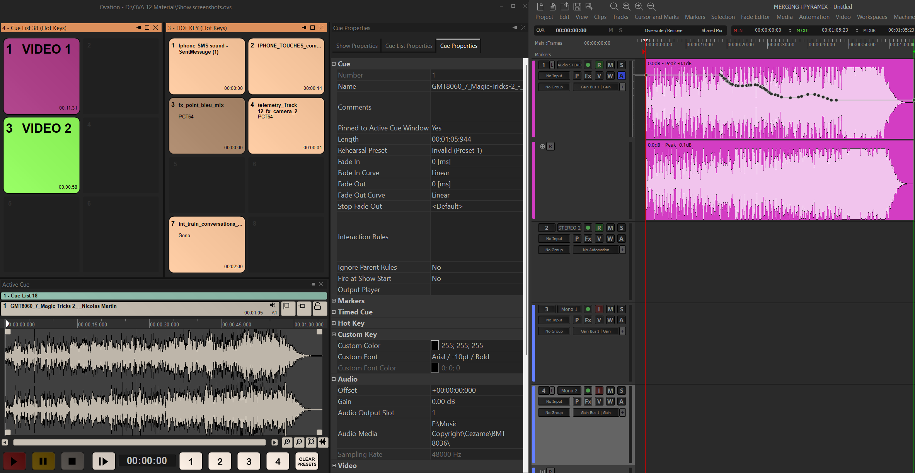

Expanded I/O and Performance Headroom
Ovation 12 significantly increases the number of simultaneous inputs and outputs available in Native mode across the ELEMENTS, PRO, and PREMIUM editions, while continuing to scale to extreme channel counts when paired with MassCore.
This expansion provides greater headroom for large, multichannel productions and reinforces Ovation’s position as a high resolution, low latency platform built for the most demanding applications.
 | With Ovation 12 |  |  |  | Before Ovation 12
 | 44.1/ 48k | 88.2/ 96k | 176.4/ 192k | DSD/ DXD | 44.1/ 48k | 88.2/ 96k | 176.4/ 192k | DSD/ DXD
Ovation PREMIUM | 256 | 144 | 72 | 36 | 128 | 64 | 32 | 16
Ovation PRO | 192 | 96 | 48 | 24 | 96 | 48 | 24 | 8
Ovation ELEMENTS | 48 | 24 | 12 | 2 | 48 | 24 | 12 | 2
MassCore | 384 | 192 | 96 | 64 | 384 | 192 | 96 | 64

Designed for Mission-Critical Shows
At its core, Ovation remains a fully redundant, high resolution playout system with a highly customizable user interface, extensive protocol support, live inputs, and advanced automation tools. On-the-fly cue editing and robust synchronization make Ovation an indispensable solution for productions where reliability is non-negotiable.
Ovation 12 builds on this legacy while opening the door to richer, more integrated audiovisual experiences.
Availability
Ovation 12 will be available starting April 30, 2026.
Availability and pricing may vary by region.
For more information, please visit: www.merging.com

Stay up to date and follow Neumann on: FACEBOOK | INSTAGRAM | YOUTUBE

About Merging Technologies
Merging Technologies is a Swiss manufacturer with over 30 years of experience in developing groundbreaking, professional audio and video products for a wide range of entertainment and media industries. In July 2022, Merging became part of the Sennheiser Group and is integrated with Neumann.Berlin. With a dedicated user base in the elite end of the music, film, television, mastering and performances industries, Merging is committed to developing product ranges with unrivalled quality and flexibility, no matter what the application. Merging builds tools for people who want more from their systems, have an inherent need to push boundaries, and believe that quality always comes first. www.merging.com

About Neumann
Georg Neumann GmbH, known as “Neumann.Berlin”, is one of the world’s leading manufacturers of studio-grade audio equipment and the creator of recording microphone legends such as the U 47, M 49, U 67, and U 87. Founded in 1928, the company has been recognized with numerous international awards for its technological innovations. Since 2010, Neumann.Berlin has expanded its expertise in electro-acoustic transducer design to also include the studio monitor market, building upon the legacy of the legendary loudspeaker innovator Klein + Hummel. The first Neumann studio headphones were introduced in 2019, and since 2022, the company has increased its focus on reference solutions for live audio. With the introduction of the first audio interface MT 48, and its revolutionary converter technology, Neumann now offers all the necessary technologies needed to capture and deliver sound at the highest level. Georg Neumann GmbH has been part of the Sennheiser Group since 1991 and is represented worldwide by the Sennheiser network of subsidiaries and long-standing trading partners. www.neumann.com

Neumann Newsroom
Georg Neumann GmbH
newsroom@neumann.com
+49 (0) 30 41 77 24-0
neumann.com

