Sennheiser lands in Salvador with an exclusive experience center for Carnival
In addition to supplying the task force for equipment maintenance for Carnival performers, Sennheiser’s House of Carnival also presented a demo room with state-of-the-art audio equipment

Salvador, Brazil, March 28, 2023 –— Sennheiser, a world leader in audio technology, brought an experiential demo space to Carnival to welcome artists, audio engineers, music producers, and lovers of the brand. The House of Carnival has been a tradition for over 10 years, previously functioning only as an official service center to greet customers who needed technical assistance or new audio equipment before the Brazilian revelry. This year, in addition to the service center, the big attraction was an immersive room equipped with Neumann monitors and the AMBEO Soundbar.

According to economists, without Carnival in 2022 Salvador lost an estimated R$2 billion of economic value– a loss that impacted millions of people that contribute directly or indirectly to the world famous street party. This time of the year accounts for 11% of the yearly profit of the city.

Brazilian artist Simone Mendes uses a custom SKM 9000 wireless transmitter with the MD 9245 capsule at Carnival.

The brand´s service center in Salvador has always been an expectation pre-Carnival and a service no other audio brand provides for the event. Every year, Sennheiser´s technicians move from the headquarters in Sao Paolo to Salvador with tons of Sennheiser wireless equipment to exclusively serve artists and customers during the event. Carnival is the time of the year where many Brazilian performers make the highest profit in the shortest amount of time. Some artists perform dozens of sets in a short period and need to make sure their equipment is in perfect working condition so there are no surprises along the way. Everything from preventive maintenance to firmware updates or antenna replacement can be done right away by the Sennheiser product specialists.
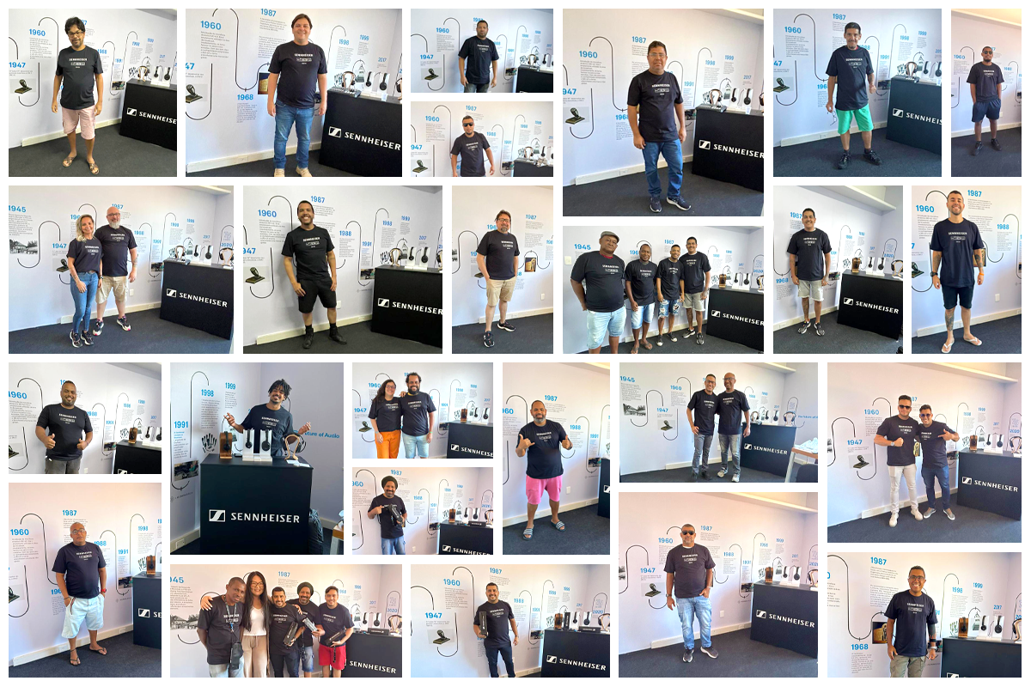 | Sennheiser’s technical team supported the performers with service requests and equipment repairs throughout Carnival.

In addition to Sennheiser’s service center at Carnival, the brand opened its House of Carnival for the first time to some of the biggest Pro Audio names in Brazil for a joint demo space. Allen & Heath, Audio Systems, MGA Pro Audio and Carbocase also had their own space to greet customers and offer solutions for the biggest street party on the planet.

“This year, we were able to take advantage of our legacy here and make room for other partners in the professional audio industry, amplifying local support and offering a space with open doors for visitors, such as producers and sound engineers, responsible for the sonic magic behind the parade, large stages and recording studios”, says Daniel Reis, Sennheiser´s country partner in Brazil. In addition to his role with Sennheiser, Daniel Reis was also the longtime audio engineer responsible for the sound of one of Brazil´s most iconic bands.

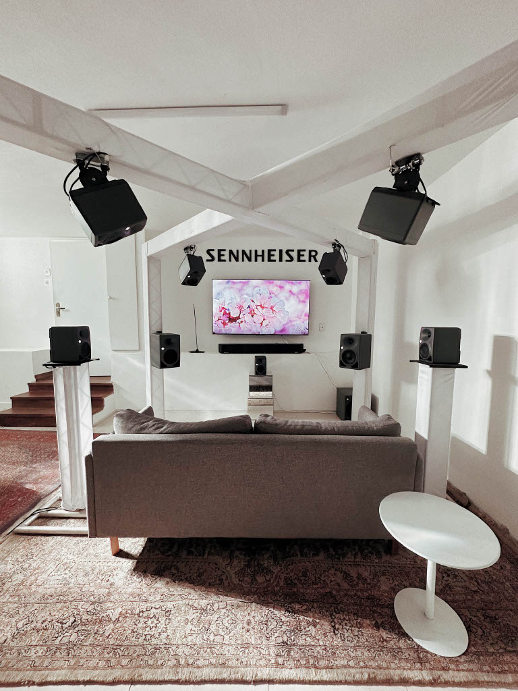 | House of Carnival’s immersive audio room featured an array of Neumann monitors.

With many different environments, the House of Carnival offered an immersive room set up with Dolby Atmos technology and Neumann monitors, including a pair of KH 150s, 11 KH 80s and one KH 750, in addition to the AMBEO Soundbar that simulates a 7.1.4 system. With this, there was a high-end listening room with some of the most recognizable headphones of the brand along with the iconic HE 1 – considered the best sounding headphone in the world and valued in half a million in local currency.

In a different space, there was a showroom with the professional audio portfolio as well as an exhibition about the history and development of the audio industry.

Starting in the beginning of February, the space held workshops on topics such as RF coordination at big events, myths and facts about RF, and the future of wireless systems.

About the Sennheiser Group
Building the future of audio and creating unique sound experiences for our customers - this is the aspiration that unites the employees of the Sennheiser Group worldwide. The independent family-owned company Sennheiser was founded in 1945. Today, it is managed in the third generation by Dr. Andreas Sennheiser and Daniel Sennheiser and is one of the leading manufacturers in the field of professional audio technology. Within the Sennheiser Group are Georg Neumann GmbH (Berlin, Germany), manufacturer of studio-grade audio equipment; Dear Reality GmbH (Düsseldorf, Germany), known for its binaural, Ambisonics, and multichannel encoders with realistic room virtualization; and Merging Technologies SA (Puidoux, Switzerland), specialist in high-resolution digital audio recording systems.
sennheiser.com | neumann.com | dear-reality.com | merging.com

Local Press Contacts
Daniella Kohan Caroline Medeiros
daniella.kohan@sennheiser.com caroline.medeiros@cmvaudiogroup.com
+1 (860) 227-2235

