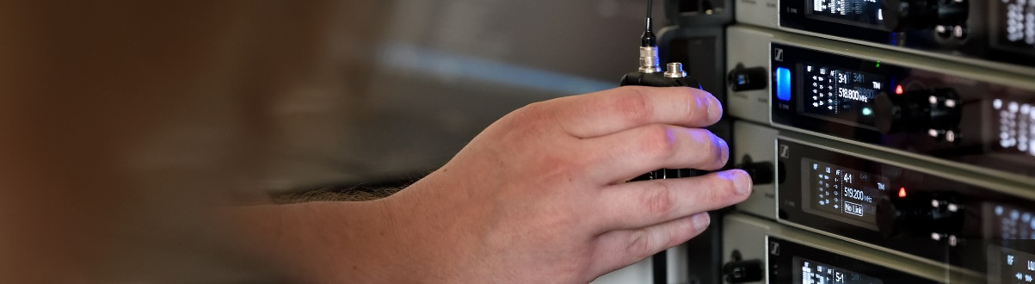#DontStopTheEducation
New seminars on conferencing and learning during the pandemic, a live visit to Aalborg University and learn new workflows for hybrid learning and contactless audio

Marlow/UK, July 10, 2020 – Join informative discussions about conferencing and higher education in Sennheiser’s #DontStopTheEducation series! On July 15, Aalborg University opens its doors to you – albeit virtually – to show you how a university with three locations handles audio and control requirements. On July 16 and 17, a consultant round table will discuss the new normal in higher education and conferencing. To best account for the breadth of challenges faced in various regions, this round-table discussion is available from a range of global locations, with different panellists for each region. In addition, further online seminars from Sennheiser will be looking at touchless audio and hybrid learning, and the TeamConnect Ceiling 2 microphone. All hosts and panellists are very much looking forward to answering your questions.

Wireless Microphones at Aalborg University
Wednesday, July 15, at 8:30, 13:30 and 18:00 Copenhagen time (CEST, UTC+2)
Per Mouritzen | 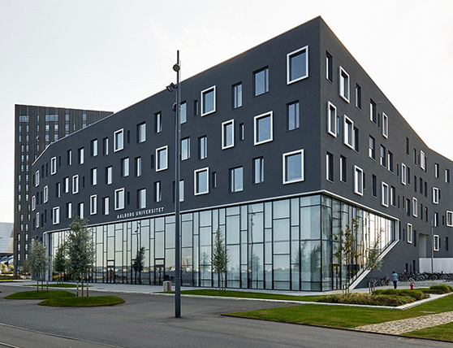 | 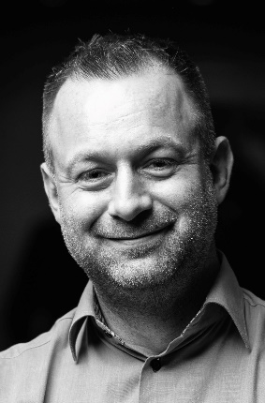  Christian Almer

In this one-hour live seminar, Aalborg University in Denmark demonstrates how they centrally manage and control all microphones at their three locations. Sennheiser’s Christian Almer, a sound engineer and RF specialist, is joined by Per Mouritzen from Aalborg University, who has been working in the AV industry for more than 20 years, both as an end user, installer and technician. Per holds a CTS and has a master in ICT and learning and is responsible for the classroom set-up at Aalborg University. Registrations are now open at:
08:30: https://zoom.us/webinar/register/WN_9DOuh1kLSG2txsnQ3oVjdA
13:30: https://zoom.us/webinar/register/WN_8TJL-3KNQja3JjA3Av_SVQ
18:00: https://zoom.us/webinar/register/WN_3K1txzFqSyi_okYRS56_Rg

Embracing the New Normal: Shifting Technology Trends in Online Conferencing and Remote Learning / Blended Learning
Thursday, July 16 and July 17 – four sessions available for different regions
In this 90-minute live round-table discussion, the panellists and hosts will take an in-depth look at the ‘new normal’ for corporate meeting spaces and universities and answer some of the most typical and pressing questions that have arisen in the wake of the coronavirus crisis: Are we ready for a post-pandemic technology shift to address the new social distancing norms – and what could this look like for online conferencing and e-learning? How do we continue being engaging and productive with travel restrictions and social distancing in place? And what new tech solutions and ideas would consultants wish to see designed and implemented?

Australia/New Zealand, July 16, 15:00 Sydney, 17:00 New Zealand https://zoom.us/webinar/register/WN_wlhsU9VuSgSCd6JJj4SNlw
Sennheiser host Jason Grbevski will welcome Christopher Khoo (Norman Disney Young), Graham Vincent (Beca), Jamie Pereira (Pereira Projects) and Peter Hunt (Hewshott International).

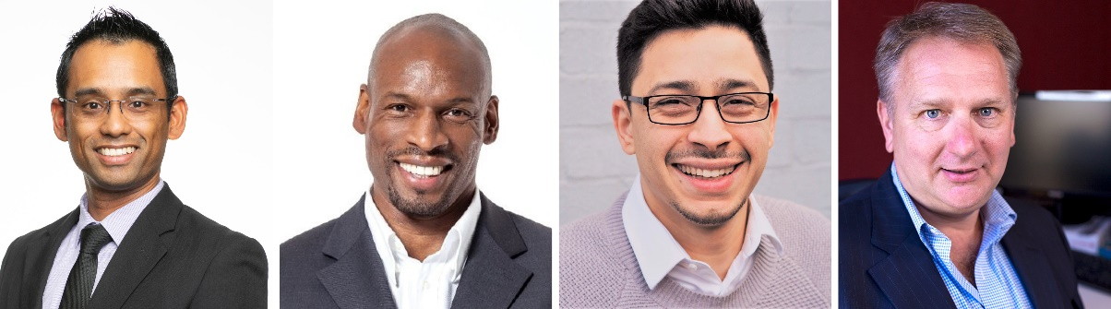
The panellists of the Australia and New Zealand Round Table: Christopher Khoo, Graham Vincent, Jamie Pereira and Peter Hunt (from left to right)

Asia, July 16, 11:00 UAE, 12:30 IST, 15:00 SIN, 15:00 CHN
https://zoom.us/webinar/register/WN_DwRDflXcTjCR-kidIUln7Q
Sennheiser host Kenan Phang will welcome Gerald Stewart (Inhabit Group), Mradul Sharma (3C Design Networks), Ratnesh Javeri (Innovative Systems & Solutions) Robert Soo (Cogent Acoustics) and Stone Yao (Acoustics Design Institute).

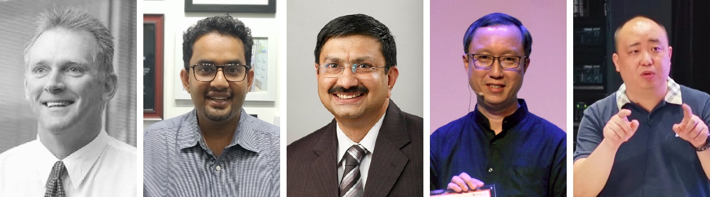
The panellists of the Asia Round Table: Gerald Stewart, Mradul Sharma, Ratnesh Javeri, Robert Soo and Stone Yao (from left to right)

Europe – July 16, 15:00 UK, 16:00 CEST https://zoom.us/webinar/register/WN_szcFxKIsSryxbX_DUYXv6Q
Sennheiser host Christian Almer will welcome Christophe Bezault (Atelier Audiovisuel), Gert van Ginkel (Defender Projects), Kristian Glahn (Vowi), Paul Marshall (Recursive Digital) and Paul Rushbrooke (PTS Consulting).

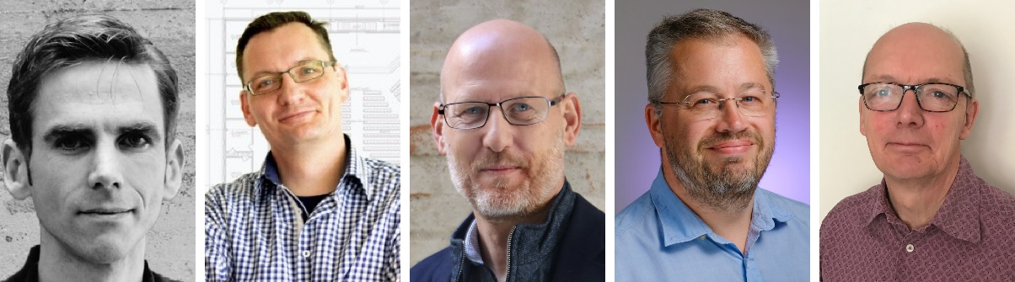
The panellists of the Europe Round Table: Christophe Bezault, Gert van Ginkel, Kristian Glahn, Paul Marshall and Paul Rushbrooke (from left to right)

Americas – July 17, 13:00 EDT https://zoom.us/webinar/register/WN_Libl0VJ9ShCHMCuPpFCHzw
Sennheiser hosts Dave Missall, Steve Wingo and Frédéric Girard will welcome Brian Brustad (Cerami Associates), Eric Kinsinger (Syska Hennesy Group), Jean Desarmenien (Jean Desarmenien Consulting), Mark Peterson (Shin, Milsom and Wilke LLC), Martin van Dijk (Engineering Harmonics) and Pat Galardo (Smith + Andersen).

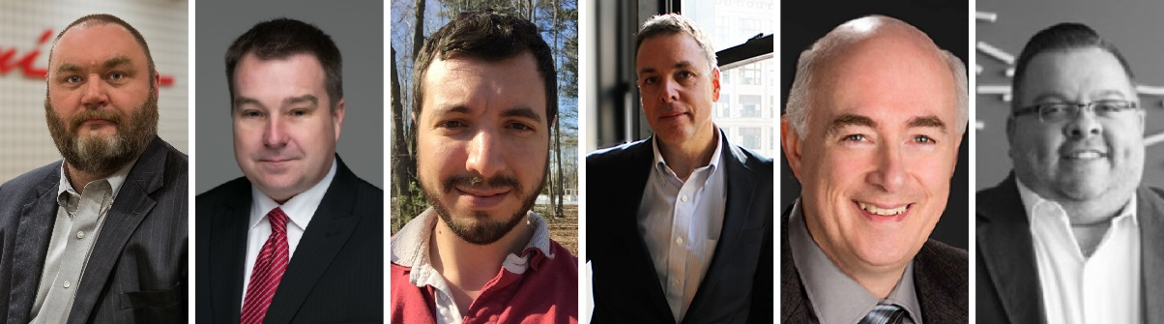
The panellists of the Americas Round Table: Brian Brustad, Eric Kinsinger, Jean Desarmenien, Mark Peterson, Martin van Dijk and Pat Galardo (from left to right)

Other seminars

Hybrid Learning and Touchless Audio
July 9, 16:00 Berlin time and July 16, 16:00 Berlin time (CEST, UTC +2)
This online seminar looks at solutions for contact-free microphone capture of lectures and seminars and shows alternative delivery methods to avoid device sharing in a world with Covid-19. New workflows will be explored that allow for classroom collaboration between multiple locations to maximize student and instructor interaction in de-centralized classroom applications. Also, the seminar will show methods to implement voice lift in a space using ceiling microphones and BYOD mobile phone listening technology, in order to overcome some of the challenges of social distancing and shared devices in a classroom environment. Registration is open at https://zoom.us/webinar/register/WN_zfBNAlc4RA6TZDppqbKUlQ.

TeamConnect Ceiling 2 Live Demo
July 14, July 21, July 28 or August 4, each seminar at 10:30 or 14:30 London time (UTC +1)
Eight opportunities to attend an in-depth live demo of TeamConnect Ceiling 2! Sennheiser’s ceiling array microphone with patented, adaptive beamforming technology can be experienced live in a meeting room setting. Registration is open at https://zoom.us/webinar/register/WN_70tMKWW1Th-LA007b_Chzw for the 10:30 slot and at https://zoom.us/webinar/register/WN_AWMomK5ASjyqlw5-RcVwdQ for the 14:30 slot.

More SoundAcademy live seminars can be found at https://www.sennheiser.com/seminars. Participation is free of charge.

The images accompanying this press release can be downloaded at https://sennheiser-brandzone.com/c/181/i3mWJmBX.

About Sennheiser
Founded in 1945, Sennheiser is celebrating its 75th anniversary this year. Shaping the future of audio and creating unique sound experiences for customers – this aim unites Sennheiser employees and partners worldwide. The independent family company, which is managed in the third generation by Dr. Andreas Sennheiser and Daniel Sennheiser, is today one of the world’s leading manufacturers of headphones, loudspeakers, microphones and wireless transmission systems. In 2019, the Sennheiser Group generated turnover totaling €756.7 million.
www.sennheiser.com

Global Press Contact

Stephanie Schmidt
Stephanie.schmidt@sennheiser.com
+49 (5130) 600 – 1275

