10 years of Panasonic eneloop

Zellik, 28 January 2016. – Panasonic recently celebrated the 10th anniversary of its eneloop brand. This unique eco-friendly rechargeable battery offers a new lifestyle choice to customers. Today, it ships to over 80 countries and is appreciated by consumers all over the world.

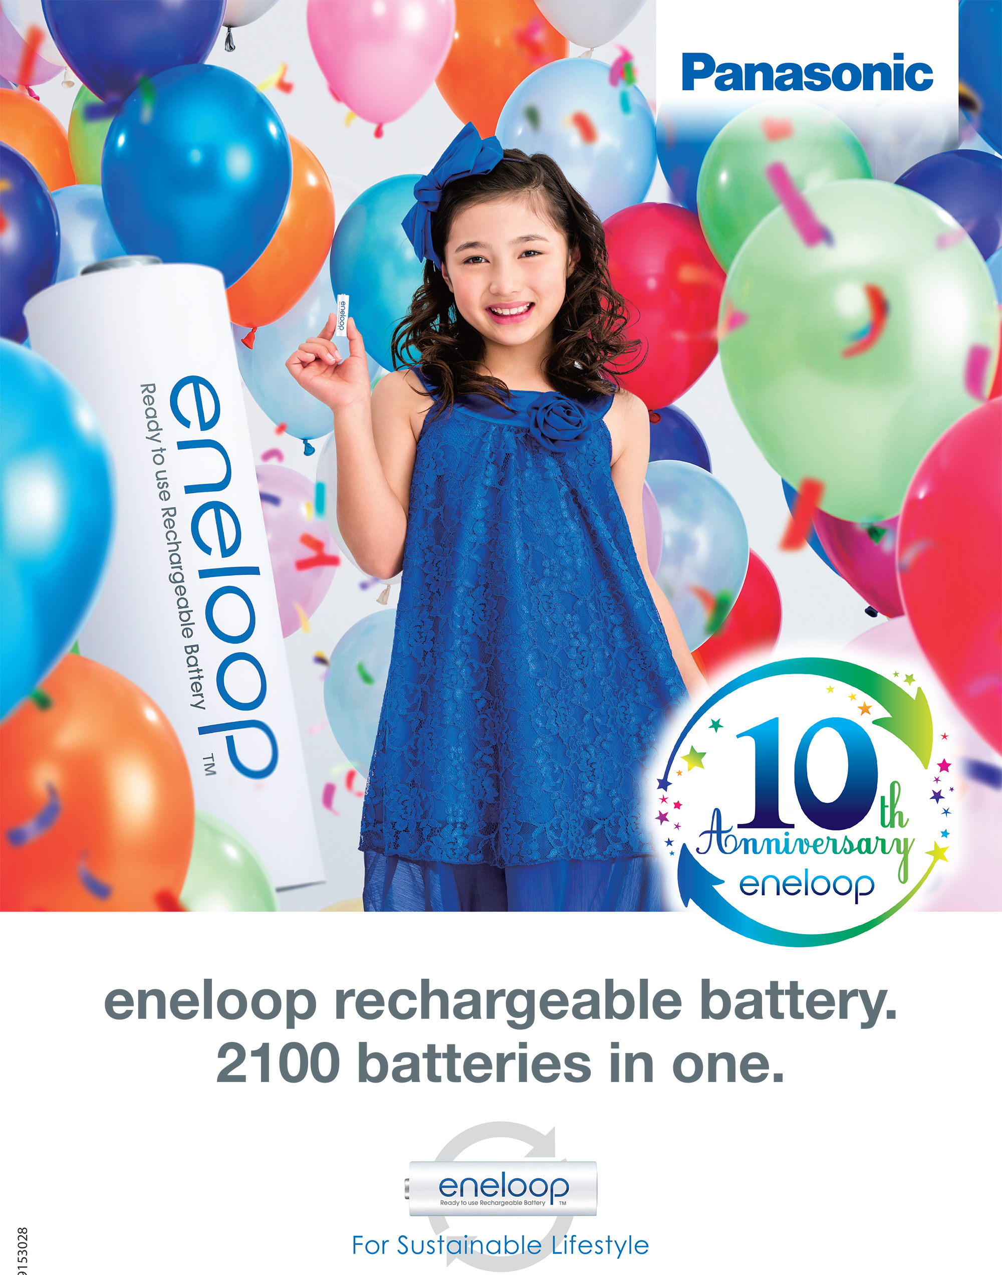

Launched in November 2005, eneloop has revolutionised the consumer-use rechargeable battery segment thanks to its unique features:

- eneloop batteries can be recharged up to 2,100 times
One of the most important characteristics of a rechargeable battery is its cycle life; the number of charge/discharge cycles it can withstand without losing capacity. eneloop can be recharged up to 2,100 times, not only making it more economical, but helping reduce the world’s waste pile of batteries.

- Ready-to-use & low self-discharge
eneloop batteries are delivered pre-charged using solar power, making them immediately useable after purchase, like primary batteries. They also have a low self-discharge rate. While other non-ready-to-use rechargeable batteries lose their charge over time, Panasonic’s proprietary eneloop technology means its batteries maintain 70% capacity even after 10 years of storage.

- Longer lasting than primary batteries
Many applications switch off or indicate low battery when voltage is lower than 1.1 volts. A traditional primary battery continuously loses voltage and reaches this critical level very quickly. eneloop batteries keep the voltage level over 1.1 volts for a long time, only falling below just before they are empty.

- High performance even at low temperatures
Contrary to primary batteries, eneloop batteries keep a high voltage at low temperatures and can even maintain a low self-discharge rate in temperatures as low as -20ºC.

Combining the pluses
eneloop is a revolutionary rechargeable battery that can be used as easily as a primary battery, and reused simply by recharging it. It brings together the advantages of both types of batteries, while also saving resources. It’s part of the reason that Panasonic was ranked in the top five of Best Global Green Brands in 2014.

Product range
Alongside standard eneloop batteries, Panasonic also offers eneloop pro and lite:
- eneloop pro have a higher capacity and are therefore the perfect choice for high energy-consuming devices such as photo strobe flash lights, wireless keyboards, mice, game controllers and household devices.
- eneloop lite can be recharged up to 3,000 times, making these batteries ideal for low to medium power consumption devices, such as DECT phones and remote controls.

10th Anniversary
To celebrate eneloop’s 10th anniversary, Panasonic has launched a special campaign with activities happening across Europe, including a revamped website in 13 languages, a drawing competition and several spectacular events. Also currently running is an International photo challenge around the theme of sustainability and the environment. Visit https://photochallenge.panasonic-eneloop.eu/en for more details.

About Panasonic Energy Europe NV
Panasonic Energy Europe NV is Europe's largest battery manufacturer. The company belongs to the
Panasonic Corporation, a leading provider on the international stage of electronic and electrical goods. Thanks to Panasonic's many years of experience and expertise in the consumer electronics field, Panasonic Energy Europe NV has a unique market position in Europe. The company supplies "mobile" energy in over 30 European countries. In addition to its European Centre in Brussels, Panasonic Energy Europe NV runs production lines in Belgium (Tessenderlo) and Poland (Gniezno), in which over a billion batteries are manufactured every year. Panasonic Energy Europe NV’s broadly diversified product range embraces, inter alia, alkaline and zinc-carbon batteries, cells, photo-lithium-, silver oxide and zinc-air batteries, as well as button cells.
Further information at www.panasonic-batteries.com.

About Panasonic
The Panasonic Corporation is a leading company worldwide in the development and manufacture of electronic goods for a wide range of private, trade and industrial uses. The Group, based in Osaka, Japan, in financial year ended 31 March 2015 posted consolidated net sales of around 57.28 billion EUR. Panasonic Corporation's shares are listed on the Tokyo, Osaka, Nagoya and New York stock exchanges (NYSE symbol: PC). Panasonic wants to become by its 100th birthday in 2018 the world's leading company for green innovations in the electronics industry.
More information about the company and the Panasonic brand name at www.panasonic.net.

PRESS CONTACT

ARK Communication
Ann-Sophie Cardoen
Content & PR Consultant
T +32 3 780 96 96
ann-sophie@ark.be
www.ark.be

ARK Communication
Ann Velghe
Content & PR Manager
T +32 3 780 96 96
ann@ark.be
www.ark.be

Panasonic Energy Europe NV
Vicky Raman
Brand Marketing Manager
T +32 2 467 84 35
vicky.raman@eu.panasonic.com
www.panasonic-batteries.com
www.panasonic-eneloop.com

