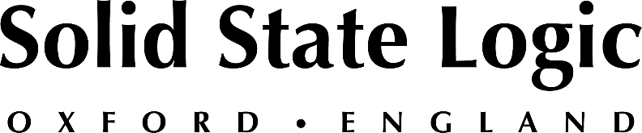

UNDER EMBARGO UNTIL JANUARY 13th 2020 7:00 a.m. PST

Solid State Logic’s New Audio Interfaces Bring Studio Quality To Personal Studios

Professional personal and collaborative studio packages bring together 40 years of music production knowledge and technology

OXFORD ENGLAND - Solid State Logic (SSL) has launched their first-ever dedicated audio interfaces as part of their new personal studio range: the SSL 2, and SSL 2+. Both are USB-powered and include class-leading mic preamps, legacy 4K analogue enhancement mode inspired by classic SSL consoles, studio-quality monitoring, and an SSL Production Pack software bundle.

SSL has been designing cutting-edge mixing consoles and processing tools for the world's finest recording studios for over four decades, and the new SSL2 and SSL2+interfaces takes this technology and know-how, and places it in the hands of today’s creatives and aspiring professionals. Designed to be at the heart of a project or personal recording set up, the SSL 2 personal studio is perfect for individual singers, songwriters, or media producers, while the SSL 2+ collaborative studio provides expanded I/O for musicians working and recording together.

“When SSL's founder, Colin Sanders set about making his first mixing console in the early 70s, he did so because every other console at the time fell short of his expectations and needs,” comments SSL Director of New Products, Niall Feldman. “Fast-forward 40 years, that same philosophy has inspired the team to create the SSL 2 and SSL 2+ for the personal studio market, and share some of that amazing technology in a new format.”

The 2-In/2-Out SSL 2 packs in two classic analogue mic preamps together with pristine 24-bit/192kHz conversion to capture and hear every detail, a single high-grade headphone output, easy-to-use monitor mix control for critical low-latency monitoring tasks, and balanced monitor outputs with an impressive dynamic range. In addition, the ‘Legacy 4K mode – inspired by the studio favourite, hit-making SSL 4000 series consoles - gives you the ability to add extra analogue character and sparkle to your input sources. The included ‘SSL Production Pack’ software bundle, which includes some of SSL's own studio-grade Native plug-ins, gives you an incredible arsenal of tools for refining your recordings.

The SSL 2+ feature set builds in a production hub for those wanting to collaborate, with an additional headphone output with independent monitor mix, MIDI I/O, and additional un-balanced outputs for DJ Mixers.

Andy Jackson, SSL Studio Product Manager, enthuses “We focused on developing the best sounding and performing audio interfaces at this price point, and then raising the bar again with features and add-ons that make a significant difference when creating. Our attention to excellence even goes down to the use of Neutrik connectors and Alps pots throughout, because anything else is a compromise. We are fortunate to have a phenomenal heritage of product, technology and successful artists to draw on during development, so if you’re starting out in recording music, why wouldn’t you start with the best?”

The SSL 2 is available priced: £149.99 + VAT, $229.99 + Tax, €179.99 + Tax
The SSL 2+ is available priced: £199.99 + VAT, $279.99 + Tax, €239.99 + Tax

For more information please contact your favourite reseller or go to our website: www. solidstatelogic.com/music-and-audio-production/audio-interfaces

###

Solid State Logic is the world’s leading manufacturer of analogue and digital audio consoles and provider of creative tools for music, broadcast, live and post production professionals. For more information about our award-winning products, please visit: www.solidstatelogic.com.

###
For further information contact:
Ross Gilbert
+44 (0) 1865 842300
rossg@solidstatelogic.com

