MARCH 2026

Merging Technologies Announces Pyramix 16
A Leap Forward in Musical Production, Precision, and Workflow Efficiency

Puidoux, March 31, 2026 - Merging Technologies proudly announces the release of Pyramix 16, the newest major upgrade to its world-renowned digital audio workstation. Built for engineers who demand uncompromising sound quality and production flexibility, Pyramix 16 delivers groundbreaking audio innovations, seamless Dolby Atmos® workflows, and expanded compatibility for modern production environments.

Pyramix 16 is available in three versions: ELEMENTS, PRO, and PREMIUM. It further enhances each tier's capabilities, delivering new features, improved performance, and deeper integration options while maintaining the clear workflow distinctions professionals rely on. Driven by the mission to help engineers capture extraordinary music and deliver it with unmatched sonic precision, Pyramix 16 introduces a major new pillar of innovation.

Revolutionary Sound: PanNoir
Developed in collaboration with acclaimed recording engineer and producer Jean-Daniel Noir, PanNoir fundamentally rethinks how spot microphones blend with a main stereo pair.
Traditional DAWs rely solely on level differences when panning spot mics, often resulting in phase issues and compromised stereo imaging. PanNoir, now built directly into the Pyramix mixer, solves this by introducing both level and time of arrival differences, respecting how sound reaches a main stereo microphone pair and ultimately how human hearing works.
“PanNoir sounds remarkably natural. When I bring spot mics into the mix, I simply gain clarity while preserving the stereo image, tonal balance, and musicality of the main pair. If needed, I can push them much louder than without PanNoir. It offers an unmatched level of flexibility and intimacy with the music.” Jean-Daniel Noir, Recording Engineer and Producer.

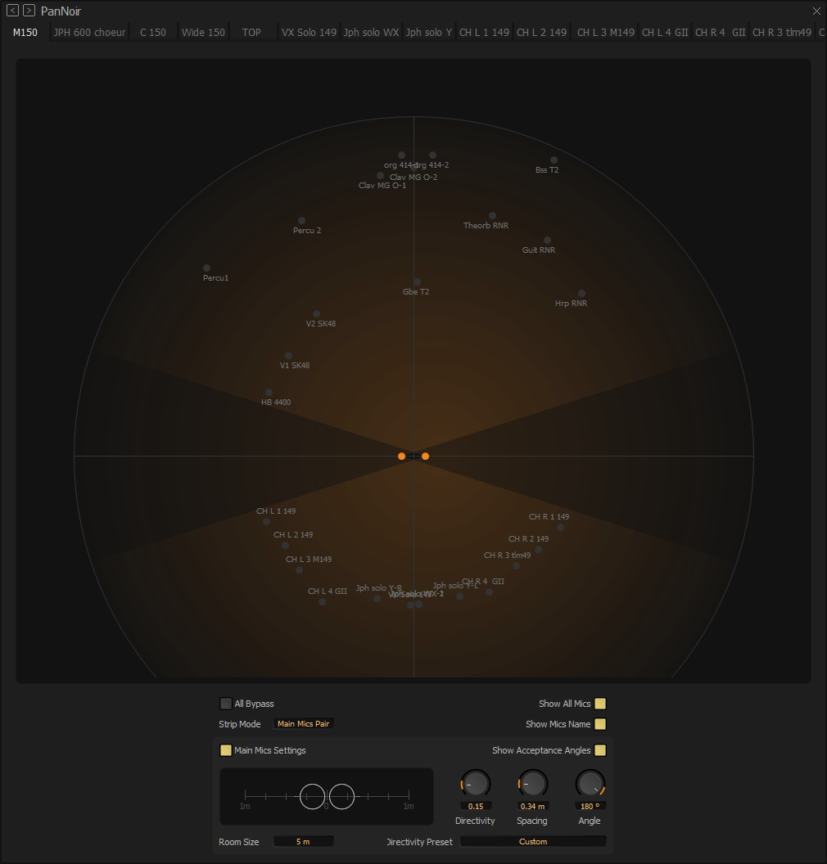
PanNoir user interface - Each track is represented in the same window, providing full visibility and control over panning in coherence with the main pair.
- Spot mics maintain phase coherence with both channels of the main pair, stopping comb filtering.
- Stereo imaging becomes more accurate, stable, and natural
- Engineers gain unprecedented control for classical, jazz, and acoustic productions
- Autodetection of mic positioning and Neumann microphones' directivity presets further streamline the workflow

This marks a significant leap for music producers striving for authenticity.
Jean-Daniel Noir adds “The realism of PanNoir is astonishing. In a recent opera production where we couldn’t place a main stereo pair above the conductor, PanNoir allowed me to rely solely on the spot mics, yet the mix still delivered a natural, coherent stereo image.”

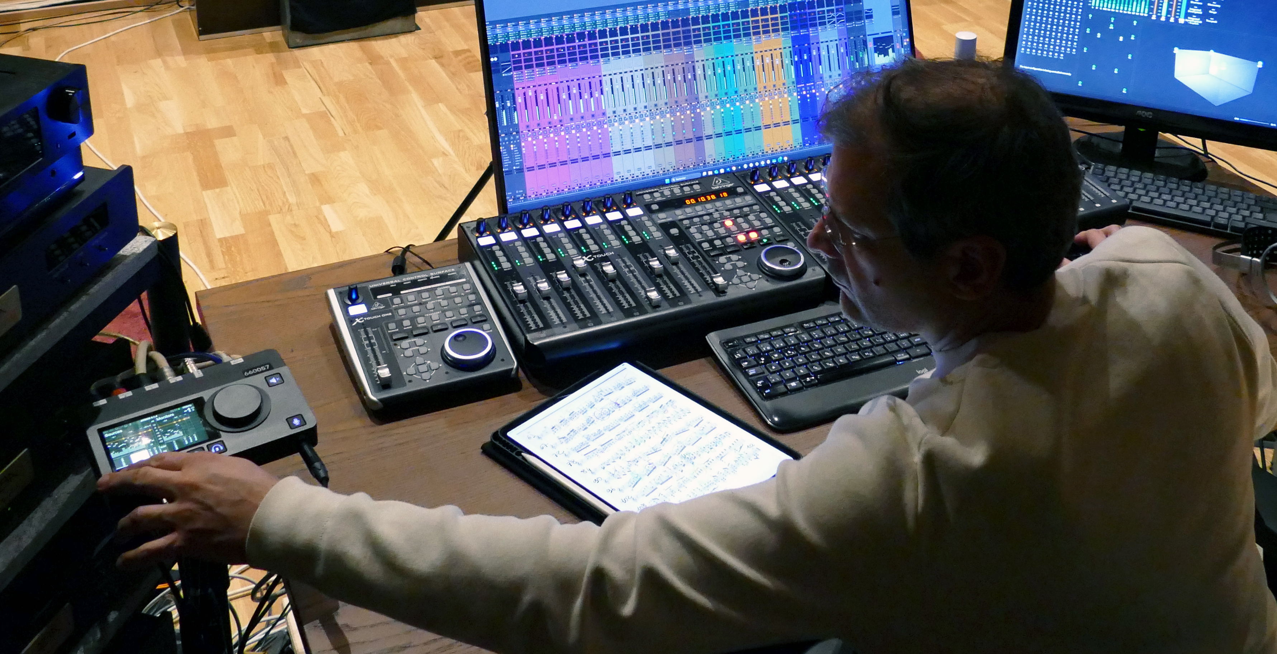
Jean-Daniel Noir's workflow is based on Anubis and Pyramix

Built-in Dolby Atmos Renderer
Responding to the growing demand for immersive music production, Pyramix Premium now includes a built-in Dolby Atmos Renderer supporting speaker configurations up to 9.1.6 and binaural for headphones. This also includes Live Re-Renders, enabling loudness measurements with the Pyramix Final Check meter. This integration dramatically reduces setup complexity and accelerates production times.
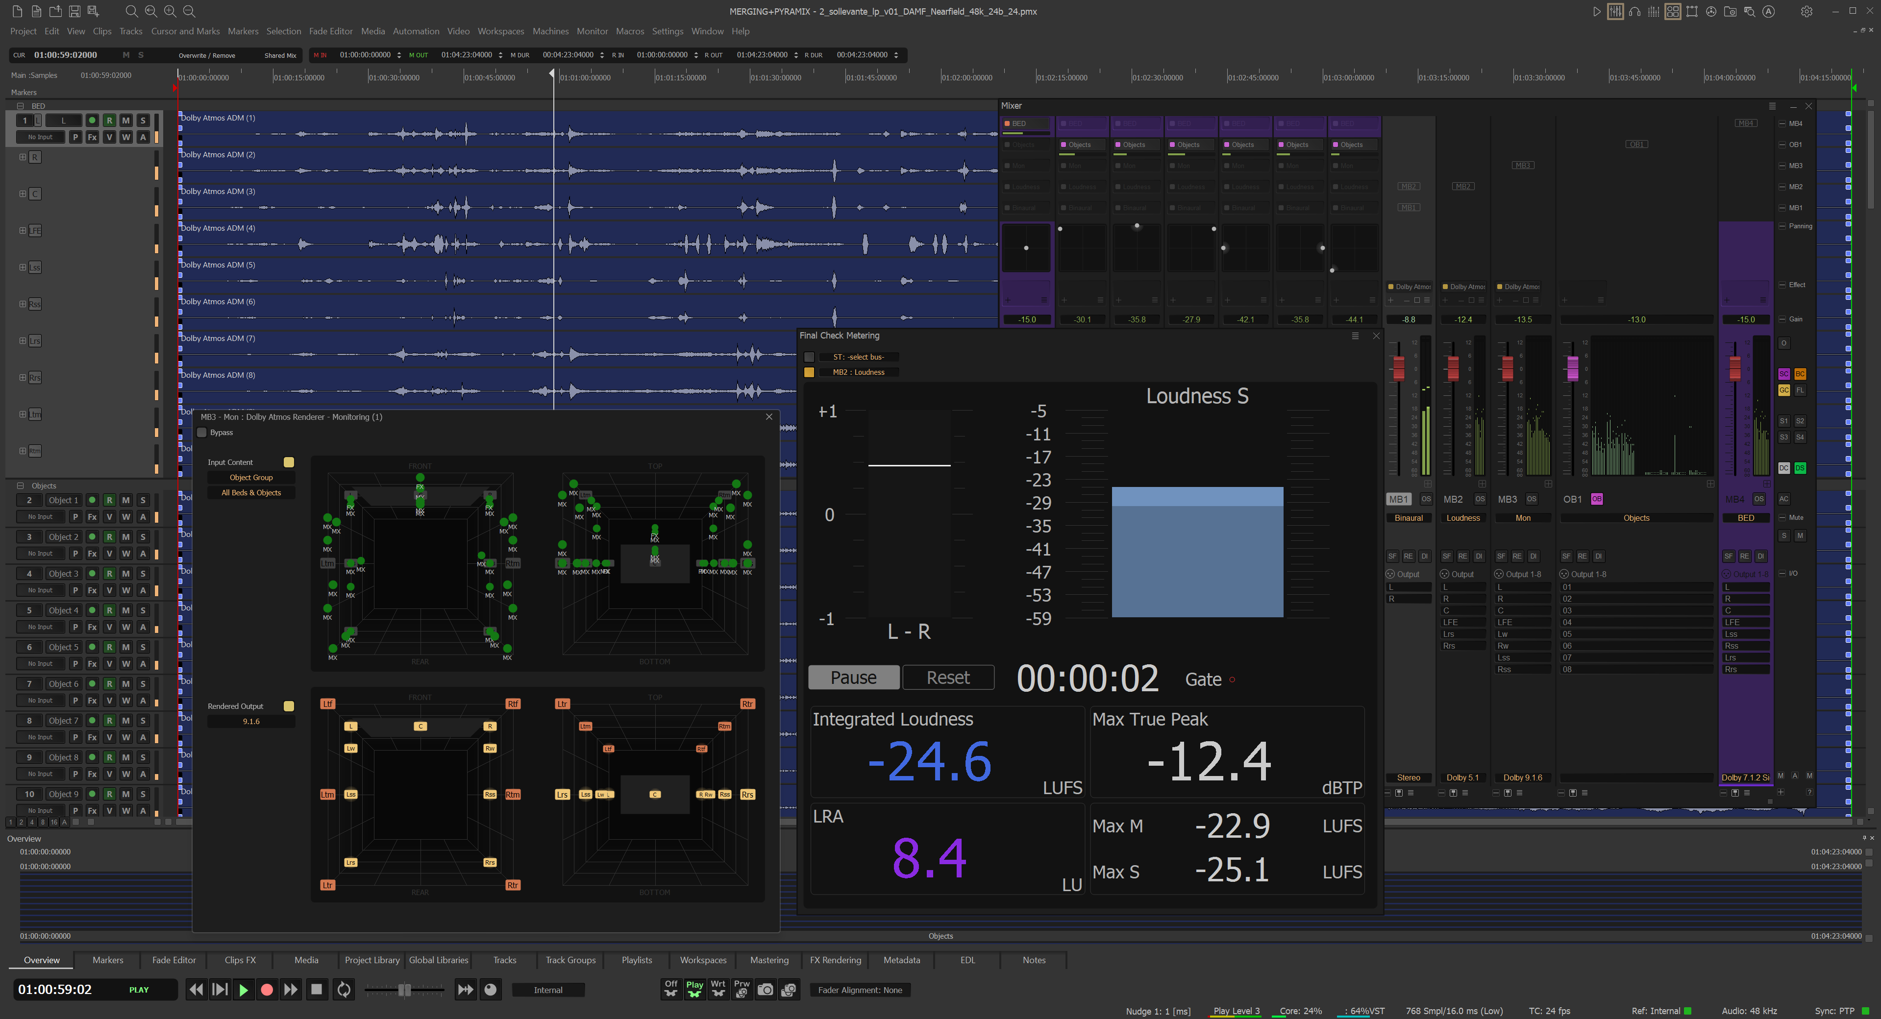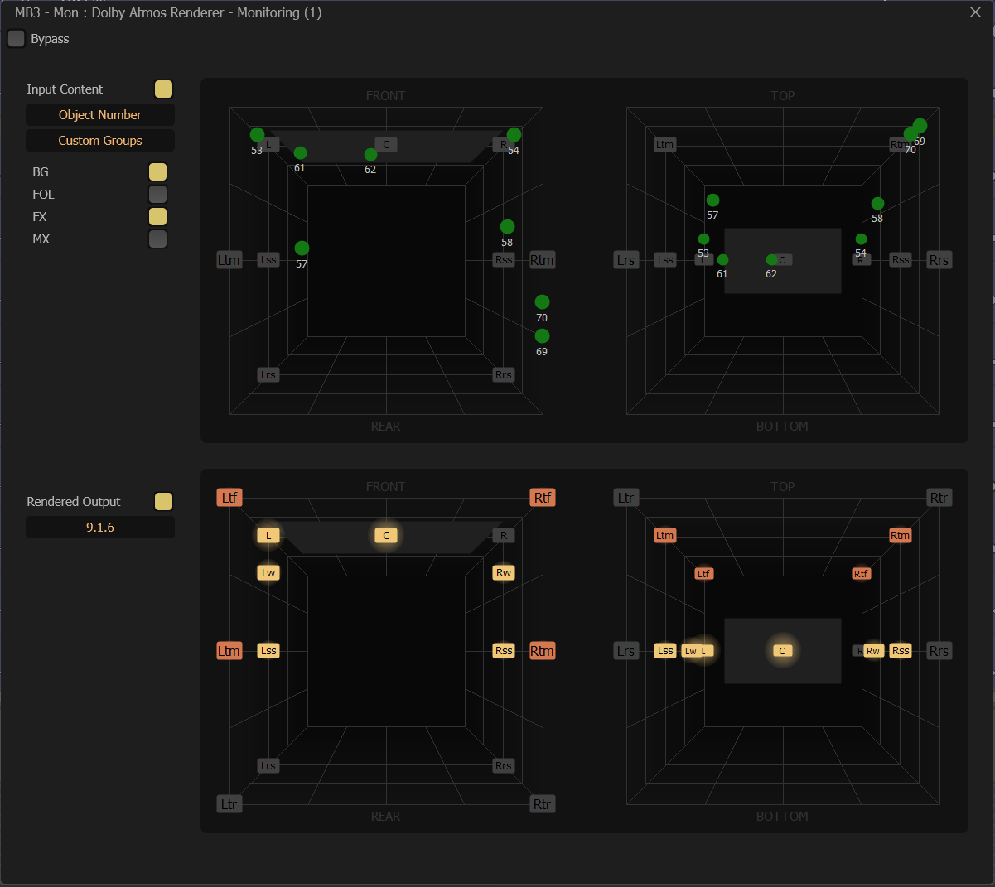

Enhanced Performance, New I/O Capacities, and Parallels Desktop Support for macOS
Pyramix 16 also delivers notable performance improvements engineered in close collaboration with users and new I/O capacities. The added Parallels Desktop® support effectively brings Pyramix one step closer to macOS, allowing Mac users to run Pyramix alongside their native applications with far greater convenience.
Product Manager Maurice Engler adds, "Thanks to invaluable feedback from our customers and the dedication of our team, we are proud to deliver a new version that we believe is focused on what our users specialize in: capturing great music and delivering it to a wide audience in the best possible way."

Three Versions Tailored to Every Workflow
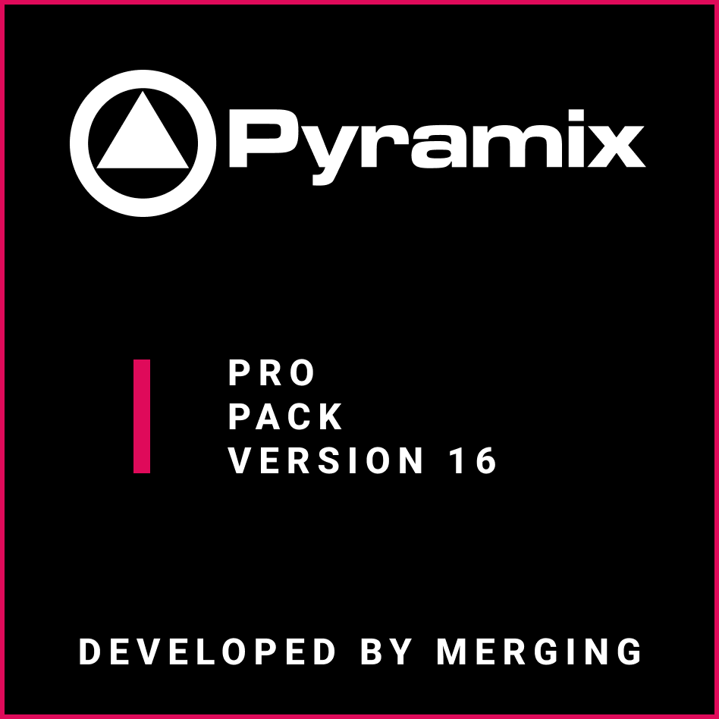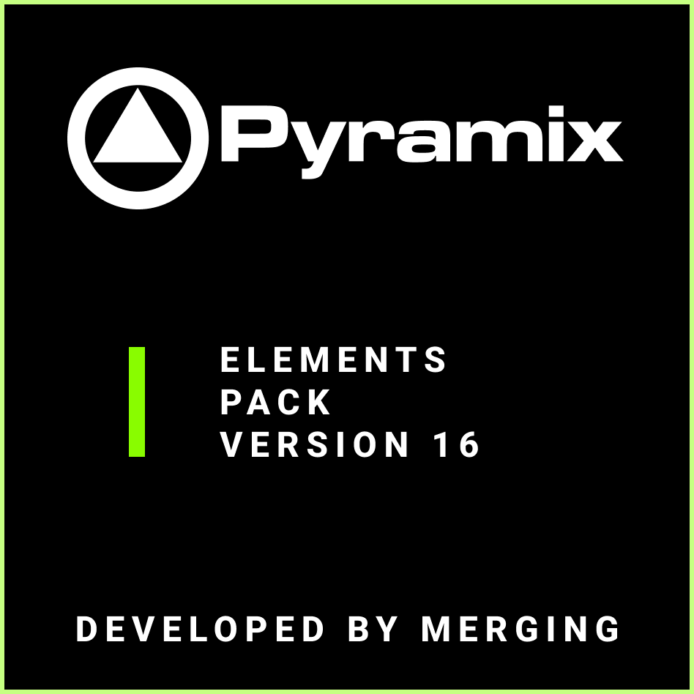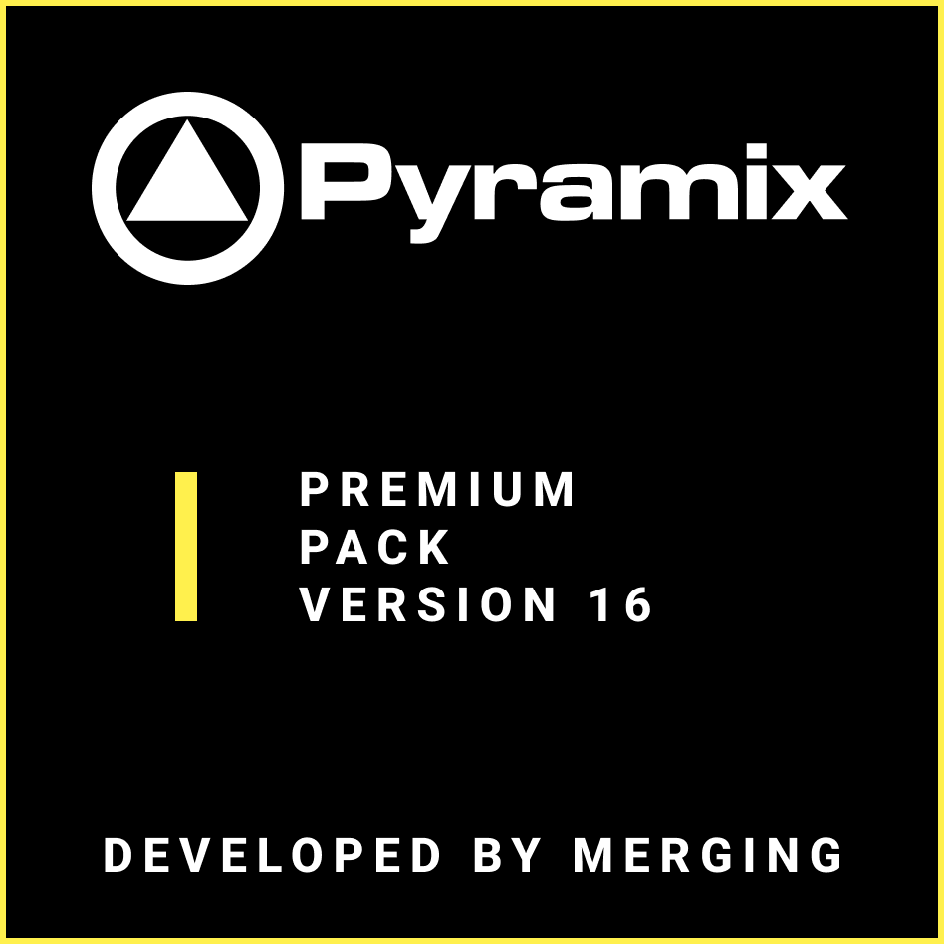

Pyramix ELEMENTS – The cost-effective DAW for modern creators
Ideal for smaller studios, project workflows, podcasters, and music creators who want the renowned Pyramix editing engine at an accessible price point. ELEMENTS includes Pyramix’s powerful recording and editing toolkit, high-resolution audio support, Pyramix’s real-time editing engine, and the built-in PanNoir technology.

Pyramix PRO – The editing workhorse for professional studios
Suited for editors and engineers managing demanding multitrack projects, broadcast workflows, and detailed post-production tasks. PRO expands I/O capabilities, adds advanced mastering, Source–Destination editing, extended loudness features, and broader controller support, making it the ideal choice for highly active production environments.
Pyramix PREMIUM – The fully featured flagship DAW
Designed for top-tier facilities in music recording, classical production, film, and immersive audio. PREMIUM includes the built-in Dolby Atmos Renderer, supports custom immersive speaker layouts, DSD/DXD workflows, multi-recorder setups, and the complete set of Pyramix’s advanced mastering, immersion, and integration features. This edition represents the most complete Pyramix system ever released.

Price and Availability
The latest Pyramix product lineup will be available starting 31 March. For customers in the EMEA region, pricing is as follows (in EUR):
- Pyramix PREMIUM: €1,890.00
- Pyramix PRO: €699.00
- Pyramix ELEMENTS: €119.00
Availability and pricing may vary by region. Learn more: www.merging.com

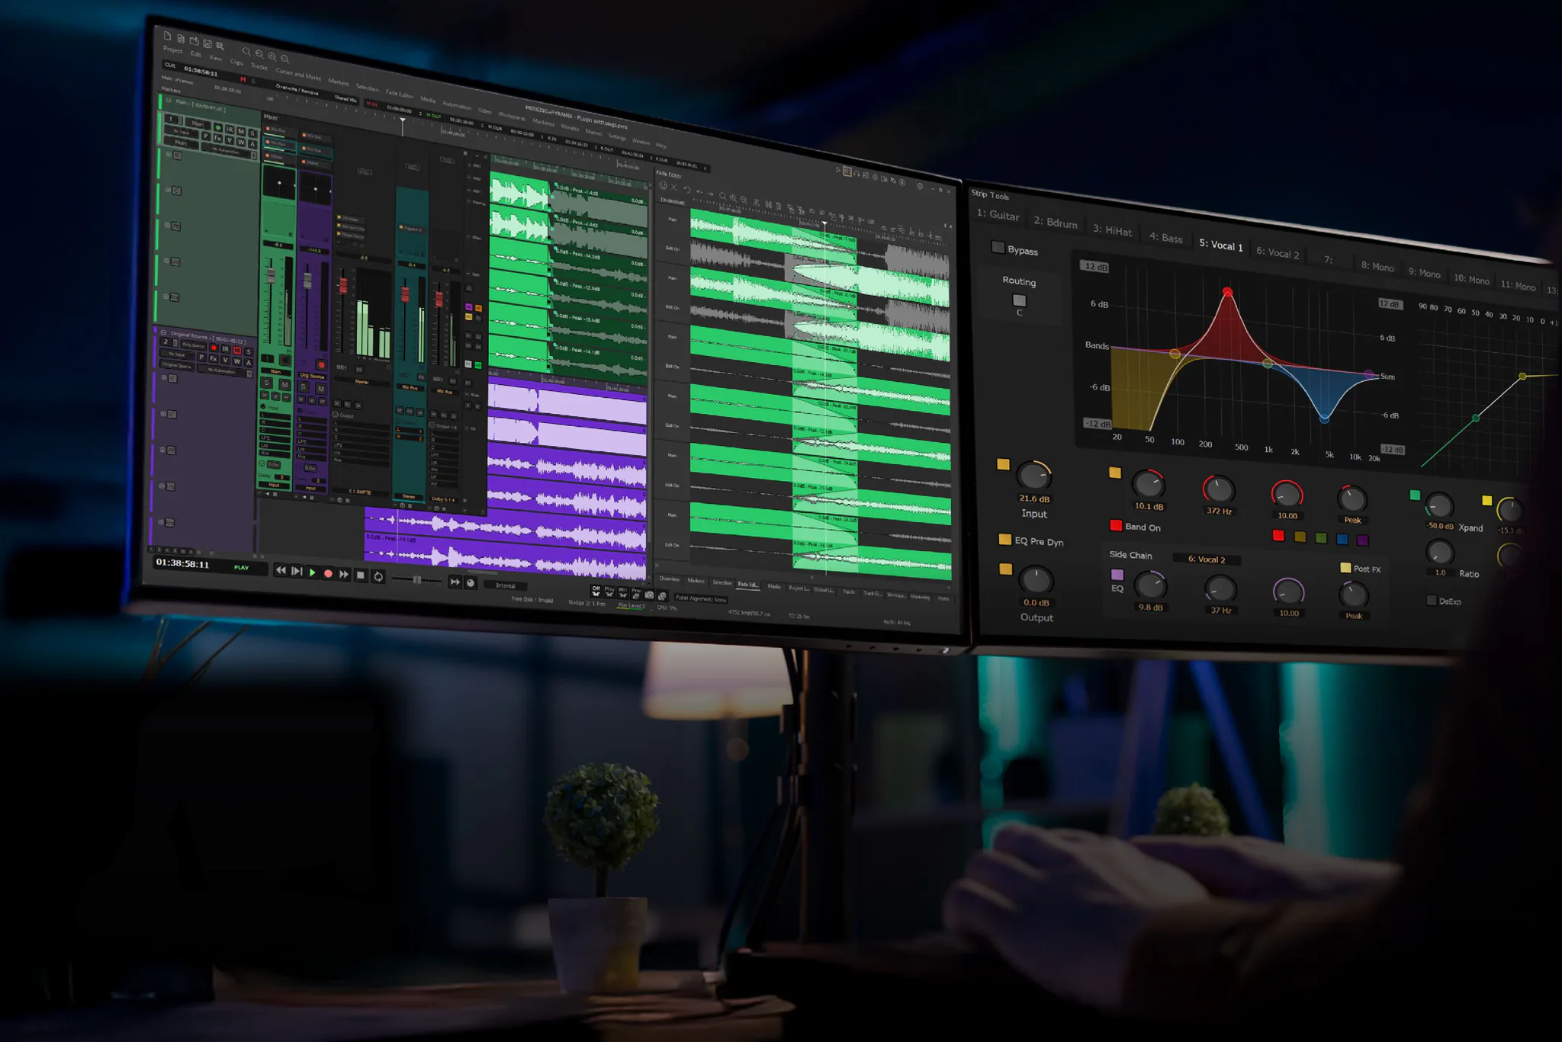

Dolby Atmos is a trademark of Dolby Laboratories Licensing Corporations.
Parallels, the Parallels logo, and Coherence, are trademarks or registered trademarks of Parallels International GmbH.
Stay up to date and follow Neumann on: FACEBOOK | INSTAGRAM | YOUTUBE

About Merging Technologies
Merging Technologies is a Swiss manufacturer with over 30 years of experience in developing groundbreaking, professional Audio and Video products for a wide range of entertainment and media industries. In July 2022, Merging became part of the Sennheiser Group and is integrated with Neumann.Berlin. With a dedicated user base in the elite end of the music, film, television, mastering and performances industries, Merging is committed to developing product ranges with unrivalled quality and flexibility, no matter what the application. Merging builds tools for people who want more from their systems, have an inherent need to push boundaries, and believe that quality always comes first. www.merging.com

About Neumann
Georg Neumann GmbH, known as “Neumann.Berlin”, is one of the world’s leading manufacturers of studio-grade audio equipment and the creator of recording microphone legends such as the U 47, M 49, U 67, and U 87. Founded in 1928, the company has been recognized with numerous international awards for its technological innovations. Since 2010, Neumann.Berlin has expanded its expertise in electro-acoustic transducer design to also include the studio monitor market, building upon the legacy of the legendary loudspeaker innovator Klein + Hummel. The first Neumann studio headphones were introduced in 2019, and since 2022, the company has increased its focus on reference solutions for live audio. With the introduction of the first audio interface MT 48, and its revolutionary converter technology, Neumann now offers all the necessary technologies needed to capture and deliver sound at the highest level. Georg Neumann GmbH has been part of the Sennheiser Group since 1991 and is represented worldwide by the Sennheiser network of subsidiaries and long-standing trading partners. www.neumann.com

Neumann Newsroom
Georg Neumann GmbH
newsroom@neumann.com
+49 (0) 30 41 77 24-0
neumann.com

