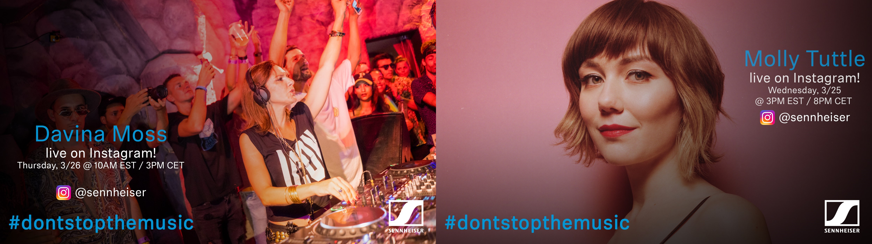

#DontStopTheMusic

New streamed concerts announced!

Wedemark/Germany, March 25, 2020 – Sennheiser is excited to announce the next streamed concerts in its exclusive #DontStopTheMusic series! Stay in with brilliant performances from Molly Tuttle, Davina Moss, Heart Attack Man and Shiba San. Life might be on pause, but thanks to Sennheiser there’s no need to stop the music!

Live concert streams from Wednesday, March 25, to Thursday, March 26:
- Molly Tuttle (@mollytuttle): Wednesday, March 25 at 3 p.m. EST / 8 p.m. CET
- Davina Moss (@davina_moss): Thursday March 26, at 10 a.m. EST / 3 p.m. CET
- Heart Attack Man (@heartattackmon): Thursday March 26, at 3 p.m. EST / 8 p.m. CET
- Shiba San (@shibasanmusic): Thursday March 26, at 6 p.m. EST/ 11 p.m.

It’s free but why not donate to fight the Corona virus?
At Sennheiser, we’re delighted to be working with these fantastic artists to help spread positivity by putting on exclusive concerts. They’re totally free, but if you do want to say thank you, do consider supporting the WHO in its fight against the corona virus:
https://www.who.int/emergencies/diseases/novel-coronavirus-2019/donate

Keep up to date with further concert news!
To keep informed of new concerts, just follow @Sennheiser on Instagram as dates and artists may change at short notice. Make sure to switch on notifications in IGTV to receive alerts.

Further dates will also be announced at http://www.sennheiser.com/anniversary. As well as the latest livestream dates, there’s a great selection of music videos, ranging from immersive jazz club recordings, to living room electro sets, to live takes from recording studios. Just put on your headphones (or turn up the speakers) and immerse yourself in the music!

For your social media channels:
Enjoy your favorite artists at home and check out the exclusive concerts in Sennheiser’s (@Sennheiser) streaming concert series – live on Instagram! #DontStopTheMusic #TogetherAtHome

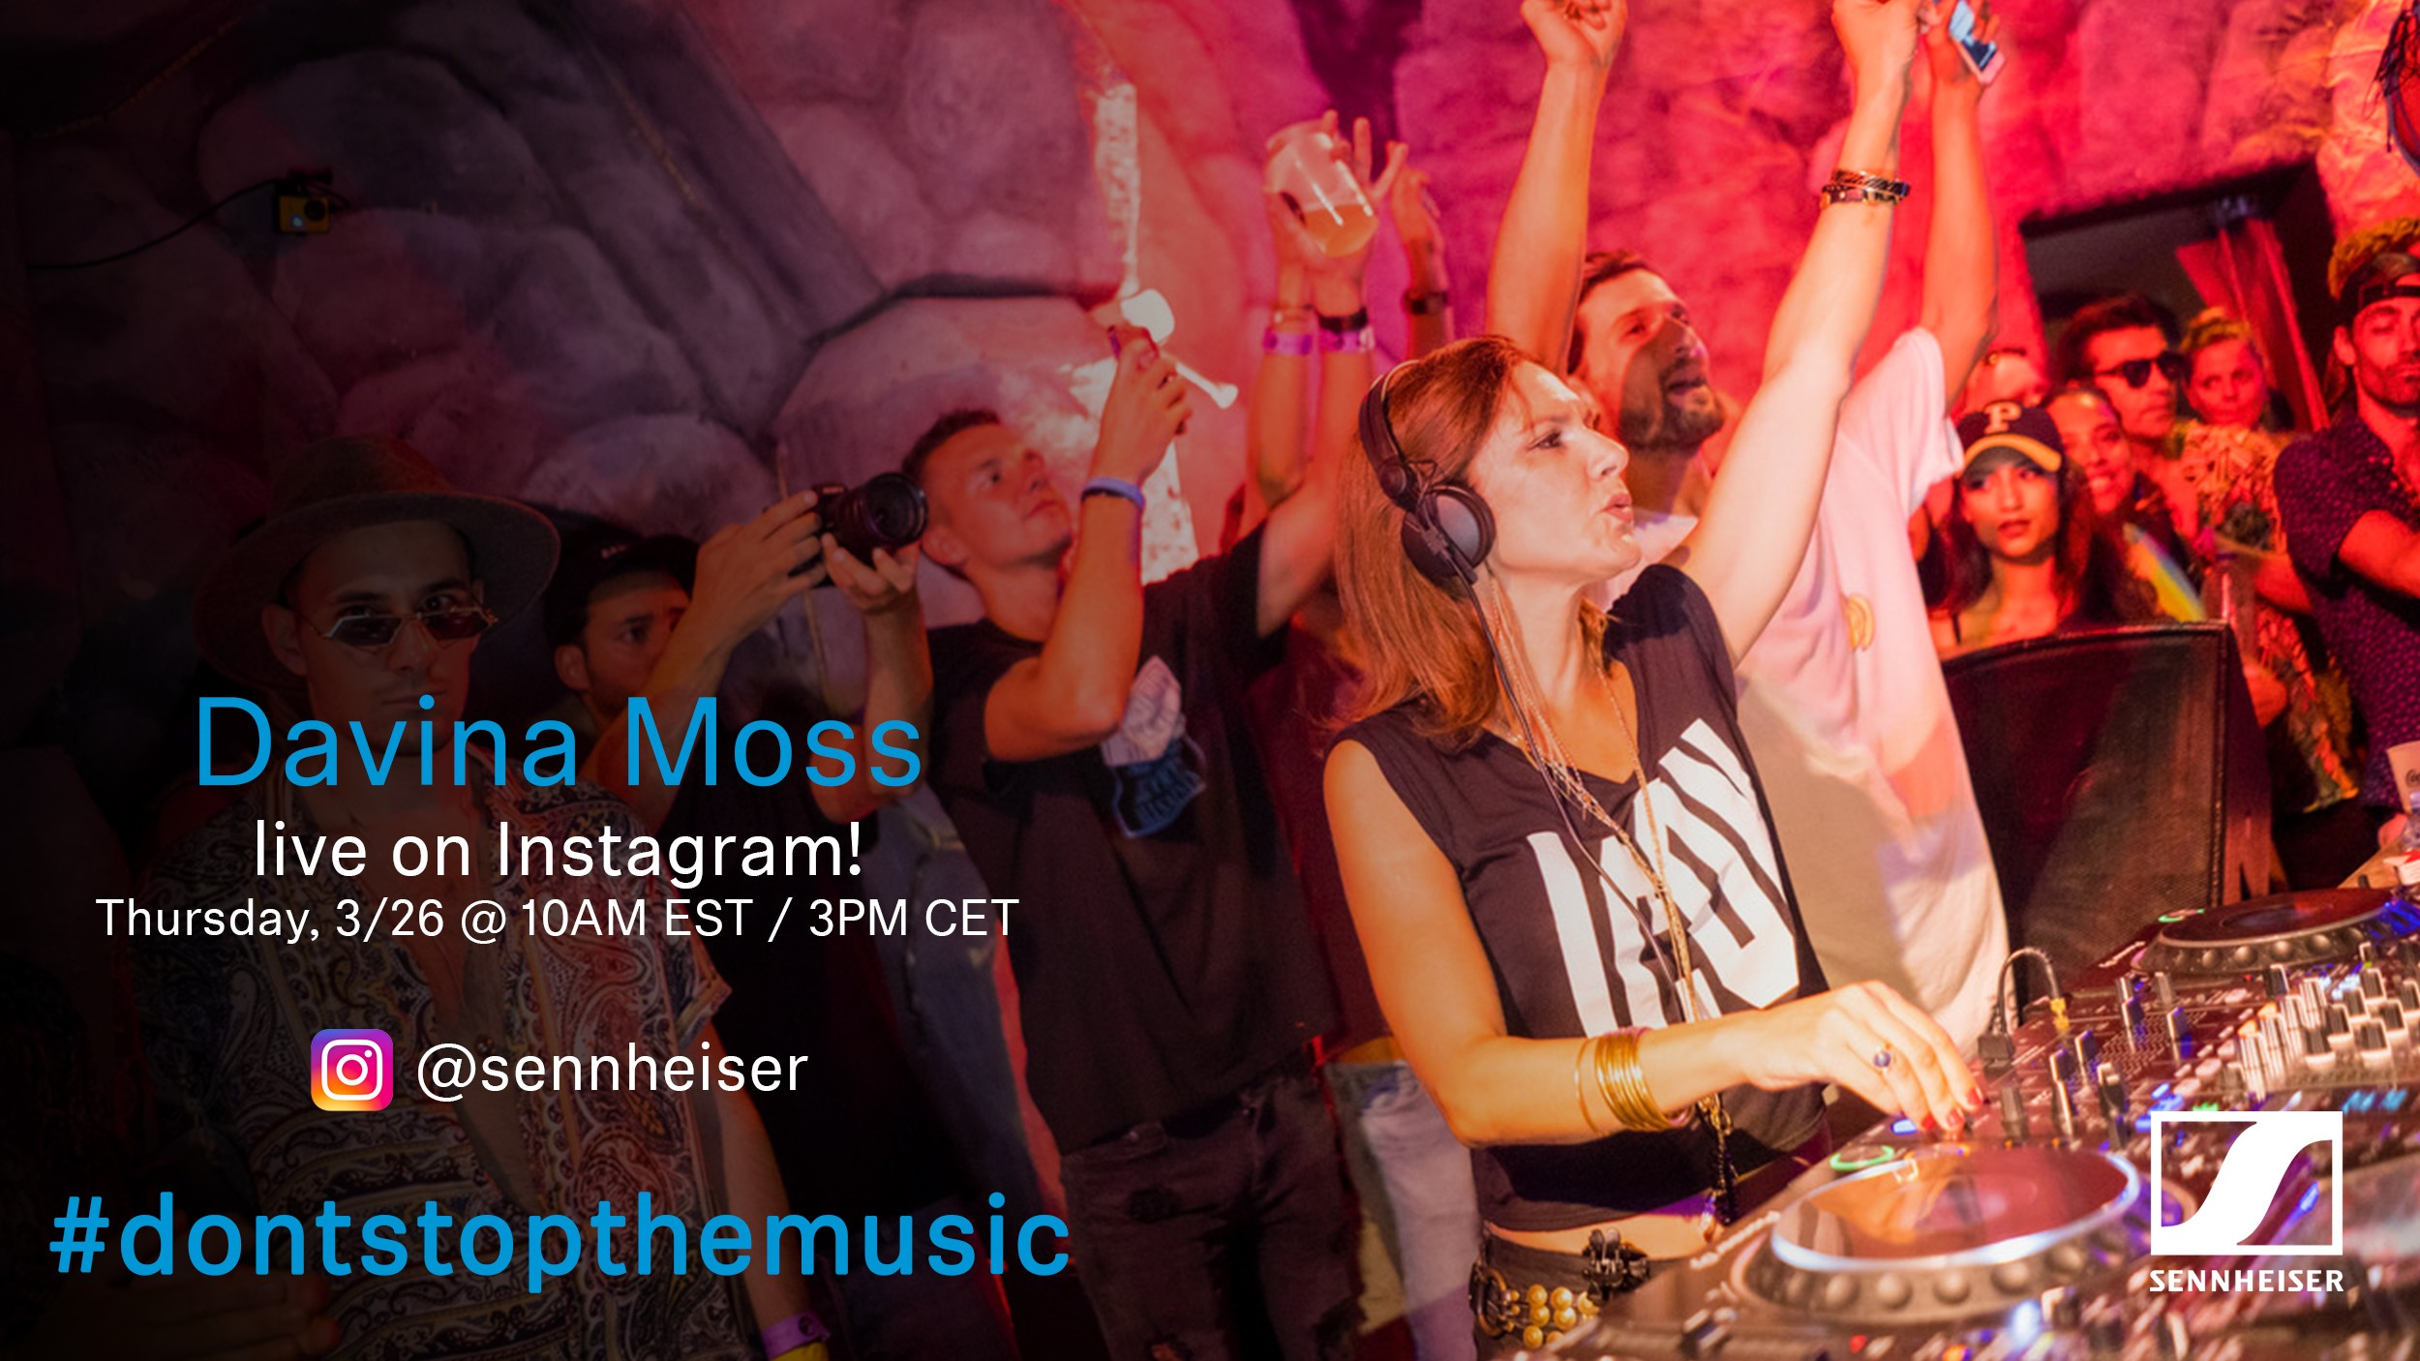

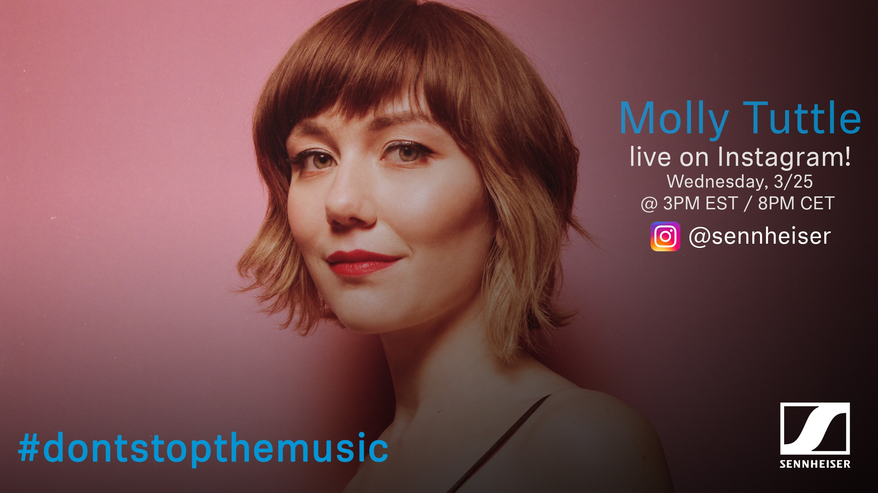

About Sennheiser
Founded in 1945, Sennheiser is celebrating its 75th anniversary this year. Shaping the future of audio and creating unique sound experiences for customers – this aim unites Sennheiser employees and partners worldwide. The independent family company, which is managed in the third generation by Dr. Andreas Sennheiser and Daniel Sennheiser, is today one of the world’s leading manufacturers of headphones, loudspeakers, microphones and wireless transmission systems. In 2018, the Sennheiser Group generated turnover totaling €710.7 million. www.sennheiser.com

Press Contacts

Mareike Oer Stephanie Schmidt
mareike.oer@sennheiser.com stephanie.schmidt@sennheiser.com
T +49 0(5130) 600 – 1719 T +49 0(5130) 600 – 1275

