For immediate distribution
PK Sound Rings in New Year With Return of Bassnectar NYE360 Celebration
Over 22,000 Bassnectar fans treated to 360-degree sonic experience powered by PK Sound
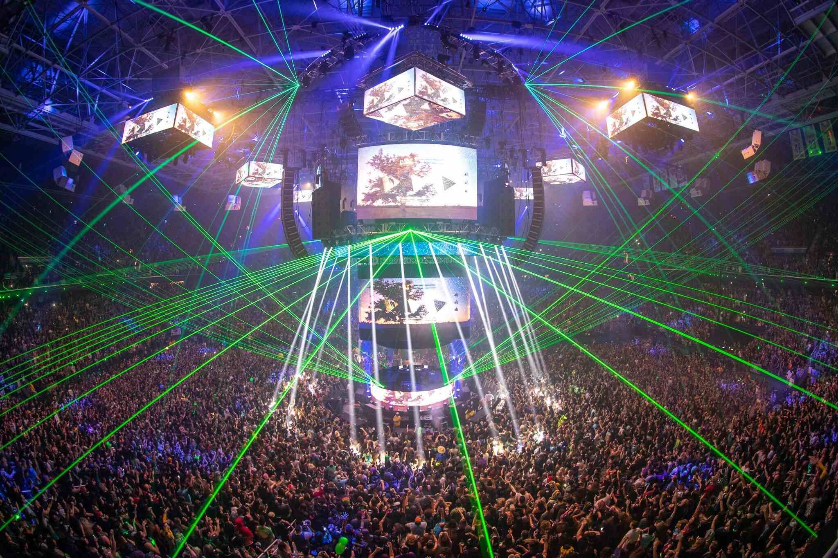
Greensboro, North Carolina —DJ Lorin Ashton, better known by his stage name Bassnectar, upped the ante for electronic music shows in 2019 with the Return of NYE360, his annual New Years performance. Hosted at the Greensboro Coliseum Complex in Greensboro, North Carolina on December 31, 2018, Bassnectar — as well as support acts G Jones b2b Eprom, Manic Focus, and Anna Morgan — treated 22,000 free-roaming attendees to a fully-immersive sonic experience by utilizing a vast array of robotic speaker systems provided by the Calagary-based Pro Audio firm, PK Sound.
Bassnectar FOH Engineer and System Designer Kyle Pace, along with PK Production Manager and System Designer Arlen Cormack, used the unique advantages of PK Sound loudspeaker technology, as well as fan feedback from previous 360-degree Bassnectar shows, to meticulously fine-tune the PA system, ensuring every attendee in the free-roam arena — from the floor, to the bleachers and upper mezzanine — experienced mesmerizing, pristine audio quality, no matter where they moved throughout the venue.
Pace and Cormack, who were faced not only with the task of pleasing Bassnectar fans, but the DJ himself — who had expressed some doubts about booking future 360-degree shows — took up the task of designing the PA system knowing that the sound system design for the Return of NYE360 could be the make-or-break moment for future 360-degree Bassnectar events.
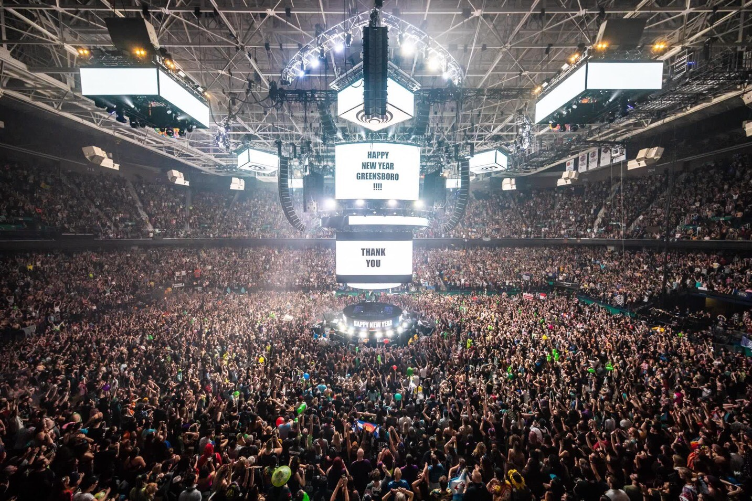
In addition to the challenges associated with mixing 360-degrees of high-SPL audio in an enclosed arena, Pace's task was further complicated by the fact that a crowd composed of Bassnectar fans, known collectively as Bassheads, would be full of audiophiles who regularly attend electronic music events and would be able to compare the Return of NYE360 with other shows they may have previously attended. “Bassnectar fans are very, very picky about what they want to hear,” Pace said. “They want the highs to overtake their bodies, and they want the mids to warm their soul.” Not to mention, as the moniker suggests, enough bass to blow away every Basshead in attendance.

Overcoming Onstage Rumble
The first challenge Pace and Cormack had to address involved the same issue that gave Ashton reservations about scheduling future 360-degree shows. "All of the past 360 designs have had major issues with the rotating stage vibrating too much," Pace said, "making it hard for artists to see their screens, or even to breathe."
To remedy the stage's low-end rumble, the PK team designed a system using 48 PK Sound CX800 Ground Subwoofers in a circular reversed cardioid polarity setup, forming a circular subwoofer inner ring and outer ring to create maximum cancellation in the center of the stage where the artists stood. "We ended up delaying the outer ring to the inner ring," Pace said, "boosting the inner ring clusters up exactly 2.1 dB louder than the outer ring, and then flipped the polarity on the inner ring, creating dead energy in the middle of the room."
The next challenge came from the four clusters of flown subs, consisting of five PK Sound Gravity 218s in each cluster, which generated some energy on the stage. The PK team solved the problem by putting a single Gravity 218 in the middle of the room under center stage to offset the delay from the flown subs and create a dead spot where the artists stood. “It felt like you were in a bubble and everything around you was booming and vibrating,” Pace said. “But then when you stepped away from the stage you were immersed in the sound field."
Making Levels Uniform Throughout the Arena
Another issue Pace and Cormack had to address came from reviews of previous 360-degree shows in which audience members reported a lack of low end in the upper mezzanine, where the highs became more piercing than in other parts of the venue. For a free-roaming crowd, this meant that an audience member "could walk down ten feet and get a completely different image of the PA," according to Pace. "For the Return of NYE360, I wanted to make sure that if someone wanted to go to the ground for one artist and then up to the bleachers for the next, they would still have the same show whether they were on the ground or at the top."
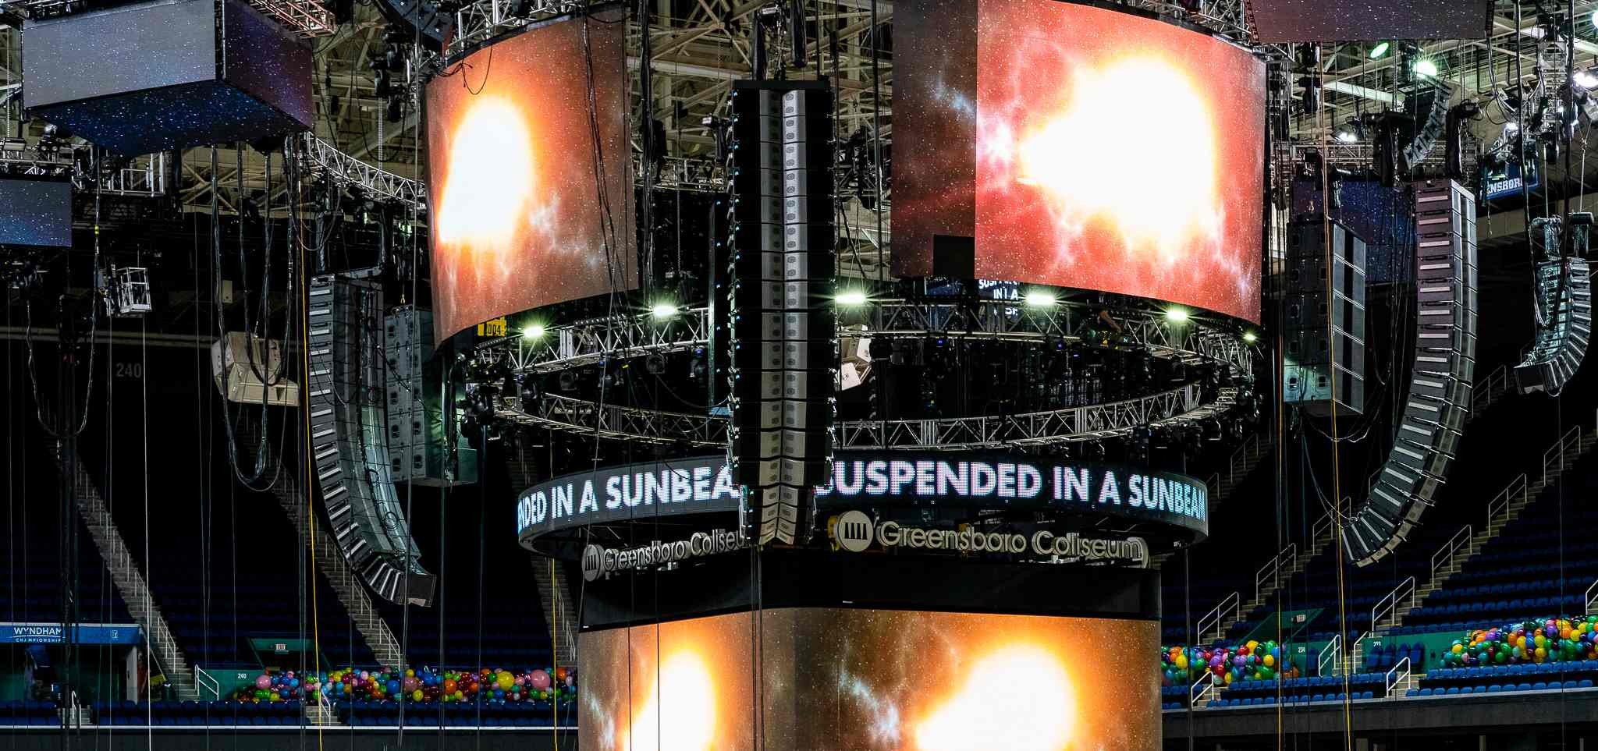
To create uniform mids and highs throughout the venue, Pace and Cormack took advantage of a variety of PK Sound line array technologies. Beginning with four main hangs consisting of 14 Trinity Advanced Robotic Line Array boxes and four Trinity 10s at the base, the team used the flagship Trinity boxes' long-throw capabilities to reach the upper balconies, while the four Trinity 10s tacked on to the bottom of each main hang ensured the lower bleacher and ground-level audience members were not unnecessarily bombarded with an overabundance of mids and highs. "Often, I feel like the floor and lower bleachers get blasted by very large, flagship-format PAs, and it makes it a little unbearable to listen to," Pace said. "Using Trinity 10s as the last four boxes on the main hangs made it so that the people who were on the floor had exactly the same sound that the people were getting up top."

PK Sound Saves NYE360
The Return of NYE360 proved an overwhelming success for Bassnectar, his fans and PK Sound. The show, which garnered a host of rave reviews on social media — especially in regard to the overall sound system design — served as an unforgettable example of the kind of New Years Eve party that electronic music fans have come to crave. Bassheads can rest assured it will certainly not be the last either, as due to the success of the sound system design, Pace reported that he "was personally thanked by Lorin after the show," and, as of Jan. 9, Bassnectar has already announced via social media that they will be putting on another NYE360 celebration next year.
For more information, please visit PK Sound’s website at: https://www.pksound.ca/
About PK Sound
At PK Sound we are passionate about providing a powerful connection between artist and fan. We believe that every audio experience should be exceptional. Our loudspeakers are well known for their transparent, full bodied, powerful sound; a result of new technologies created by people who love music, focusing on the evolving demands of artists, engineers and fans.

Media contacts

Steve Bailey
Public Relations
Hummingbird Media
+1 (508) 596-9321
steve@hummingbirdmedia.com

Jeff Touzeau
Public Relations
Hummingbird Media
+1 (914) 602 2913
jeff@hummingbirdmedia.com

