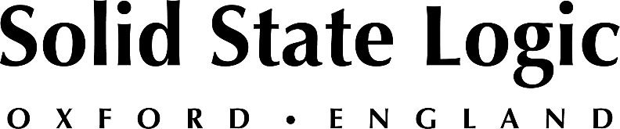

Solid State Logic Announces New X-Delay Plug-In,
Expanding its Complete Bundle Offering

Love Delay, Love X-Delay: Endlessly creative sync-able 4-tap digital delay is inspired by iconic '80s hardware delay units

Oxford, England, February 21 — Solid State Logic announces its latest plug-in release: SSL X-Delay. The new plug-in, which is inspired by legendary and iconic hardware delay units from the '80s, is available now in several formats including VST2, VST3, AAX and AU at a cost of $199 or as part of the SSL Complete Bundle Subscription from $14.99 per/m (Ts&Cs apply). As X-Delay falls within the Love Your ‘X’ Valentine’s Sale, SSL is offering a special 35% discount until February 28th, 2022.

SSL X-Delay, the latest in SSL's creatively focused plug-in offering, complementing the recently announced SSL X-Echo and is fully controllable from a gorgeous and easy-to-use user interface. Producers and music creators will appreciate the various combination of sounds achievable from up to 4 independently sync-able taps: from saturated slapback vocal delays, to vast stereo soundscapes appropriate for lush synth pads and more. The SSL X-Delay is augmented by global FX such as built-in modulation, SSL’s signature analogue saturation, and a reverb offering multiple diffusion effects and rooms from a single control.

The new X-Delay is the latest entry in SSL's expanding Plug-In bundle, which is available by subscription on its new eStore. Combined with its sibling X-Echo, SSL X-Delay helps users cover the spectrum between vintage tape and vintage digital delay sounds. By tweaking its powerful modulation, saturation, diffusion and de-essing settings, X-Delay is capable of moving between stark, crisp delays and darker, dirtier soundscapes and of course the huge delay sounds of the ‘80s.
Features of the new X-Delay include:

- 4 configurable delay taps, including independent level, ping-pong and panning controls.
- Combine SSL-style saturation, modulation, reverb and de-essing to shape an endless variation of different delay sounds.
- Create out-of-control soundscapes by driving the feedback beyond 100%, and use freeze and kill to build risers and drops.
- Get the perfect mix-ready delay using the high and low pass filters, mid/side width and mix controls.

For more information on the SSL X-Delay plug-in or to purchase, please visit SSL's new eStore at https://bit.ly/SSLeStore.

Solid State Logic is the world’s leading manufacturer of analogue and digital audio consoles and provider of creative tools for music, broadcast, live and post production professionals. For more information about our award-winning products, please visit: www.solidstatelogic.com.

###
For further information contact:
Jeff Touzeau
+1 (914) 602-2913
jeff@hummingbirdmedia.com

Ross Gilbert
+44 (0) 1865 842300
rossg@solidstatelogic.com

