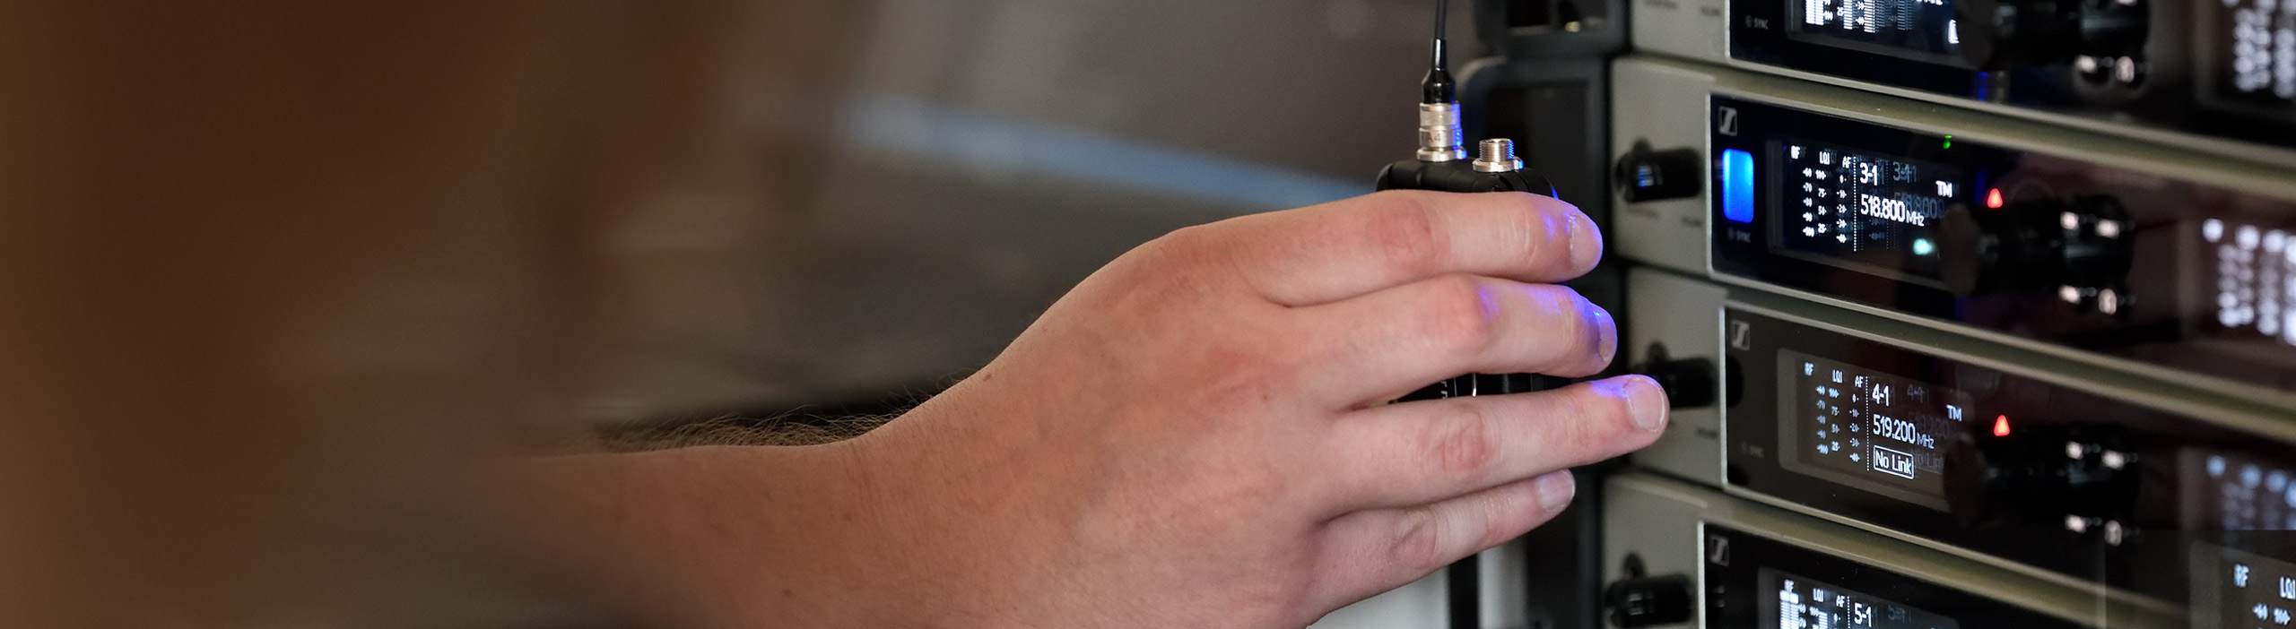

#Dontstoptheeducation

Sennheiser SoundAcademy delivers free webinars to your home – special sound engineer roundtable on 31 March

Wedemark, 27 March 2020 – The Sennheiser SoundAcademy has started to provide free pro audio training webinars and product demonstrations globally. The webinars will cover a wide range of topics from wireless microphones, to audio for video, to conference beamforming microphones. They have been created for customers from the music industry, AV industry, film and video production teams as well as the education and corporate sectors. The free training sessions will be offered at 8:30 a.m., 1:30 p.m. and 6 p.m. (all times CET), which allows people from around the globe to tune in.

“These webinars are part of our three-pillar plan to support our customers during this unique and difficult time,” explained Volker Schmitt, Director Customer Development and Application Engineering, who heads the Sennheiser SoundAcademy. “In addition to the webinars, which are open to everybody, we have also shifted individual customer training into the digital world. Furthermore, we are planning to have industry experts share their expertise in webcasts. Thanks to these webinars, we are very much looking forward to staying in touch with you all.”

Unique roundtable on “Mixing for live sound – mixing IEMs and monitors”
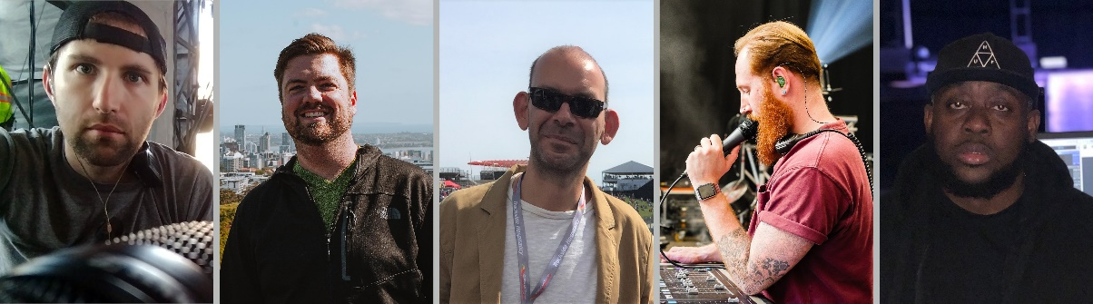
Five leading professional sound engineers will participate in “Mixing for live sound – mixing IEMs and monitors”: Brad Baisley, Landon Storey, Charles “Chopper” Bradley, Alex Cerutti, Andre Williams (l/r)
A highlight of the webinar series will be a sound engineer roundtable on “Mixing for live sound – mixing IEMs and monitors”. On 31 March, at 5 p.m. Berlin time (CEST), the Sennheiser Relationship Management team is joined by five leading professional sound engineers to discuss the strategies of live sound mixing. Brad Baisley (Blake Shelton), Landon Storey (Khalid), Charles “Chopper” Bradley (Harry Styles), Alex Cerutti (Dua Lipa), and Andre Williams (A$AP Rocky / Summer Walker) will be available to answer as many of your questions as possible. Duration: 90 min.
Please register at https://zoom.us/webinar/register/WN_Gq8hQZYbQWGwuko0Ixvxgw.

Upcoming webinars
Please visit https://www.sennheiser.com/webinars for a full, up-to-date list of the free SoundAcademy webinars including registration links. Webinars will usually be offered in English, but there are also some German and French sessions.

The following topics have been planned for the next two weeks (until April 9):
Installed sound and business solutions:
- G4 best practice for installers and integrators
- Beamforming microphones for meeting rooms
- Campus-wide audio
- SpeechLine Digital Wireless – the DECT approach

Live audio:
- Microphone Basics
- Wireless microphone basics: Theory I
- Wireless microphone basics: Theory II
- Digital wireless microphone transmission
- An introduction to the Wireless Systems Manager software
- Antenna system design
- Digital 6000 live demonstration

The Sennheiser SoundAcademy is very much looking forward to welcoming you to the webinars and roundtables.
About Sennheiser
Founded in 1945, Sennheiser is celebrating its 75th anniversary this year. Shaping the future of audio and creating unique sound experiences for customers – this aim unites Sennheiser employees and partners worldwide. The independent family company, which is managed in the third generation by Dr. Andreas Sennheiser and Daniel Sennheiser, is today one of the world’s leading manufacturers of headphones, loudspeakers, microphones and wireless transmission systems. In 2018, the Sennheiser Group generated turnover totaling €710.7 million. www.sennheiser.com

Global press contact

Stephanie Schmidt
stephanie.schmidt@sennheiser.com
T +49 0(5130) 600 – 1275

Local Press Contacts

Sarah James Maik Robbe
sarahj@gasolinemedia.com maik.robbe@sennheiser.com
+44 (0) 1483 223333 +44 (0) 7393 462484

