Embargoed until September 1, 10:00 CEST

Be heard
New MKE 200 microphone enhances audio for cameras and mobile devices

Wedemark, September 1, 2020 – Audio specialist Sennheiser adds the new MKE 200 to its portfolio of audio-for-video microphones. The mini-microphone is designed for easy on-camera use with DSLRs and mirrorless cameras as well as mobile devices, where it ensures clean and crisp audio and gives that professional touch to video clips.

“With the MKE 200, we are offering creators the first step to upgrading their sound,” said Tobias von Allwörden, Head of Portfolio Management – Audio for Video at Sennheiser. “Improved audio significantly increases the overall quality of your content. The MKE 200 makes this possible with its unique design which minimizes handling and wind noise. Simply attach it to the shoe mount, select the appropriate cable for your device and you’re good to go!”
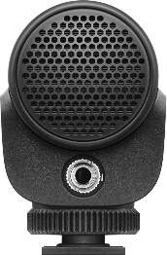 | 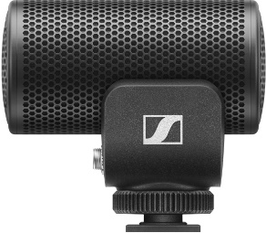 | 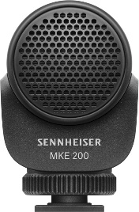 | 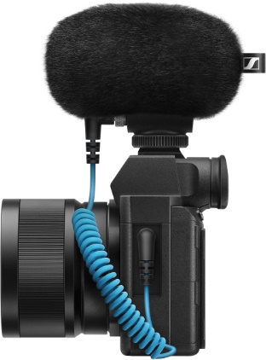

Directional, clean audio
The MKE 200 features a directional design which captures the sound of your subject while rejecting unwanted background noise. To minimize any handling noise, the microphone is fitted with a clever internal shock-mount which acoustically decouples the capsule from the housing. To protect from wind noise, Sennheiser engineers designed the MKE 200 with an integrated layer of protective mesh inside the housing. This protection is further enhanced by using the included furry windshield when filming outdoors.

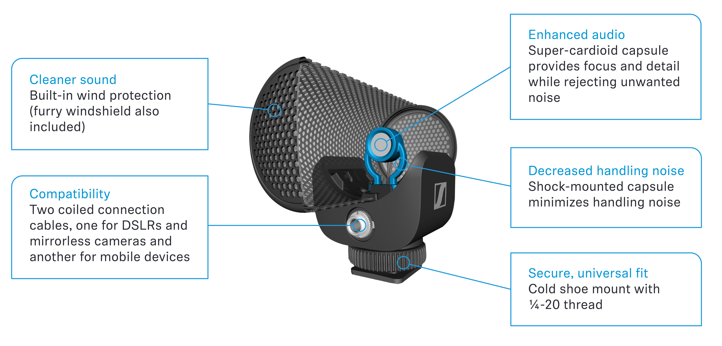

A compact companion
The MKE 200 features a compact, sleek design with a stylish finish thanks to a fully integrated shock-mount and built-in windscreen. Battery-free operation and a lightweight design allow for optimal gimbal performance.

The MKE 200 upgrades the sound of cameras and mobile devices

The MKE 200 comes complete with a furry windshield, two locking connection cables for DSLRs or mirrorless cameras (3.5 mm TRS cable) and mobile devices (3.5 mm TRRS cable) plus a draw-string pouch for storage.

The accessories that come with the MKE 200

The MKE 200 is available from September 1 and retails at EUR 99 MSRP (USD 99.95 MAP).

(Ends)

Below please find the download links for
MKE 200 product images: https://sennheiser-brandzone.com/c/1590/8XDDh2XK
MKE 200 application images: https://sennheiser-brandzone.com/c/1590/dMpXDxiX

TECHNICAL SPECIFICATIONS
Transducer principle | Pre-polarized condenser
Frequency response | 40 to 20,000 Hz
Pick-up pattern | Super-cardioid
Sensitivity at 1 kHz | -33 dB V/Pa
Max. SPL at 1 kHz | 120 dB SPL
Equivalent noise level | 20 dB SPL (A)
Plug-in power required | 2 – 10 V
Connectors | 3.5 mm locking jack (TRS and TRRS)
Dimensions | 69 x 60 x 39 mm
Weight | 48 g

About Sennheiser
Founded in 1945, Sennheiser is celebrating its 75th anniversary this year. Shaping the future of audio and creating unique sound experiences for customers – this aim unites Sennheiser employees and partners worldwide. The independent family company, which is managed in the third generation by Dr. Andreas Sennheiser and Daniel Sennheiser, is today one of the world’s leading manufacturers of headphones, loudspeakers, microphones and wireless transmission systems. In 2019, the Sennheiser Group generated turnover totaling €756.7 million. www.sennheiser.com

Global Press Contact

Stephanie Schmidt
Stephanie.schmidt@sennheiser.com
+49 (5130) 600 – 1275

