AES Convention New York
Sennheiser and Neumann workshops at AES

Wedemark/New York, 8 October 2019 – AES New York is soon to open its doors, with the convention not only presenting the latest in recording technology but also a host of practical workshops. One of the highlights is a hands-on Ambisonics production workshop where Sennheiser will collaborate with experts including Grammy award winner and former AES President Andres Mayo to bring to life every stage of the Ambisonics production process.

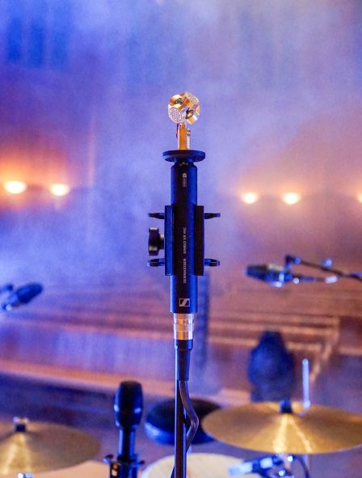 | Participants in the “Immersive & Spatial Audio Track Event IS08” (Saturday, Oct 19, 9 a.m. to 12 noon) will learn every step in Ambisonics production, including working hands-on with the Sennheiser AMBEO VR Mic

The “Immersive & Spatial Audio Track Event IS08” on Saturday, October 19 (9:00 a.m. to 12:00 noon in 1E13) is presented by Sennheiser’s Brian Glasscock alongside Andres Mayo, Ianina Canalis of the National University of Lanús and Martin Muscatello of 360 Music Lab. This hands-on workshop will give 45 participants the opportunity to learn every step in Ambisonics production – from recording with the AMBEO VR Mic, to mixing in Virtual Reality with Dear Reality tools, to playback options for the spatial content. Participants can discover and experiment with both hardware and software. In addition to the technical aspects of production, the workshop will also explore the artistic questions that mixing engineers face in 3D, and answer participants’ questions. This ticketed event can be booked together with the convention’s All Access Badge. For more information please see http://www.aes.org/events/147/spatialaudio/?ID=6899

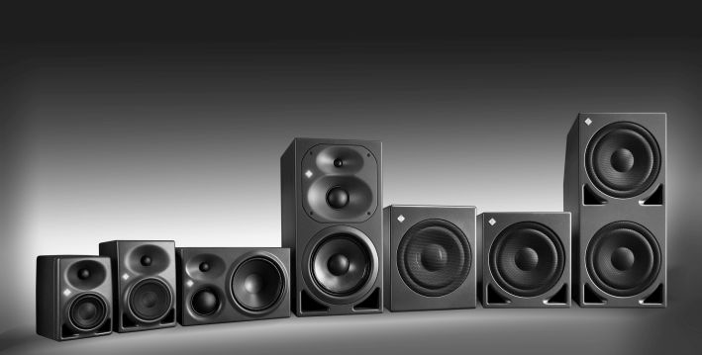 | The Neumann KH line will be demoed in 1E04

The Sennheiser and Neumann booth (#724) will showcase Sennheiser wireless, AMBEO recording gear, VR/AR mixing software from Dear Reality as well as Neumann mics, the full line of KH series monitors plus the NDH 20 studio monitoring headphones. While Dear Reality will demo its award-winning dearVR SPATIAL CONNECT software and the upcoming multi-channel feature of dearVR PRO at the booth, Sennheiser’s Dave Missall and a series of guest presenters will put the Neumann monitor line through its paces in a dedicated demo room (#1E04).

The v1.4 update for dearVR PRO will support multichannel playback formats from 5.0 to 13.1 | 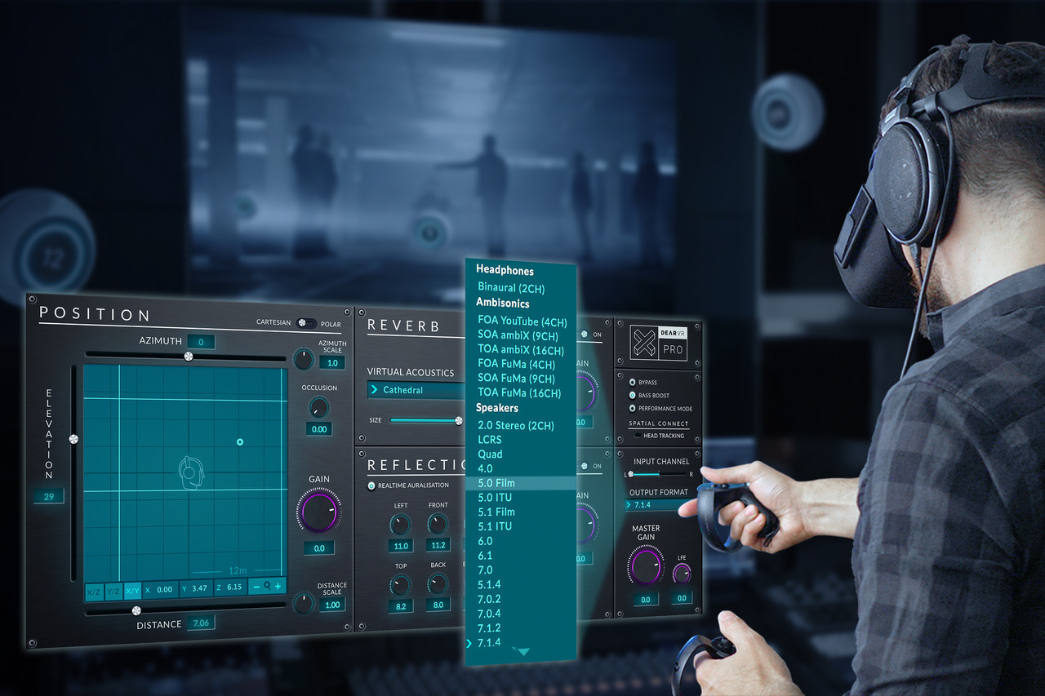

The demo room is fitted with a 7.1.4 loudspeaker set-up with KH 310, KH 420 and KH 870 models plus a stereo configuration with KH 310, KH 120 and KH 80 DSP monitor loudspeakers.
High-profile mixing, recording and mastering engineers will be playing their immersive audio content each day and present their approach to engineering for Immersive. Two sessions are dedicated to presenting the Neumann speaker line.

The demo room schedule in detail:
Wednesday, October 16
11 a.m. – 12 noon: Neumann monitor speaker presentation
1 p.m. – 2 p.m.: Morten Lindberg
3 p.m. – 4 p.m.: Andres Mayo
5 p.m. – 6 p.m.: Jim Anderson

Thursday, October 17
10 a.m. – 11 a.m.: Jim Anderson
12 noon – 1 p.m.: Elliot Scheiner/Gavin Lurssen
2 p.m. – 3 p.m.: Michael Bishop
4 p.m. – 5 p.m.: Michael Romanowski

Friday, October 18
9 a.m. – 10 a.m.: Neumann monitor speaker presentation
11 a.m. – 12 noon: Lasse Nipkow
1 p.m. – 2 p.m.: Eric Schilling
3 p.m. – 4 p.m.: Darcy Proper/Ronald Prent

Visit Sennheiser and Neumann at AES, booth No. 724 and demo room No. 1E04.

About Sennheiser and Neumann
Shaping the future of audio and creating unique sound experiences for customers – this aim unites Sennheiser employees and partners worldwide. Founded in 1945, Sennheiser is one of the world’s leading manufacturers of headphones, loudspeakers, microphones and wireless transmission systems. Since 2013, Sennheiser has been managed by Daniel Sennheiser and Dr. Andreas Sennheiser, the third generation of the family to run the company. As part of the Sennheiser Group, Georg Neumann GmbH, known as “Neumann.Berlin”, is the world’s leading manufacturer of studio microphones. Founded in 1928, the company has been recognized with numerous international awards for its technological innovations. Since 2010, Neumann.Berlin has expanded its expertise in electro-acoustic transducer design to also include the studio monitor market, and has recently added studio headphones to its portfolio. In 2018, the Sennheiser Group generated turnover totaling €710.7 million.
www.sennheiser.com | www.neumann.com

Global Press Contacts

Andreas Sablotny Stephanie Schmidt
andreas.sablotny@neumann.com stephanie.schmidt@sennheiser.com
T +49 (30) 417 724 – 19 +49 (5130) 600 – 1275

