Xytech to Demo Transmission, Automation Modules Along with
Sky Express at NAB New York

The company will showcase how its software streamlines the management
of operations for facilities of all sizes

New York, October 16, 2017 — Xytech, the leader in facility management software for the broadcast, production, media services and video transmission industries, is exhibiting at the NAB Show New York [hall 3B stand N902] between October 18–19 and will be demonstrating its new MediaPulse Transmission and Digital Order Automation features in addition to its new Sky Express, software tailored for smaller facilities featuring monthly subscriptions.
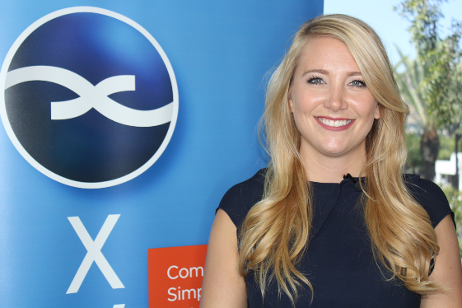
Available now, the new transmission and automation releases are integral components of the company's best-in-class software platform MediaPulse. MediaPulse Transmission offers end to tend operations and comprehensive financial management tools designed specifically to streamline transmission and automation functionality across broadcast platforms, while Digital Order — the company's automation module — captures an order and drives required tasks to ensure a seamless multi-threaded workflow. Both will be available for user demos during the NAB Show New York.

A Solution for the Modest-Sized Company
Tailored for modest-sized facilities and featuring a monthly subscription, Sky Express builds on Xytech's MediaPulse. Sky Express supports small user counts, sets up in under a week and is available in Xytechs’s Microsoft Azure Managed Cloud. The monthly subscription provides modest-sized facilities with access to all the innovative dashboards, graphs and charts of MediaPulse Sky — Xytech’s completely web-based user interface to MediaPulse. Not simply a portal, MediaPulse Sky is a complete user interface reimagined for the web and mobile devices.

Using Sky Express, users can manage scheduling, bidding, billing and reporting within the system.
The web interface allows users to access and make real-time changes with any mobile device — making IT hardware issues a thing of the past.

Xytech will be demoing the new MediaPulse modules as well as Sky Express in hall 3B stand N902 throughout the NAB Show New York. If you are interested in scheduling an appointment, please contact Alexandra Kuipers at akuipers@xytechsystems.com, + 1 (818) 698-4958 or Aurore Gilewicz at agilewicz@xytechsystems.com, +44 203 478 1462.

About Xytech Systems: For over 25 years, the world’s premiere media companies have depended on Xytech to run their businesses. MediaPulse is the only end-to-end solution for the complete content lifecycle. MediaPulse provides scheduling, automation, asset management, billing and cost recovery for broadcasters, media services companies and transmission facilities in a scalable platform-independent solution.

For more information, visit xytechsystems.com.

Media Contacts:

Media contact
Jeff Touzeau
Public Relations
Hummingbird Media
+1 (914) 602 2913
jeff@hummingbirdmedia.com

Katie Kailus
Public Relations
Hummingbird Media
+1 (630) 319-5226
katie@hummingbirdmedia.com

