Friday, January 3, 2020
Toyota Motor Corporation
GAZOO Racing Company

TOYOTA GAZOO RACING READY FOR DAKAR RALLY TITLE DEFENCE

TOYOTA GAZOO Racing completed preparations for the upcoming 2020 Dakar Rally which is scheduled to start in the Saudi Arabian city of Jeddah on January 5. The team and crews spent the first days of the New Year re-assembling the four Toyota Hilux race cars shipped from the team’s South African headquarters near Johannesburg before conducting a full-scale shakedown in the desert south of Jeddah.

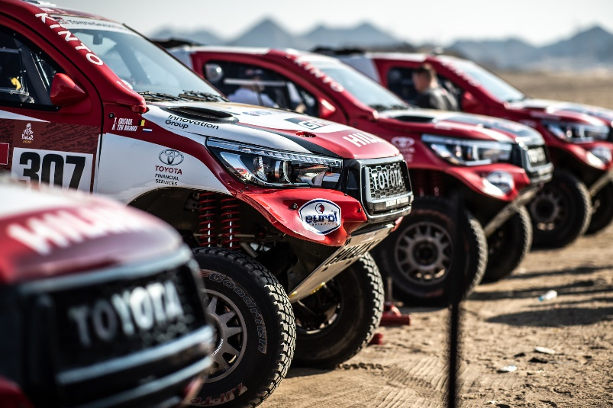

The purpose of the shakedown was to confirm that all four vehicles performed as designed, while some adjustments were also made to the suspension setups in order to ensure the best possible handling in the terrain expected at the start of the rally.

In keeping with TOYOTA GAZOO Racing’s ethos of making ever-better cars, the latest version of the Hilux features a host of refinements compared to the car that won the 2019 Dakar Rally in the hands of Nasser Al-Attiyah and navigator Mathieu Baumel. To prepare for the 2020 edition of the Dakar Rally – the 42nd running of the endurance rally raid race, and the first running in the Kingdom of Saudi Arabia – the team concentrated on the suspension setup with a week-long test session ahead of the Rally of Morocco helping engineers dial in the cars.

Beyond the suspension, every sub-system of the Hilux has been refined during 2019 and a number of new parts were tested and manufactured for use in the upcoming 2020 edition of the legendary rally raid event.

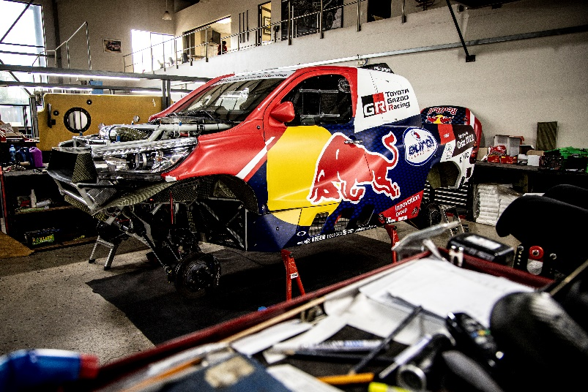

TOYOTA GAZOO Racing is spearheaded by reining Dakar Rally winner Nasser and Mathieu looking to defend their title and add to their impressive list of achievements. Toyota stalwart Giniel de Villiers, winner of the Dakar Rally in 2009, is partnered with navigator Alex Haro, with the pair looking to continue the good form they showed when they won the 2019 Rally of Morocco. Bernhard ten Brinke is partnered with Tom Coulsol, both looking to achieve strong results. Completing TOYOTA GAZOO Racing’s exciting line-up is newcomer Fernando Alonso, two-time Le Mans 24 Hours winner, reigning FIA World Endurance Championship title holder with TOYOTA GAZOO Racing, two-time Formula 1 World Champion, and winner of the 24 Hours of Daytona, and Marc Coma, six-time FIM Cross Country World Champion and five-time Dakar Rally winner on the motorbike.

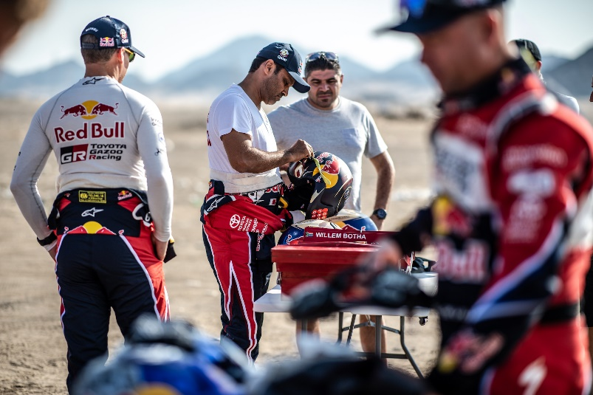

The latest edition of the Dakar Rally will be contested solely in the Kingdom of Saudi Arabia, made up of twelve competitive stages, with a rest day at the mid-point.

Starting from the city of Jeddah on January 5, a 319-kilometre special stage will see crews tackling fast and winding tracks across sand dunes and rocky terrain concluding at the coastal city of Al Wajh. The following day will see crews traverse some 367 kilometres of tracks with tricky navigation up the coast to the future city of Neom. Stage 3 is a 427-kilometre looped stage, starting and finishing in Neom, crossing canyons and mountains where the Dakar Rally will reach the highest altitude of 1,400 metres. From Neom, crews start to make their way in the direction of the capital city of Riyadh on the fourth day with a 453-kilometre special to Al Ula featuring sand and gravel. The scenery changes on Stage 5 as crews head towards Ha’il on a 353-kilometre stage where huge rock formations will serve as valuable navigational markers, although travelling over sand hills covered in desert grass will require advanced driving skills. Stage 6 sees another scenery change where sand is the predominant feature on this 477-kilometre special finishing in Riyadh for some much-needed rest and repairs.

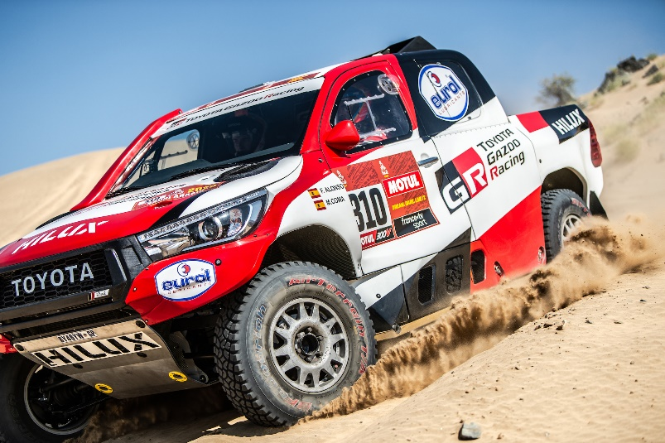

The first stage after the Rest Day is also the longest stage on January 12 from Riyadh to Wadi Al Dawasir, clocking in at some 546 kilometres over varied terrain, featuring a scattering of sand dunes over the route where navigators will need to be focussed. Stage 8 is another looped stage of 477 kilometres, starting and ending in Wadi Al Dawasir, where crews will be met with mountainous landscapes, canyons and contrasting black stones on white sand. Another 410 kilometres of hard ground and rough terrain will bring crews to Haradh as the rally enters into a new phase. Rub’ al Khali, also known as the “Empty Quarter”, a desert covering some 650,000 square kilometres will be waiting for crews on the marathon Stage 10, where endurance is key to complete the 534-kilometre stage to Shubaytah. The penultimate Stage 11 sees the rally start to make its way back in the direction of Riyadh with crews crossing some of the finest sand dunes in the country and covering 379 kilometres to the village of Haradh. The final stage to Qiddiya is still a 374-kilometre challenge with tricky navigation all the way to the chequered flag on January 17.

Glyn Hall, Team Principal: “Our shakedown went very well. All four TOYOTA GAZOO Racing crews were very happy with the cars, which is good news for me. If the drivers are happy, it means we are well-prepared for the race. Everything is looking good so far, and we are excited for the race to get under way.”

Nasser Al-Attiyah (No. 300): “My third Dakar victory last year was really special. We dominated from start to finish and to give Toyota’s first-ever overall Dakar Rally victory was really special. I had an excellent 2019 season with nine wins from 10 rallies. I only retired in Morocco, but it was actually a good thing. We experienced electrical problems which allowed us to better prepare the car and anticipate other problems for the big race. I’m ready for the Dakar Rally and quite excited. It’s going to be completely different, but I know the terrain very well. I took part in and won races in 2008 and 2011 on this terrain so I know exactly what to expect. The dunes are very tricky and totally different than those in South America. We have the same kind of dunes in Qatar and I grew up driving them with my father. There are only 110 kilometres between the dunes in Qatar in those in Saudi Arabia. The terrain suits me to a tee. So, I believe that I’m the favourite."

Giniel de Villiers (No. 304): “I grew up on a farm and raced everything I could. It began when I was four with a pedal kart. My father loved motor racing and he passed the bug on to me. I started my career in circuit racing, notably in touring cars before switching to all-terrain. The last Dakar Rally was a huge disappointment. We hit a rock and our hopes for victory were gone on day three. I have experienced a lot of highs and lows last year, but the Rally of Morocco win really boosted my confidence tremendously. I feel good in the Hilux. We’ve been able to make some good improvements during our many tests. Everything is in place. I’m getting used to my new navigator, Alex. We spent a lot of time together with the TOYOTA GAZOO Racing Team testing in South Africa. For sure, it’s strange to have someone different next to me, but sometimes change is good. Dakar Rally in Saudi Arabia will be new for everyone, except for our teammate Yazeed competing with Overdrive Racing also in a Hilux. The navigation will be interesting. We’ll find ourselves in completely isolated places just like it was when the rally was in Africa. It has been more than ten years since we experienced that. Our objective is still victory.”

Bernhard ten Brinke (No. 307): “I’ve recently sold my business which now gives me more time to do the things I want to do, such as preparing for the Dakar Rally. I’ve shown that I’m capable of Top 5 and podium results. We have the best car with the Toyota Hilux, the support of a full manufacturer team with TOYOTA GAZOO Racing, I have a great navigator in Tom, and my own condition is better than ever. Although there is never a guarantee of success, I know we are well-prepared. Despite some back luck in rallies last year, we’ve shown we’re fast.”

Fernando Alonso (No. 310): “I’m racing in my first Dakar Rally to see what this legendary event is like, but even more so I want to finish it. I know it will be a very big challenge. I don’t think there is anything more different compared to Formula 1 than the Dakar Rally. It’s an interesting and exciting challenge which certainly looks difficult on paper, but I want to take on the challenge, push myself to the limit, and learn from the experience to become a more complete racing driver. The preparation that I’ve done with TOYOTA GAZOO Racing over the past few months enriched me so much as a driver which is one of my priorities when I confront these kinds of challenges: to be better at the end of each experience.”
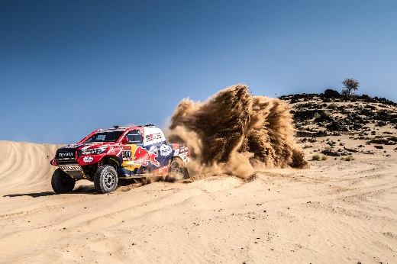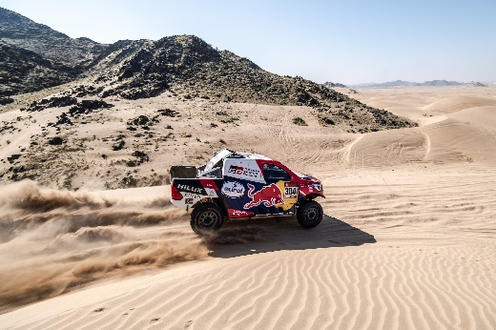
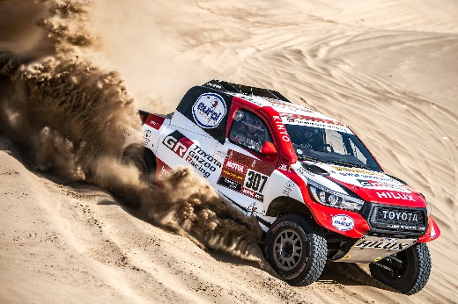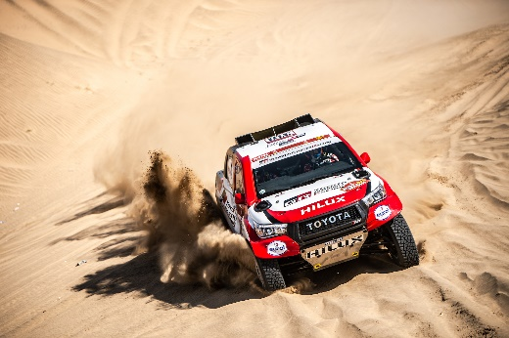

Copyright-free, high-resolution images can be found at https://www.tgr-dam.com
TOYOTA GAZOO Racing official website: http://toyotagazooracing.com/

