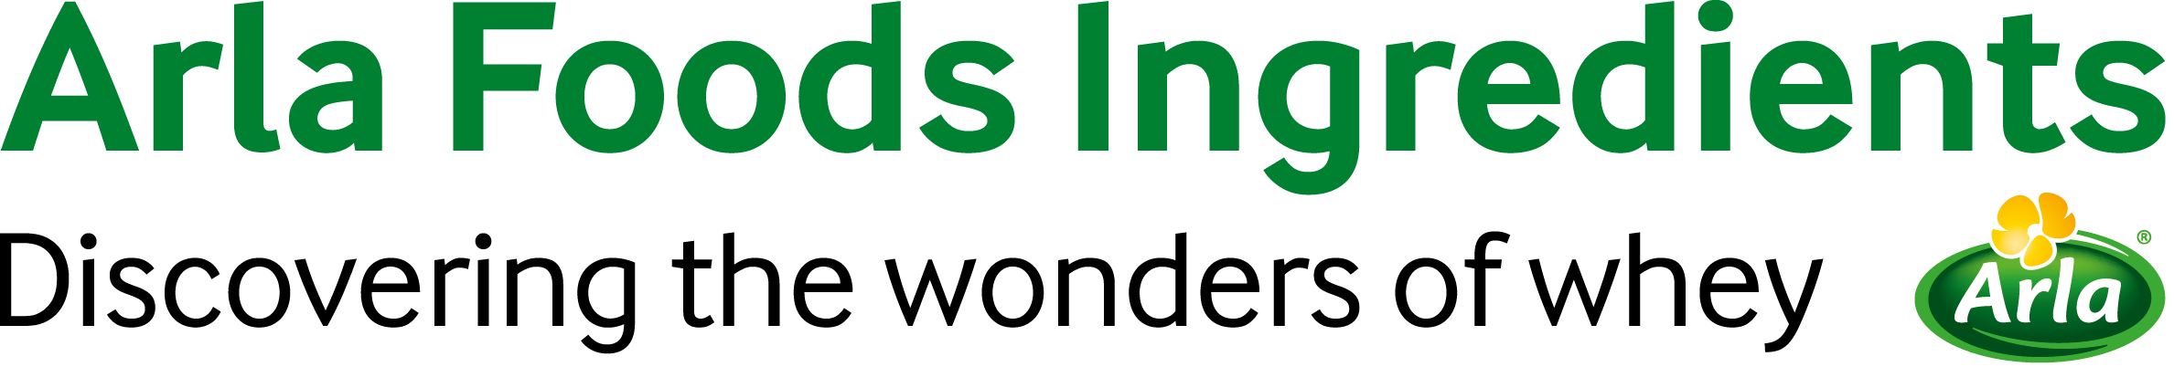
12th December 2019
PRESS RELEASE
Arla Foods Ingredients: Protein hydrolysates
increasingly important in allergy fight

Arla Foods Ingredients is highlighting the growing potential of milk protein hydrolysates for the management of allergy and discomfort in infants.

The prevalence of allergic diseases is rising globally,¹ while up to 30% of formula-fed infants often experience gastrointestinal discomfort.²

Milk protein hydrolysates are the result of an enzymatic process in which protein is cut into smaller peptide fragments. Where breastfeeding is not possible, infant formulas with hydrolysates are often recommended because of their benefits for allergy management and the reduction of discomfort.

For example, clinical studies have observed reduced risk of atopic dermatitis in infants fed hydrolysed infant formulas compared with those based on intact proteins.³ Growing awareness of such benefits means protein hydrolysates are increasingly used in infant nutrition products. Between 2014 and 2018 global launches of formula products with whey protein hydrolysates increased by 7.9% CAGR.⁴

Furthermore, recent consumer research by Arla Foods Ingredients found that 32% of mothers worldwide, and 49% of those in China, were aware of whey protein hydrolysates. Of those who were familiar with the ingredient, 31% expressed a preference for formula containing it.⁵

Arla Foods Ingredients’ offers a range of scientifically proven milk protein hydrolysate products in its Lacprodan® and Peptigen® ranges. In one study, high-risk infants were either breastfed or given a hypoallergenic formula based on Peptigen® IF-3080. There were no significant differences regarding the development of atopic dermatitis or measured immunological outcomes.^{6,7}

Manel Romeu Bellés, Industry Marketing Manager at Arla Foods Ingredients said: “Infant discomfort is one of the most common reasons parents switch formulas, so it’s essential that the risks of allergy and gastrointestinal problems are minimized. Protein hydrolysates are both clinically proven and sought after by consumers. At Arla Foods Ingredients we have over 25 years’ experience of producing high-quality milk protein hydrolysates for formula. Infant safety is paramount, which is why we’ve invested heavily in both pre-clinical and clinical research so we can offer a range of products that are proven to be safe and effective.”

ENDS

Pawankar et al., 2013 The WAO White Book in Allergy
2 Vandenplas et al, 2015, J. Pediatr. Gastroenterol Nutr
3 Alexander and Cabana, J Pediatr Gastroenterol Nutr.
4 Innova Market Insights, 2019
5 YouGov and Arla Foods Ingredients, 2018
6 Nentwich et al. 2003. Klin. Pediatr. 215, 275-279
7 Nentwich et al. 2009. Klin. Pediatr. 221, 78-82

For more information contact:

Steve Harman Ingredient Communications
Tel: +44 (0)7538 118079 | Email: steve@ingredientcommunications.com

About Arla Foods Ingredients
Arla Foods Ingredients is a global leader in value-added whey solutions. We discover and deliver ingredients derived from whey, supporting the food industry with the development and efficient processing of more natural, functional and nutritious foods. We serve global markets within early life nutrition, medical nutrition, sport nutrition, health foods and other foods and beverage products.

Five reasons to choose us:
- We have R&D in our DNA
- We offer superior quality
- We are your trusted business partner
- We support sustainability
- We ensure security of supply

Arla Foods Ingredients is a 100% owned subsidiary of Arla Foods. Our head office is in Denmark.

RSS Feed
Visit our website at http://www.mynewsdesk.com/arla-foods-ingredients and sign up to our News RSS feed for all the latest developments – updated regularly.

Twitter
Follow us on twitter for all the latest updates @ArlaIngredients

LinkedIn
http://www.linkedin.com/company/arla-foods-ingredients

Facebook
https://www.facebook.com/arlaingredients

