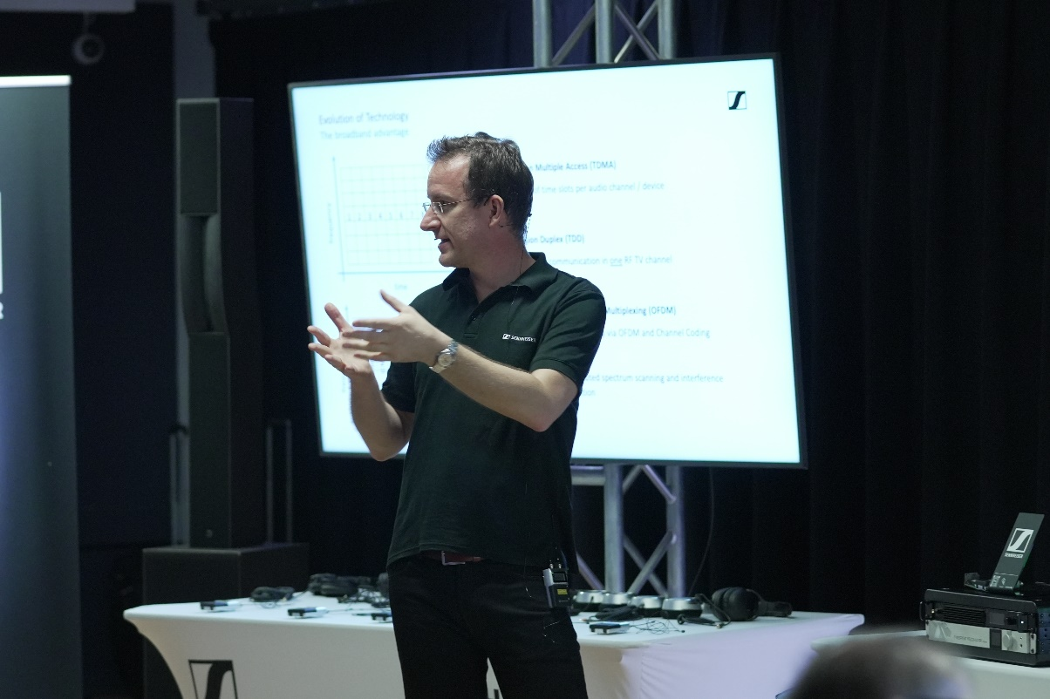

Sennheiser Wireless Multi-Channel Audio Systems (WMAS) Preview Inspires and Delights New York City’s Pro Audio Industry Leaders
New York’s finest audio professionals including esteemed sound engineers and RF coordinators received an exclusive preview of the revolutionary WMAS technology from one of its inventors

New York, NY, September 7, 2023 – New York’s pro audio industry leaders across the live production space came together on August 15 to attend an exclusive hands-on workshop demonstrating the potential of Sennheiser’s groundbreaking Wireless Multi-Channel Audio Systems (WMAS) technology. The event was presented by Dr. Sebastian Georgi, one of the research and development engineers who invented WMAS at Sennheiser’s German headquarters, and Greg Simon, Manager, Regional Technical Application Engineer.

According to Dr. Georgi, “with this technology, we are re-thinking wireless audio transmission in multi-channel applications such as big live events, theaters, and broadcast studios – wherever many audio channels are up in the air. Sennheiser’s implementation of WMAS is essentially a bi-directional wireless broadband technology, which combines microphones, in-ears, and remote control in just one broadband RF channel.” WMAS would tackle many of the common pain points for sound engineers, including RF fading and dropouts, while maximizing the increasingly scarce frequency resources available across the US.
 | Dr. Sebastian Georgi presents the technology and theory behind WMAS, and how this innovation will drive the future of wireless audio transmission in multi-channel applications.

The presentation offered an in-depth, technical look at WMAS, including how the technology adapts existing broadband techniques to the stringent requirements of professional wireless audio transmission, going beyond the obvious advantages of frequency efficiency and an extremely reliable wireless signal. Attendees were notably treated to a firsthand demonstration of how future Sennheiser solutions will tangibly implement this technology.

While the products deploying WMAS are currently in development, once realized, these forthcoming solutions will enable a single bodypack to simultaneously support a wireless mic and in-ear monitor for artists. With this, the solution will free up space backstage at events, taking away the need for busy racks of receivers and transmitters as a single base station would feasibly handle 32 inputs and 32 outputs. Live audio engineers and frequency coordinators will benefit from additional control, less clutter and negligible RF fading, amongst many other advantages.
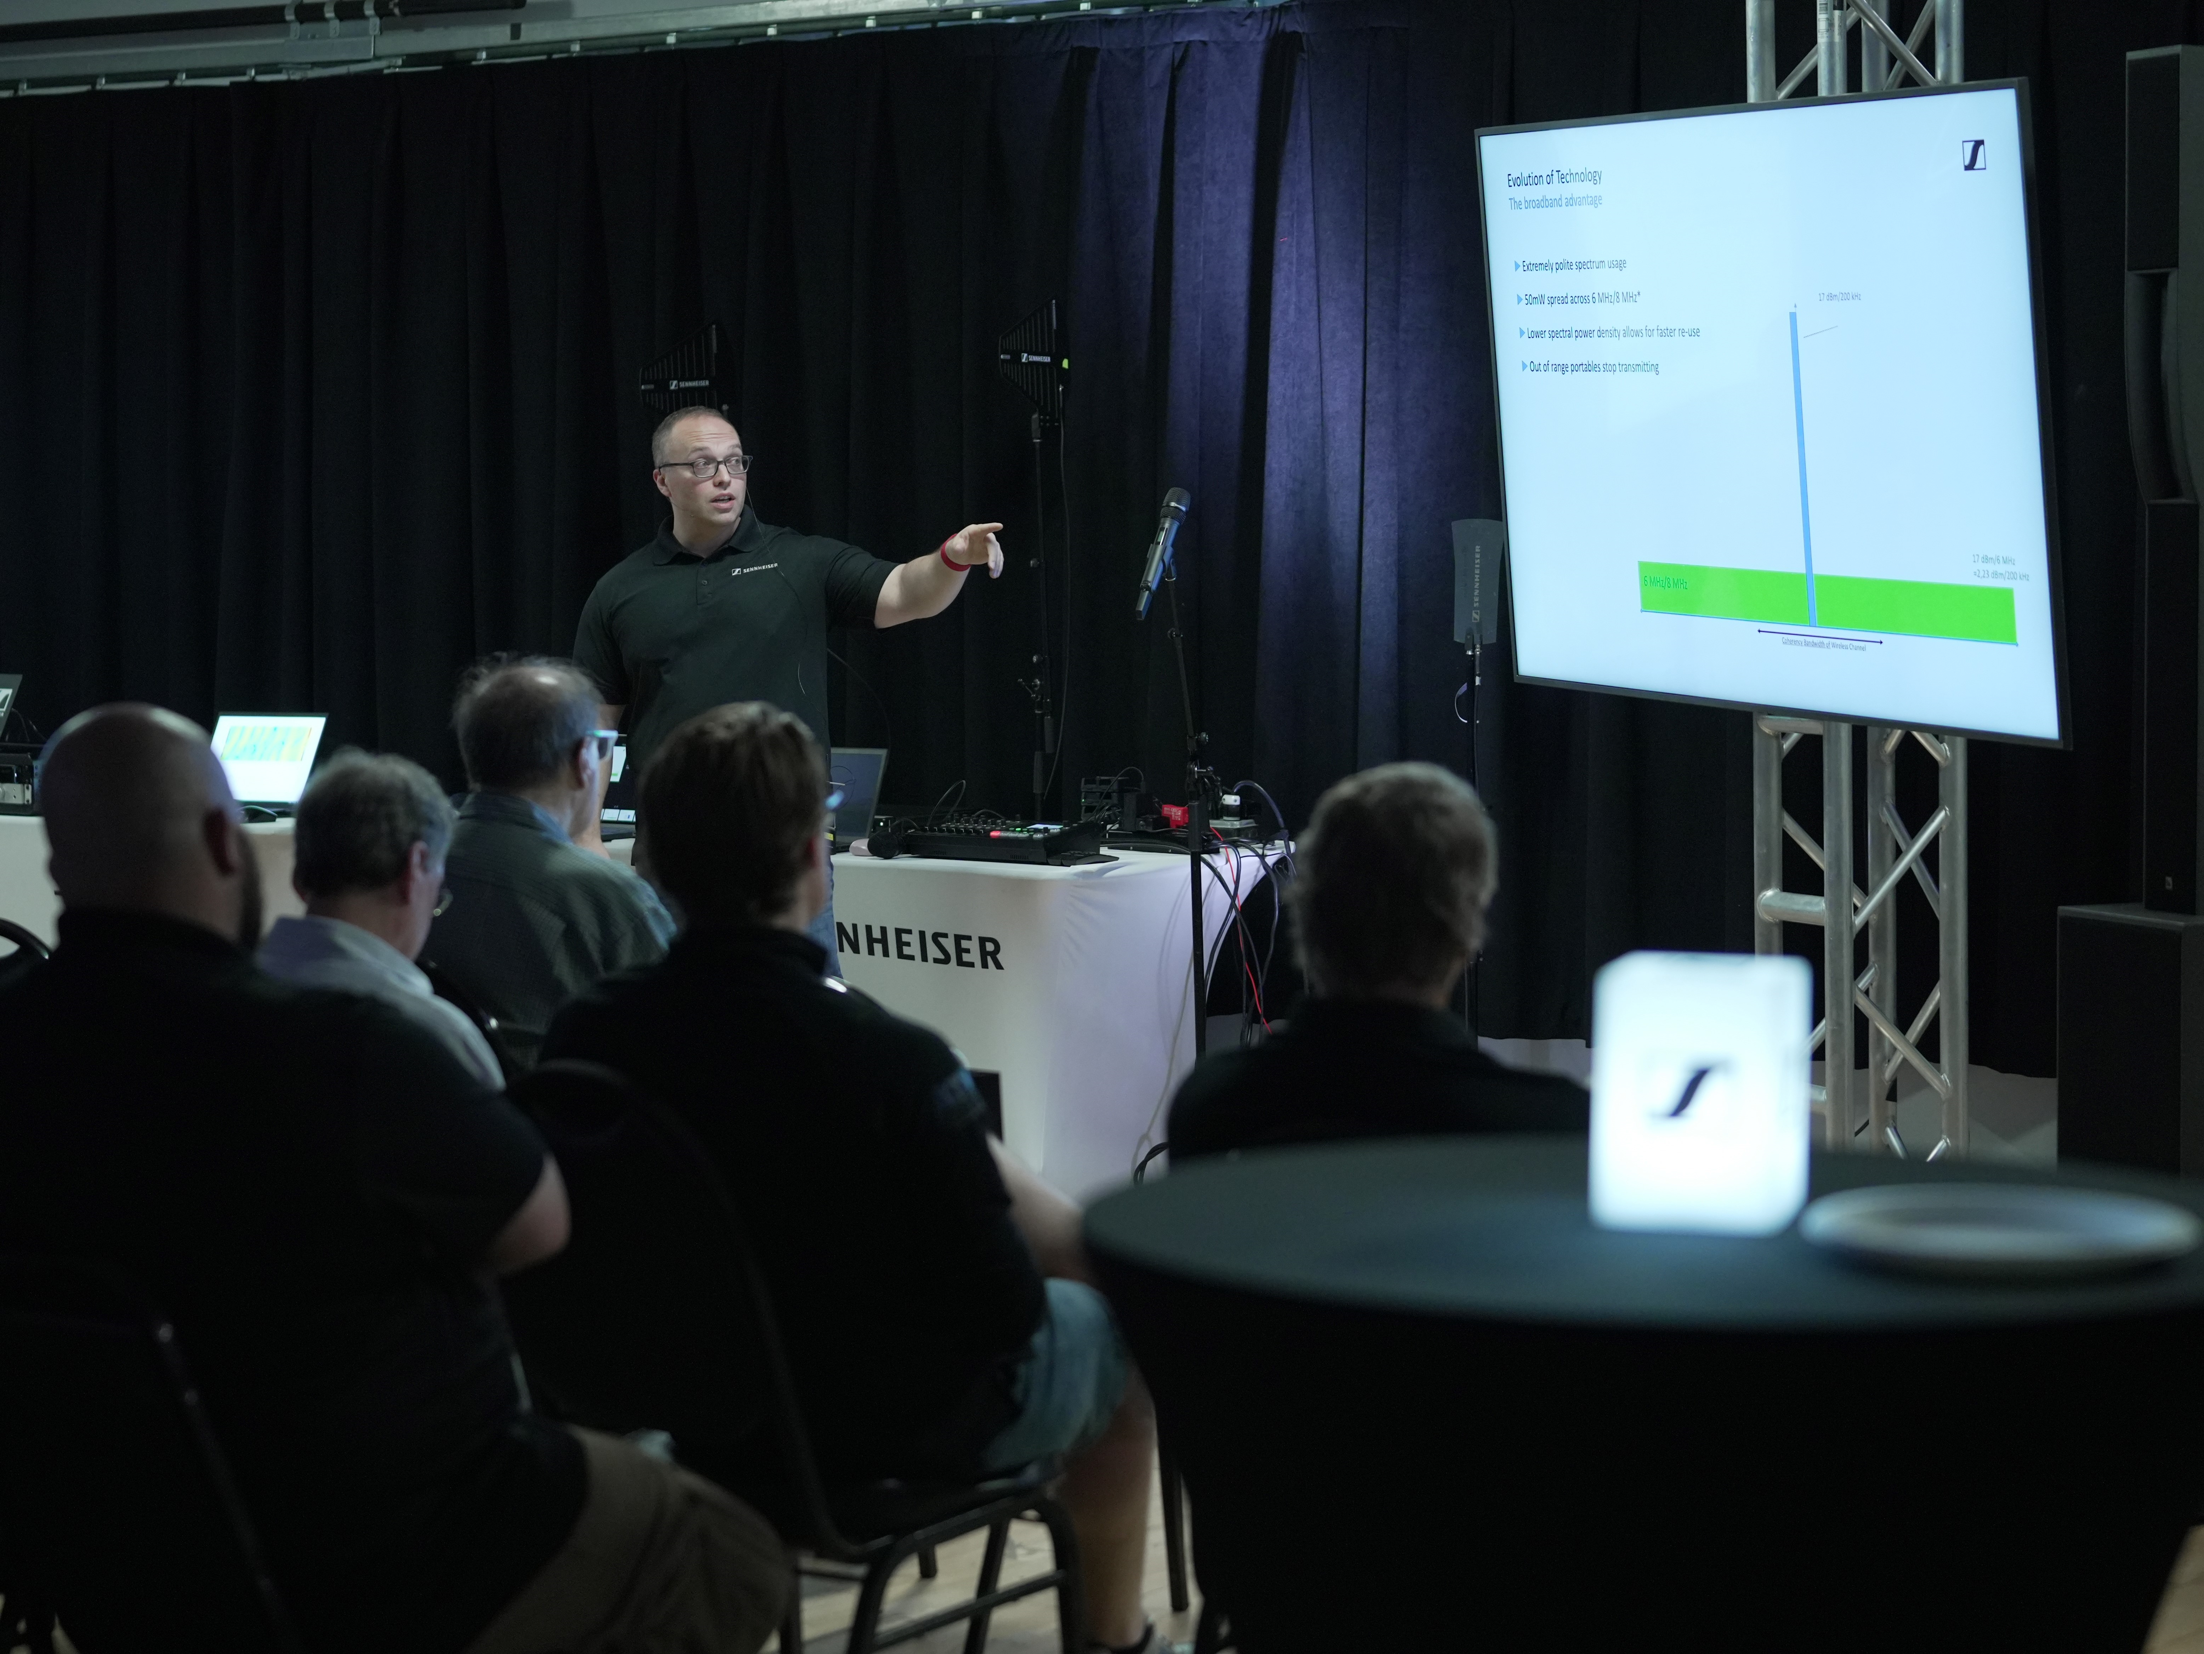
Greg Simon presents WMAS technology and future solutions.

The inside scoop: key takeaways from the experts
On the back of the educational event, attendees including esteemed audio engineers and experts shared their impression of WMAS, and how the technology will impact and streamline their workflow.

“I think the WMAS Technology is truly the next step in RF management and organization. The presentation was an eye-opening experience to see what’s possible now, thanks to Sennheiser’s innovative R&D engineers. I am looking forward to using this technology when it becomes available in the United States and have high hopes for its integration into tours and theaters.” – Jason Banta, Live and Studio Engineer for artists including Amos Lee, Better Than Ezra and Tonic

“It’s a hackneyed phrase but it’s great to see a manufacturer thinking “out of the box” to provide the solutions the industry desperately needs.” – Philip Barrett, Director of Audio, Creative Technology Group, Inc.

“WMAS represents the logical evolution of digital radio microphone technology, and Sennheiser has masterfully envisioned its implementation. Future workflows employing WMAS will simplify equipment deployments and RF spectral efficiency for the technician while improving the user experience for the artist.” – Henry Cohen, Senior RF Systems Design Engineer, CP Communications

“Sennheiser’s WMAS technology skips several technology iterations to bring RF audio to the present and drive it into the future. This technology will push industry innovation, while making coordination, deployment, and operation both simpler and more reliable.” – Kevin Tucker, Design Engineer, NEP Broadcast Services

Looking ahead: the future of WMAS in the US
Currently, Sennheiser is working alongside audio industry peers to educate the broader wireless community about WMAS and achieve the necessary FCC approval to bring this important innovation to market. Joe Ciaudelli, Director of Spectrum & Innovation at Sennheiser, shares, “WMAS is a completely new approach to wireless microphone design that requires a rule change issued by the Federal Communications Commission (FCC). Revolutionary technologies in any industry are often met with trepidation, but Sennheiser has demonstrated that WMAS not only fulfills the FCC goal for spectral efficiency but also provides greater protection against interference to other devices that share the same spectrum, including traditional wireless mics and IEMs. Sennheiser graciously thanks the numerous industry leaders who have provided their names to the FCC in support for the necessary rule change, clearly demonstrating strong enthusiasm for this problem-solving technology. Hopefully, this will inspire the FCC to enact a favorable Report & Order soon.”

Joe Ciaudelli discusses WMAS and the path forward for this technology in the US.

WMAS has already attained the necessary government authorizations in most of EMEA and in many APAC countries. With the support of leading industry experts, Sennheiser is taking steps to accelerate this crucial regulatory step and bring this revolutionary technology to the vibrant live audio industry in the United States.

To learn more about WMAS and receive the latest updates on this technology, you can sign up for our newsletter or contact us here: www.sennheiser.com/wmas
[ends]

About Sennheiser Group
Building the future of audio and creating unique sound experiences for our customers - this is the aspiration that unites the employees of the Sennheiser Group worldwide. The independent family-owned company Sennheiser was founded in 1945. Today, it is managed in the third generation by Dr. Andreas Sennheiser and Daniel Sennheiser, and is one of the leading manufacturers in the field of professional audio technology.

sennheiser.com | neumann.com | dear-reality.com | merging.com

Local Press Contact
Daniella Kohan
daniella.kohan@sennheiser.com
+1 (860) 227-2235

