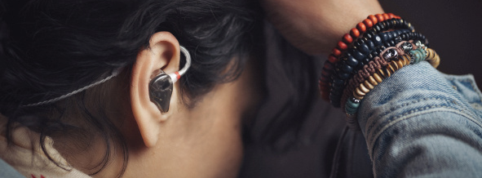Fischer Amps and Sennheiser launch first custom in-ears with TrueResponse Technology
New FA 500 Custom delivers compelling, true-to-life audio

Wedemark, 30 June 2021 – Fischer Amps, acclaimed German manufacturer of monitoring solutions for sound engineers and artists, has teamed up with audio specialist Sennheiser to create a truly exceptional in-ear, the FA 500 Custom. These in-ear monitors combine meticulously handcrafted custom earmolds by Fischer Amps with the transducer of Sennheiser’s top-of-the-range IE 500 PRO. Featuring Sennheiser’s TrueResponse® technology, the in-ears open up a completely natural, clear and spacious sound stage, enabling musicians and engineers to fully focus and critically monitor their sound.
The FA 500 Custom is exclusively distributed via Fischer Amps, and is now available in EMEA.

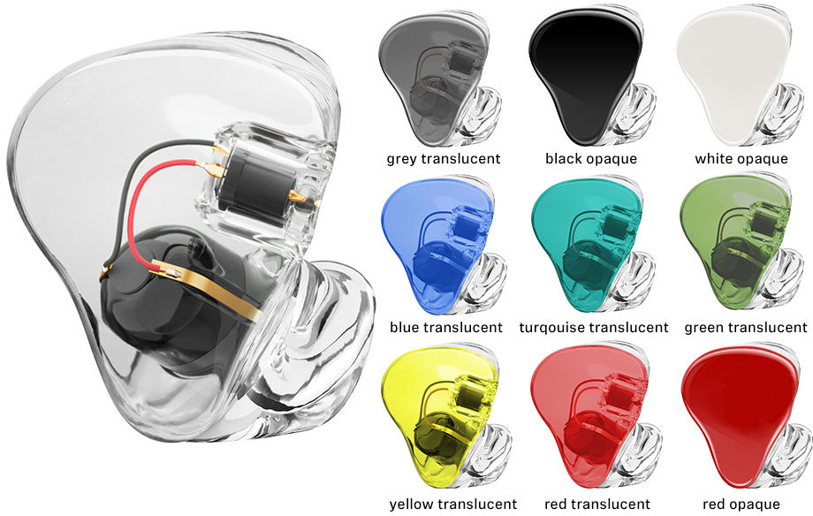 | The FA 500 Custom with just some of many more customisation options that Fischer Amps offers

Jochen Fischer, founder and owner of Fischer Amps, describes what makes the FA 500 Custom so special: “At the heart of each precisely crafted earmold sits a truly incredible dynamic wideband transducer, which allows you to precisely monitor the entire audio frequency range with a THD of as low as under 0.08%. Having just one transducer does away with the cross-over effects and phase differences known from balanced-armature types that operate with multiple drivers.”

He adds, “Custom earmolds are probably the single best investment that you can make to improve your performance. If you are able to hear precisely, you know exactly where to tweak your sound.”

Spacious sound stage and sturdy mechanics
The FA 500 Custom deliver a particularly wide and deep sound stage that allows musicians to easily localise themselves in the mix. It is fitted with a detachable cable with a reinforced ear hook and break-proof inner cable duct: The cable’s sturdy anti-kink sleeve sits directly on the earmold, providing a long-lasting solution for the rigours of stage use. The clear, twisted-pair cable provides optimised resistance to structure-borne noise.

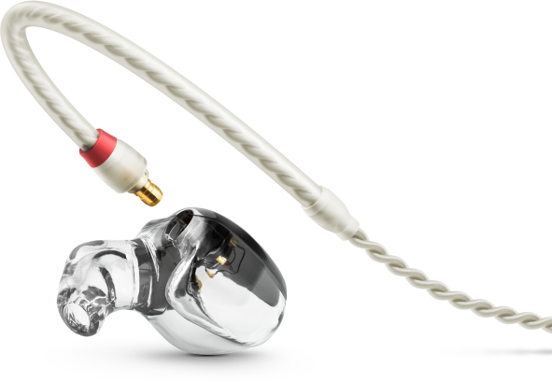 | The FA 500 Custom features a detachable cable with break-proof inner cable duct. The twisted pair cable attenuates structure-borne noise

TrueResponse technology
TrueResponse relies on a single, high-performance driver to reproduce monitor sound. Other in-ears in the same price range work on the balanced armature principle, which requires multiple drivers to reproduce the frequency range. This may lead to cross-over effects and phase differences between the individual drivers. The sound will not be as clear and accurate as with a high-performance dynamic transducer.

A further benefit of TrueResponse: With the sound being so precise and detailed, the acoustical stress for the wearer is reduced. Users will find that they can set their monitors to a lower level than usual, actively contributing to protecting their hearing. Even so, the sound still has punch – even in the loudest of surroundings.

TrueResponse technology:  A high-performance dynamic driver covers the entire audio frequency range from 6 to 20,000 hertz for accurate and natural reproduction with a THD of under 0.08% (1 kHz, 94 dB) | 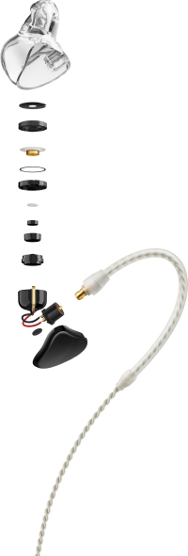 | 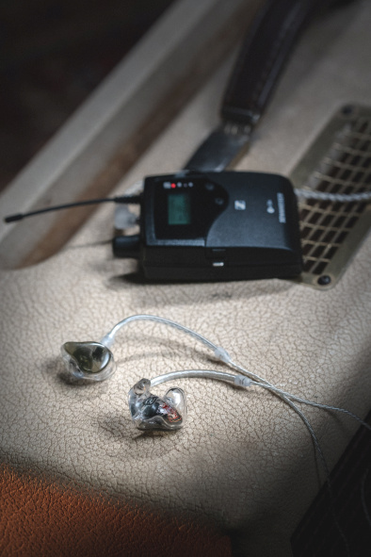

Technical data and availability
The FA 500 Custom features a frequency response of 6 to 20,000 Hz; if needed, it can take sound pressure levels of up to 126 dB. THD is ultra-low at under 0.08% (1 kHz, 94 dB). Noise attenuation is around 26 dB. Further specs: an impedance of 16 ohms, magnetized field strength of 2 mT and an operating temperature range of -5°C to +50°C. .

The FA 500 Custom retails at EUR 1349 (incl. VAT) and is available now in EMEA. It can be ordered via a dedicated order form here.

(Ends)

For your social media channels:
The FA 500 Custom in-ears combine meticulously crafted Fischer Amps earmolds with the high-performance dynamic wideband transducer of Sennheiser’s IE 500 PRO.

Download the high-resolution images accompanying this media release here.

* TrueResponse® is a trademark of Sennheiser electronic GmbH & Co. KG, registered in the U.S. and other countries.

About Sennheiser
Shaping the future of audio and creating unique sound experiences for customers – this aim unites Sennheiser employees and partners worldwide. Founded in 1945, Sennheiser is one of the world’s leading manufacturers of headphones, loudspeakers, microphones and wireless transmission systems. Since 2013, Sennheiser has been managed by Daniel Sennheiser and Dr. Andreas Sennheiser, the third generation of the family to run the company. In 2019, the Sennheiser Group generated turnover totaling €756.7 million. www.sennheiser.com

Global Press Contact

Stephanie Schmidt
Stephanie.schmidt@sennheiser.com
+49 (5130) 600 – 1275

