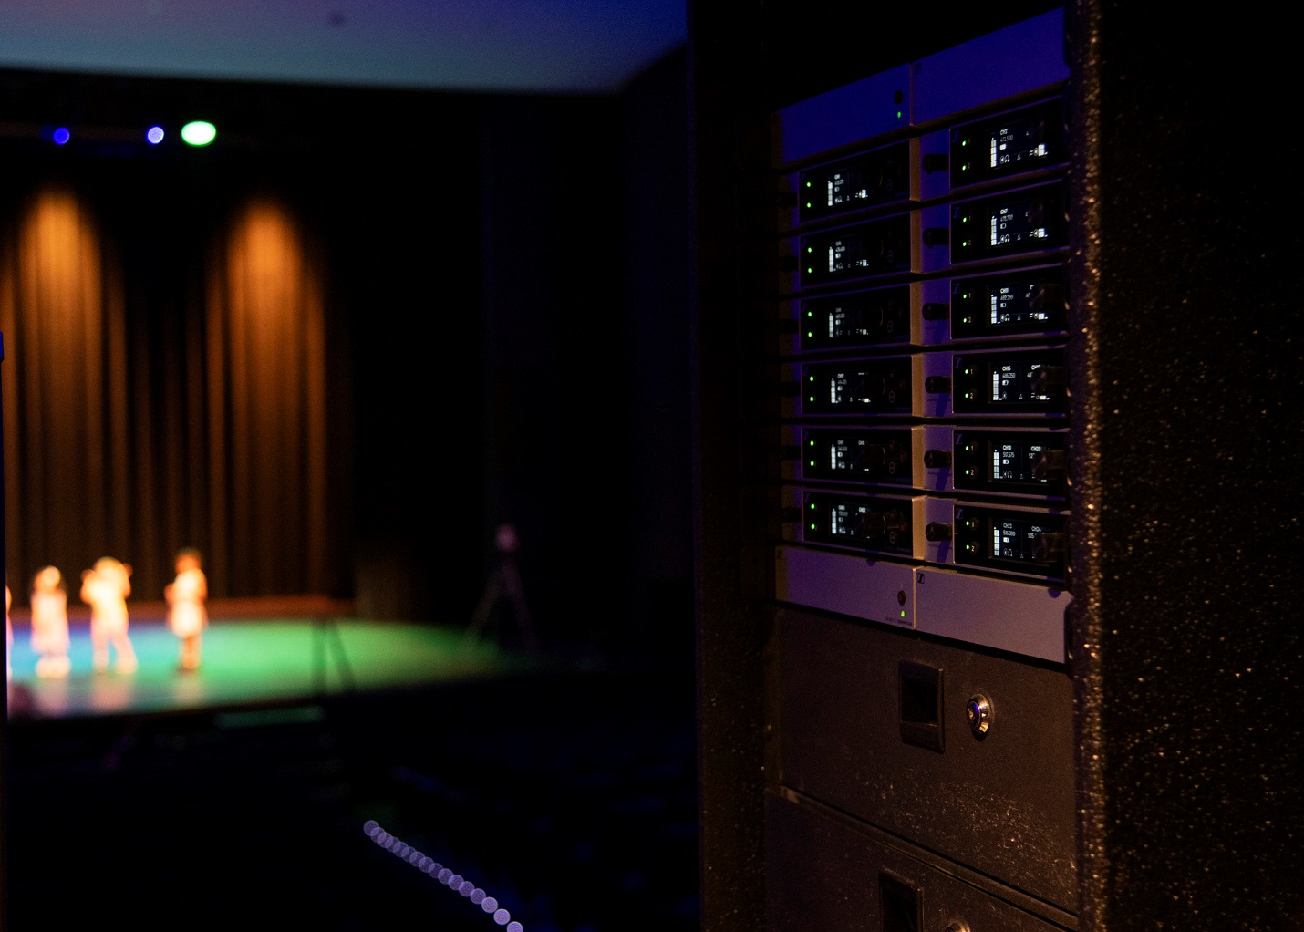

**Berkeley Preparatory School upgrades to Sennheiser’s EW-DX System for a networked, campus-wide and consistent wireless audio solution   
The prestigious Florida day school has outfitted multiple performance spaces including its 820-capacity theater and chapel with 40 channels of Sennheiser’s newest wireless microphone system**

***Tampa, FL, June 22, 2023* — Berkeley Preparatory School, a highly ranked Pre-K to Grade 12 day school in Tampa, has a jam-packed schedule of activities for its 1,400+ students, as well as its faculty and staff, from theater productions to chapel services, daily staff meetings in the auditorium and more, all of which require wireless audio solutions. The state-of-the-art school has long used Sennheiser G3 wireless for its audio needs, but recently Productions Technical Director Christopher Cook has been looking for a new solution to meet RF challenges, while enabling a fully networked solution across the sprawling campus. With support from Beamworks, Inc., Berkeley Prep has rolled out 40 channels of Sennheiser’s EW-DX wireless system, the newest and most robust offering from the Evolution Wireless Digital family of products.**  
As the Productions Technical Director, Christopher is Berkeley Prep’s resource for all things AV, and solely responsible for the technical aspects of all concerts, plays and assemblies. Given the nature of his role, he does not have room for equipment failure or troubleshooting, and must always be prepared for the unexpected, “if something goes down, I need a fast repair. When you’re the one guy people look to you for answers, so you better have it.” he shares. As a longstanding Sennheiser user, Christopher was reliant on the quality of the G3 wireless system for many years, and now subsequently the EW-DX, “Luckily, things don’t go wrong often with Sennheiser. I always have a plan B, plus Beamworks is always quick and stocked with Sennheiser.”

Christopher has been a Sennheiser user since his time touring with musicians over 20 years ago. He shares, “I started working in audio in 2000, and when you go on tour, people are picky with what brand they use. Through traveling and using different wireless systems and microphones, I found that I always got more gain out of Sennheiser vs. other wireless brands. I fell in love with Sennheiser early and kept with it.”

**Total Remote Control**

As a long-time Sennheiser user and an AV team of one, Christopher’s early adoption of the new EW-DX system was a natural progression. He needed a fully networked solution that could be managed offsite. He explains, “our campus is 80 acres, so I’m not able to walk from room to room – I have to hop on the golf cart. Now I just go on computer, pop on Control Cockpit and make sure everything is good. We are networking all audio consoles.” Sennheiser EW-DX’s can be managed via Control Cockpit so Christopher can oversee, coordinate and troubleshoot wireless operations from his laptop. As Berkeley Prep’s wireless setup spans three black box theaters across the elementary, middle and upper school divisions, a main stage 820 seat theater, a recital space and a brand-new chapel, being able to manage all of these spaces and more from a centralized hub was a key consideration in their wireless audio decision.

|  |  |
| --- | --- |
|  | Berkeley Prep’s state of the art campus extends to its recital hall, where an array of professional audio equipment allows students to really shine. |

Christopher worked closely with Berkeley Prep’s trusted partners at Beamworks to plan, purchase and rollout the EW-DX system across campus. Drew McMullian, Operations Manager at Beamworks brought hands-on support to the installation process and found Control Cockpit’s networked approach to be a comprehensive solution for the school’s needs. He provided the example of the campus chapel: “getting everything connected and networked has been incredible. They built a beautiful new chapel recently, and the AV room is up a spiral staircase, so it is not accessible if you need to get there quickly,” Drew continued, “being able to control the wireless from the Control Cockpit software is a necessity for Christopher. All of this, with the flexibility to use any Neumann or Sennheiser capsules to outfit the church choir, made this a spot-on setup for Berkeley Prep.”

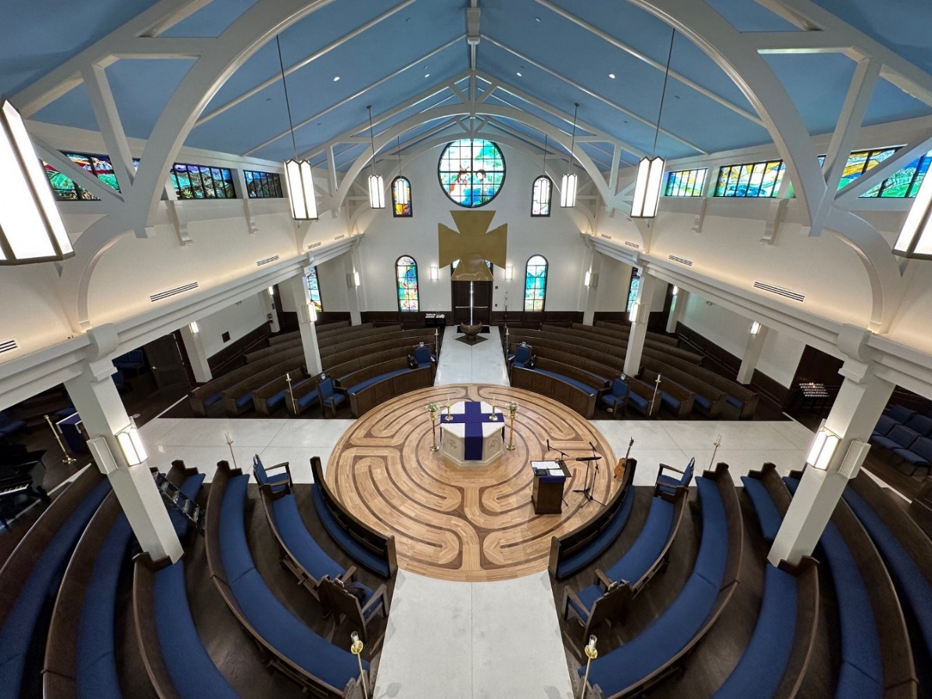

Berkeley Prep’s brand-new chapel relies on Sennheiser EW-DX for services.

**Beating RF Traffic**

Situated near downtown Tampa, frequency coordination for wireless mics can be particularly challenging. The school is a few blocks from Tampa International Airport, and there are a dozen digital TV transmitters in the surrounding area, which adds an additional layer of complexity for Christopher. “Frequency coordination can be hinky. I’ve had bad experiences in the past and have had to learn what high traffic times are at the airport. For instance, in the past I couldn’t do outdoor rehearsals around 2pm without getting squashed by air traffic.”

|  |  |
| --- | --- |
|  | Berkeley Prep’s talented student body uses EW-DX microphones for a variety of performances, including choir, musical theater and band. |

With so many daily activities across campus that require wireless audio both indoors and out, navigating air traffic and buzzy Downtown Tampa to dodge dropouts and interference can feel like an obstacle course. Berkeley Prep needed a wireless system that could handle the crowded RF spectrum while minimizing the legwork for Christopher and other wireless users. EW-DX offers the lowest latency on the market (1.9 milliseconds) and eliminates the need for frequency calculation thanks to its equidistant frequency spacing which does not pollute available spectrum with intermodulation. In Christopher’s words, “with the EW-DX units I don’t have these [frequency coordination] issues. They don’t get stomped on by anything.”

Drew underscored the challenge that Christopher was facing, “In this area, anything from 500-540MHz band completely disappeared.” Beamworks has been equipping the local Tampa market with wireless solutions since the late 1990s, and Drew has almost two decades of first-hand experience with the crowded RF environment and how to best navigate it, “EW-DX can find nooks and crannies that work whereas regular bands don’t even function.”

|  |  |
| --- | --- |
|  | Berkeley Prep’s 820-capacity theater uses 24 channels of EW-DX for a variety of performances and events. |

**A Sound Production**

The recent installation of EW-DX across Berkeley Prep’s campus was completed at a crucial make-or-break-it point. The rollout was right in time for technical week, or tech week, for the school’s highly anticipated production of Mean Girls. They were the first school in Tampa to adapt the popular musical, and the wireless system rose to the challenge, “I used 24 channels of EW-DX, and it was immediately night and day [from our previous system]. The sound quality was more natural, the intelligibility was better – they were just so clean,” says Christopher, “I didn’t change my mic technique, it was just the units. I got a lot of great comments about how natural the production sounds.”

Christopher sees that the future is bright for EW-DX on campus with opportunities to improve audio in more places, “I’m really excited to eventually merge out into the athletic fields. For now, whenever someone sings the national anthem, we bring out the EW-DX. Eventually I want each venue to have EW-DX managed through Control Cockpit. I look forward to expanding with the EW-DX line and growing with it.”

Beyond the sound quality, ease of use and centrally networked setup, the EW-DX upgrade at Berkeley Prep has given Christopher a distinct return on investment that most education industry AV and IT professionals could benefit from. He explains, “Anything that takes away stress or provides you with more time back in your workday is huge. All we have as people is our time so anything to give you more of it is worth the investment.”

**About the Sennheiser Group**

Building the future of audio and creating unique sound experiences for our customers - this is the aspiration that unites the employees of the Sennheiser Group worldwide. The independent family-owned company Sennheiser was founded in 1945. Today, it is managed in the third generation by Dr. Andreas Sennheiser and Daniel Sennheiser and is one of the leading manufacturers in the field of professional audio technology. Within the Sennheiser Group are Georg Neumann GmbH (Berlin, Germany), manufacturer of studio-grade audio equipment; Dear Reality GmbH (Düsseldorf, Germany), known for its binaural, Ambisonics, and multichannel encoders with realistic room virtualization; and Merging Technologies SA (Puidoux, Switzerland), specialist in high-resolution digital audio recording systems.

sennheiser.com | neumann.com | dear-reality.com | merging.com

**Local Press Contacts**

Daniella Kohan

daniella.kohan@sennheiser.com

+1 (860) 227-2235