

Biuro prasowe better. gaming agency
bettergamingagency.prowly.com

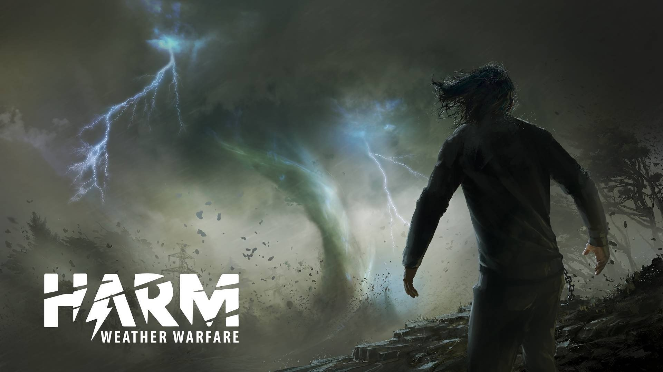

Survive among deadly anomalies, save your daughter, and unravel the secrets of the abandoned research center. HARM Weather Warfare is coming to PC in 2024

This was meant to be a peaceful, family trip outside the city; however, the forest wilderness turned out to be a place full of secrets. The unfortunate duo – a father and his teenage daughter – unexpectedly find themselves ensnared in the midst of bizarre events. Trapped by powerful weather anomalies, they will try to do anything to survive. Everything indicates that an abandoned research center called HARM is the heart of the problems. You will get a chance to unravel this mystery in 2024 when HARM Weather Warfare comes to PC.

HARM Weather Warfare is a survival game that immerses players in a world ravaged by various weather anomalies. Snowstorms in the middle of summer, roof-tearing gusts, and rains transforming roads into rushing streams are just a part of the surprises that will challenge players' survival skills. Mysterious electromagnetic discharges, accompanied by intense flashes and daytime auroras, emphasize the wild nature of this place. Escaping from this eerie trap won't be as easy as it might seem. All evacuation routes are cut off, and the only chance to regain freedom lies within the abandoned corridors of the HARM base.

HARM Weather Warfare - gameplay ​trailer

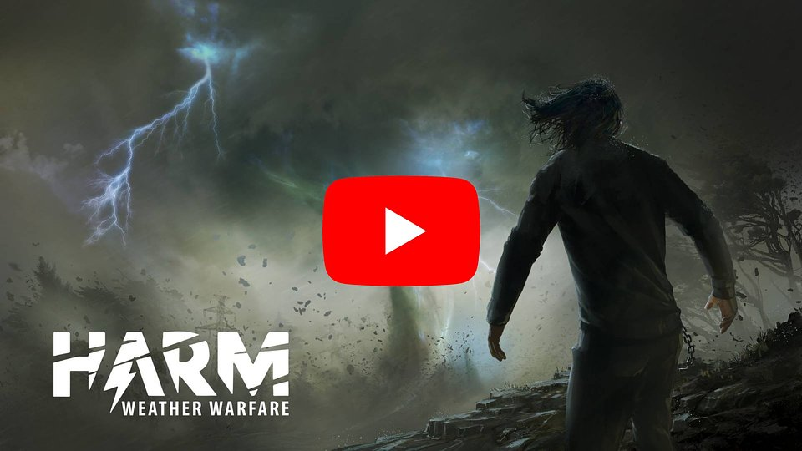
https://www.youtube.com/watch?v=Apvjc6AClPU

The challenging situation of the trapped family intensifies over time. The cabin where they were supposed to stay burned down with all their equipment, and the car was destroyed. They are forced to create makeshift shelter, search for food, and face an uneven battle with the unpredictable forces of nature. However, it quickly becomes apparent that the nearby mountain emits unusual electromagnetic waves that strongly resonate with water molecules and living creatures, causing not only local weather anomalies, but also changes in the behavior of both humans and animals.

The main features of HARM, including the need for improvisation in extreme conditions and detailed graphics, will grab the attention of survival enthusiasts. All of these elements amplify the feelings of fear, exhaustion, and loneliness that constantly accompany the main character during the fight with the forces of nature. Players must attend not only to their health and stamina, but also consistently monitor hunger, hydration, body temperature, and fatigue resulting from the lack of sleep.

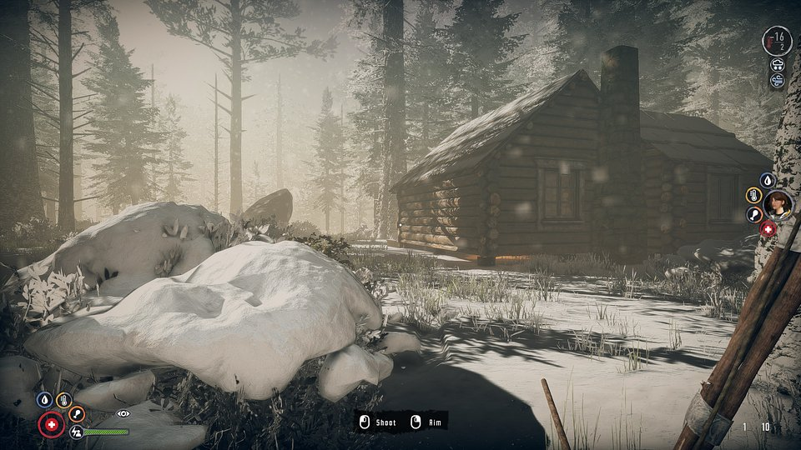

HARM Weather Warfare – key features:

🌪️The fight for life – do everything to save yourself and your daughter from death in the forgotten wastelands abandoned by the world. Strive for survival, utilizing every possible resource and opportunity while immersing yourself in a narrative that embodies timeless values such as love, trust, and sacrifice.

🌪️ Military secrets – the abandoned HARM base hides secrets that might give you a chance to escape the clutches of death. However, be aware that the deranged cult, nurturing the mystery around the mountain for years, deals ruthlessly with intruders.

🌪️ Improvise and adapt – while exploring an area cut off from the world, you will come across useful tools, devices, and materials. Build, create, and combine objects to craft items that will aid you in further exploration and in the challenging struggle against the forces of nature.

🌪️ Hunt and fish – the need to survive drives people to do things they wouldn't consider in other situations. In HARM Weather Warfare, you will not only have to hunt and fish for food, but you'll also face unpredictable cultists.

🌪️ How much can a human endure? – In a detailed player statistics system, factors like hunger, thirst, body wetness, cold, and lack of sleep show how tough and challenging it is to survive in extremely hostile conditions.

🌪️ Shivers down the spine – thanks to dynamically changing weather conditions, advanced graphics, and a compelling narrative the gameplay is as intense as blockbuster movies.

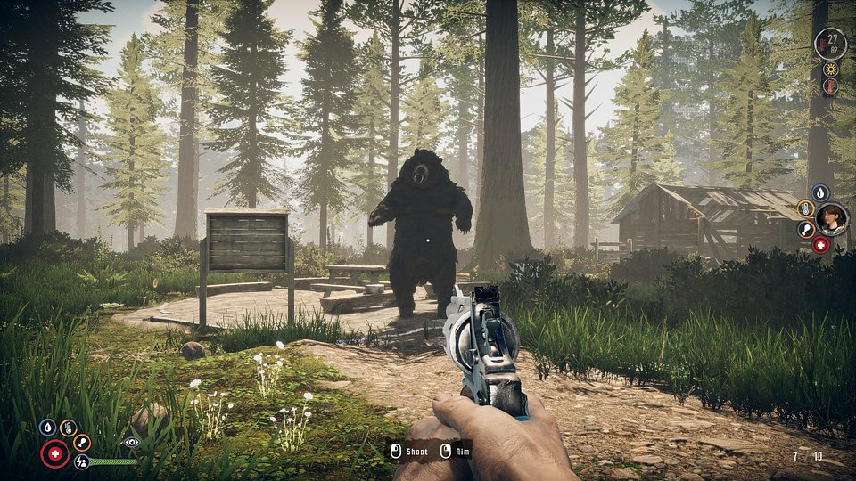

The release ofHARM Weather Warfare is scheduled for 2024, and the game will be available on PC. Feel free to add the game to your wishlist now – we highly encourage everyone interested in survival games!

A full press kit is available here.

About Aurora Studio:Aurora Studio is an independent developer and publisher based in Poland. The company produces and distributes its own games, serving as both creator and owner of intellectual property rights. The studio has been active in production and publishing since 2021, developing its titles using Unity3D and Unreal technologies. Specializing in narrative-driven survival games, the developers aim to focus on multiplayer titles in the future.



Jakub Smolak
PR Specialist at better. gaming agency
jakub.smolak@bettergaming.pro
Twitter

