Antelope Audio Sports Full Line of HDX-Compatible Interfaces at Summer NAMM
Goliath HD, Orion Studio HD, and Orion32 HD Combine for the Most Powerful Suite of Pro Tools HD Interfaces on the Market
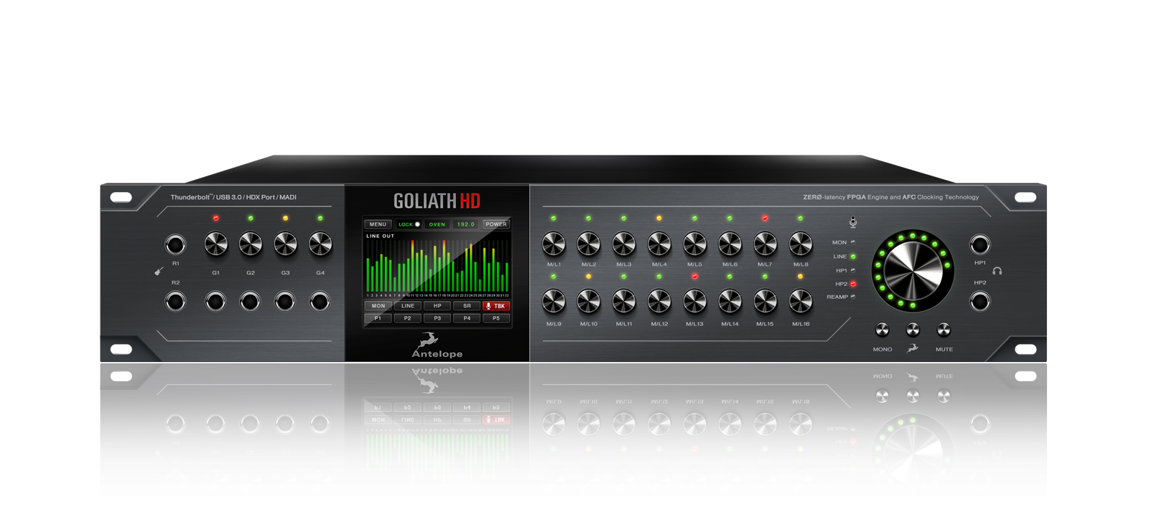
Nashville, Tenn., June 22, 2017 —Antelope Audio [Summer NAMM booth 443], a leading interface company specializing in realtime FX modeling, will showcase its industry-leading suite of HDX-compatible interfaces at this year’s Summer NAMM, beginning July 13th. The company has also announced that it’s flagship Goliath HD interface for HDX and Native DAWs has begun shipping, joining the Orion Studio HD and Orion32 HD interfaces as versatile centerpieces for Pro Tools and Native studios of all sizes.
Standing Tall
Goliath HD features a staggering 64 channels of high-quality I/O backed by Antelope’s trademark pristine conversion and the lowest harmonic distortion available in a multichannel interface across all 64 of its channels. It also brings the full complement of Antelope Audio realtime FX to both Pro Tools HD and Native platform users, providing a powerful palette of audio processing tools that can make any mix sing. Goliath HD also features Antelope’s proprietary HDX Delay Compensation, ensuring any analog or digital input is delivered to Pro Tools HD sample accurately in the timeline.
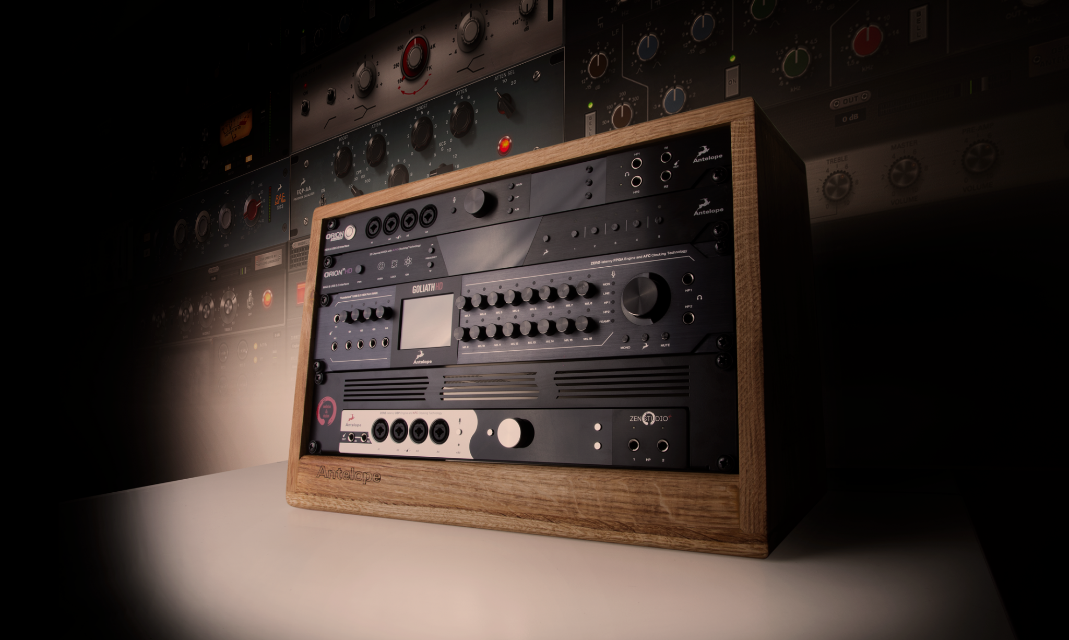
“It is a notable milestone for us having brought Antelope Audio hardware to the HDX platform, now including our most powerful interface, the Goliath HD,” says Igor Levin, CEO of Antelope Audio. “Pro Tools HD is the DAW of choice for many world’s best studios, and we want to ensure that they have access to the world’s best interfaces. With Goliath HD joining the Orion Studio HD and Orion 32 HD, Antelope Audio now offers HDX-compatible interfaces with a range of functionality and I/O configurations, allowing Pro Tools HD users to hone in on the best choice for their workflow.”
“In doing so we have also granted Pro Tools HD users access to our ever-growing library of authentic realtime hardware FX emulations, providing an enormous range of equalizers, compressors, and amp simulations that exponentially increase the sonic possibilities for studios of any size,” he added.
A Big Happy Family
The Goliath HD joins Antelope’s popular Orion Studio HD and Orion32 HD interfaces to fill out a remarkable line of Pro Tools HD compatible recording devices. The Orion32 HD offers 64 channels of superior quality 24-bit, 192 kHz I/O in an efficient single rackspace footprint, perfect for studios looking to expand their channel count or upgrade their conversion quality. Orion Studio HD combines superior Antelope Audio conversion with a range of useful features, including 12 Class A mic preamps built in, dual reamp, monitor, and headphone outputs, and additional analog I/O on DSub connectors.
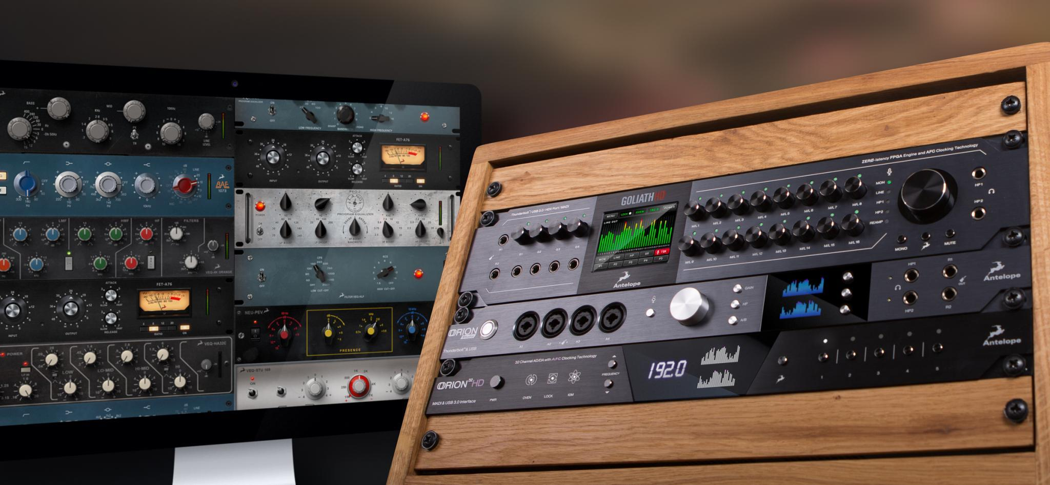
All Antelope Audio HD interfaces grant users access to the dynamic processing power of Antelope Audio Field Programmable Gate Array technology, which powers both the 40+ realtime FX available for free download as well as Antelope’s powerful desktop application, which provides superior monitor mixing and routing capabilities.
For more information, please visit Antelope Audio at Summer NAMM booth 443 or visit: http://en.antelopeaudio.com/pro-audio-devices/thunderbolt-usb-audio-interface/

About Antelope Audio
Antelope Audio is a leading manufacturer of high-end professional audio equipment and the pioneer in the adoption of Atomic clock generators, utilizing Igor Levin's over 25 years'experience in digital audio. Antelope is the first to design a 1U 32-channel audio interface and a multi-channel portable interface with 12 mic pres. The company's customers include many Grammy award-winning sound engineers and some of the most renowned recording, mastering and post-production facilities around the globe.
# # #
All brands and trade names are the property of their respective owners.

Contact information:

North America
Jeff Touzeau
Public Relations
Hummingbird Media, Inc.
(914) 602-2913
jeff@hummingbirdmedia.com

EMEA & APAC
Fani Angelova
Brand Manager
Antelope Audio
+359 2 447-2970
fangelova@antelopeaudio.com

International
Violeta Nikolova
Brand Manager
Antelope Audio
+359 2 447-2970
vnikolova@antelopeaudio.com

