Zoom and Sennheiser extend AMBEO for VR partnership
The Zoom F6 and F8n field recorders have been certified for AMBEO

Wedemark/Amsterdam, 13 September 2019 – Audio specialist Sennheiser and audio for video manufacturer Zoom are extending their AMBEO for VR partnership with the inclusion of the brand-new Zoom F6 and Zoom F8n field recorders. Both models now use AMBEO A-B software, which directly converts the A signals of the AMBEO VR Mic to processing-compatible Ambisonics B-format. Zoom has been an inaugural member of Sennheiser’s AMBEO for VR partnership program, created to ensure seamless workflows for VR and AR producers.

The Zoom F6 field recorder with Sennheiser’s AMBEO VR Mic | 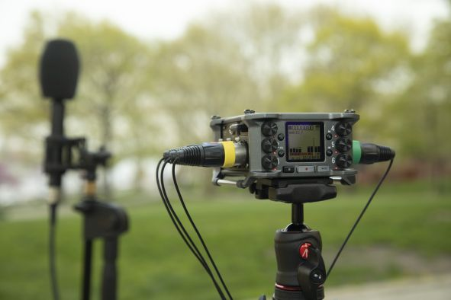

“We are delighted that the F6 and F8n from Zoom are now joining the AMBEO for VR program alongside the Zoom F4 and F8, all extremely popular field recorders with VR and AR content creators,” commented Véronique Larcher, Director of AMBEO Immersive Audio. “Similarly, the AMBEO VR Mic is the leading Ambisonics microphone in the AR and VR fields, and including the AMBEO conversion software directly in the recording tool streamlines production workflows considerably.”

“At Zoom, we are closely observing how new audio technologies are developing, and have seen AR and VR productions constantly on the rise,” commented Masa Iijima, Zoom Corporation CEO. “We are therefore happy to extend our partnernership with Sennheiser AMBEO to offer professionals and creators this innovative recording solution with our new F6 and F8n field recorders, too.”

The Zoom F6 is the first professional field recorder to feature both 32-bit float recording and dual AD converters, providing an unprecedented amount of dynamic range.

Visit Sennheiser (Hall 8, D.50) and Zoom (Hall 8, E.25) at IBC.

The image included within this press release can be accessed here: http://sennheiser-brandzone.com/pincollection.jspx?collectionName={a20f3e73-38de-4f34-b3e3-4623717b665d}

About Zoom
Founded in 1983 and based in Tokyo, Japan, Zoom produces a wide array of recording devices, including a line of portable recorders as well as multi-effects processors, effects pedals, drum machines and samplers. Over the past thirty years, the company has established a solid reputation as a manufacturer of innovative yet affordable products which are based on original microchip designs. Under the steady hand of CEO Masahiro Iijima, Zoom is dedicated to continually developing new products that allow artists to more freely express their ideas yet are accessible to anyone, from amateur to professional. The company's staff represents a fusion of engineering expertise and artistic sensibilities; combining advanced technological skills with the sense and desire to employ them creatively and imaginatively. www.zoom.co.jp

About Sennheiser
Shaping the future of audio and creating unique sound experiences for customers – this aim unites Sennheiser employees and partners worldwide. Founded in 1945, Sennheiser is one of the world’s leading manufacturers of headphones, loudspeakers, microphones and wireless transmission systems. Since 2013, Sennheiser has been managed by Daniel Sennheiser and Dr. Andreas Sennheiser, the third generation of the family to run the company. In 2018, the Sennheiser Group generated turnover totaling €710.7 million. www.sennheiser.com

Zoom – Global PR Contact Sennheiser – Global PR Contact

Takayuki Nagatomo Stephanie Schmidt
nagatomo@zoom.co.jp stephanie.schmidt@sennheiser.com
+49 (5130) 600 – 1275

