JAVIER GOMAR

JAVIER’S BLADE

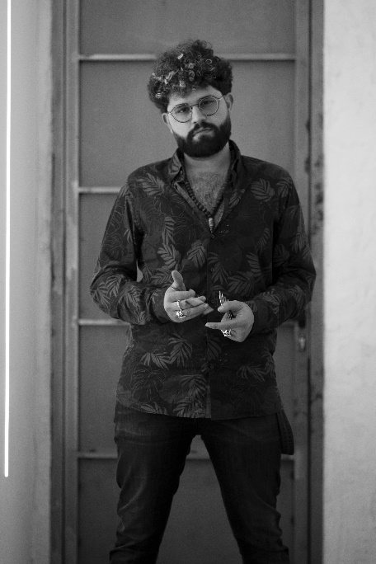
The Valencian Javier Gomar practices the profession from what he considers his creative temple, his salon, Javier´s Blade. A place in which, with freedom and specialization, connects clients with his image, though he is always open to going where he is required or needed. He fell in love with the profession when he discovered the amazing transformative power that hair exerts on image and mood. The three adjectives with which he describes himself, "squaring, cleanliness and design", show a particular vision of hairdressing in which curiosity about the processes and possible results impels him to advance and break his own limits. Besides, he has made the phrase "Imagination is more important than knowledge" his motto to continue exploring what is to be born, to unveil the novel messages with which hair can surprise and shape a new reality that is ready to be created, opposed to what is already known and pre-established.

His passion for fashion led him to discover hairdressing and to see hair as the only accessory that always accompanies us. He completed his FP in Hairdressing studies and completed them with two more years at the Gremio de Peluqueros de Valencia, participating for seven years in the Valencia competition team. Also, he has taken different courses at Toni & Guy Valencia, Vishal Baharani, X-pressure and Laura Betato. Curious by nature, he has taken advantage of his trips to Europe and the United States to visit different salons and discover first-hand other ways of practicing the trade.

He is a member of the Valencia Hairdressers Guild, as well as a member of the Valencia artistic competition team. She has also collaborated in the organization of tests and norms for the judges in Golden Chair International 2020 and participates in different contests and events held at Salon Look and Beauty Valencia. In 2019, in March he is authorized to serve as an international jury in the OMC Hairworld competition representing Spain and is appointed general delegate of OMC Hairworld Spain, being the direct contact with the organization, managing it directly with the organizers.

Despite his youth, his talent has already received numerous awards:

- Runner-up Hairstyle Fashion, Spanish Men's Hairdressing Championship (Albacete, 2015)
- Youth Champion, XXIV Spanish Men's Hairdressing Championship (Albacete, 2015)
- Colour Champion, Spanish Men's Hairdressing Championship (Albacete, 2015)
- Third place in teams, OMC Hairworld Europe Cup (2016)
- Third position Creative Haircut and Hairstyle, XXV Spanish Championship of Male Hairdressing (Valladolid, 2017)
- Third position Classic Hairstyle, XXV Championship of Spain of Male Hairdressing (Valladolid, 2017)
- Third in the general classification, XXV Championship of Spain of Male Hairdressing (Valladolid, 2017)
- Champion of Spain by teams, XXV Championship of Spain of Male Hairdressing (Valladolid, 2017)
- Award for the most viewed work in the world, OMC Hairworld World Championship (2017)
- Achievement Award for his contribution to hairdressing and beauty, OMC Hairworld World Paris (2019)
- Finalist International Visionary Awards 2020 (Cut & colour Category)
- Finalist Figaro Awards 2020 (Revelation Hairdresser category)
- TCT Awards Semi-finalist - Live Fashion Hair 2020 (Female Commercial Collection Category)
- HABIC Ireland Best of The Best Photographic Awards 2020 Finalist
- Finalist AIPP Awards 2020-2021 (Avant-Garde Category)
- Finalist International Visionary Awards 2021 (Cut & colour Category)
- Finalist Oneshot BigShot 2021 (Best Avant-Garde Shot and Best Avant-Garde Collection Categories)

