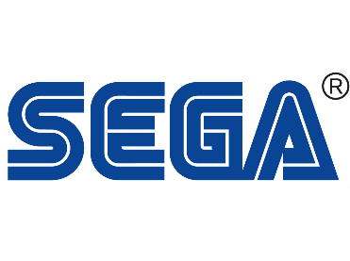
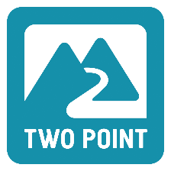

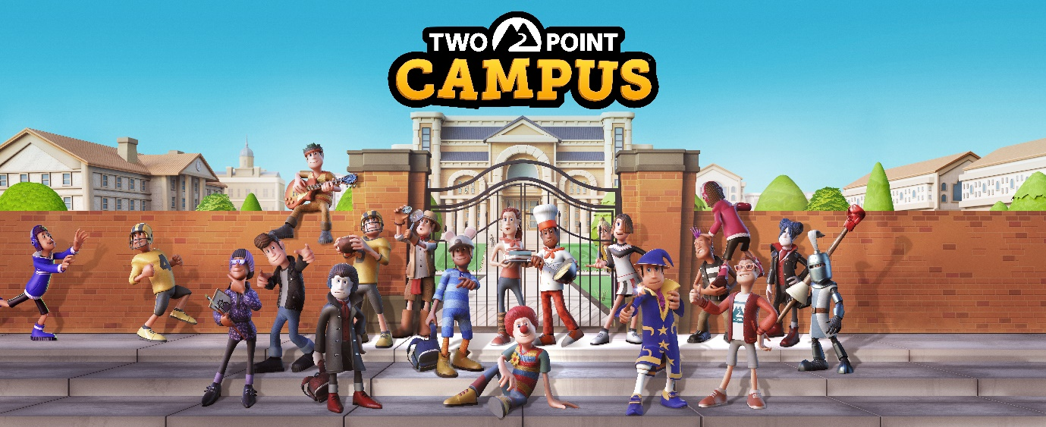
WELCOME TO TWO POINT CAMPUS – ENROL NOW TO JOIN THE CLASS OF 2022
Build Your University, Your Way!
London, England – 10 June 2021 – SEGA® Europe Ltd. and Two Point Studios™ are excited to reveal that Two Point Campus™, the sequel to the critically acclaimed management sim Two Point Hospital™, is coming to PC and consoles simultaneously in 2022! Create the campus of your dreams, shape the lives of your students, and manage everything in between! Start the fun here.
In Two Point Campus, you’ll be tasked with building and running your very own campus environment, where the decisions you make will shape the lives of the students you enrol and the staff you hire. For the first time, build in the great outdoors as you develop your very own campus grounds, buildings, and surroundings. Lay down dorms, pathways, hedgerows and more with new easy-to-use creative tools. The only limit is your imagination (and your in-game bank balance).
The fun doesn’t stop there! The people of Two Point County have slightly different priorities when it comes to education, meaning your students get to enjoy a wide range of hilariously unusual courses such as Knight School, where they’ll learn jousting and practise the noble art of chivalry. The less martially inclined can hone their skills in Gastronomy, and collaborate on all sorts of oversized culinary delights, like gigantic pizzas and equally humongous pies.
However, it’s not all about serious education – you’ll also need to nurture your students, explore their personalities, and fulfil all their wants and needs! Surround them with friends, help them develop relationships and make sure they balance everyday schoolwork with extracurricular delights like gigs, societies, and sports. Academia has never been more appealing!
“We hope that the incredible Two Point community will love all the new creative freedom that Two Point Campus will bring and that new players will be intrigued by its setting and the quirky world we’re trying to build, packed with our trademark humour and charm”, said Gary Carr, Co-founder and Creative Director at Two Point Studios.
Like Two Point Hospital, Two Point Campus is a charming, accessible, and deep management sim but now in a brand new setting. For more information about Two Point Campus head to www.twopointcampus.com, where you can also sign up for County Pass, which gives you a free coveted in-game item at launch. You can follow the game on Instagram, Facebook and Twitter. For more information about SEGA Europe, log on to www.sega.co.uk and follow us on Facebook, Instagram, YouTube on Twitter.

About Two Point Studios Ltd.
Two Point Studios is a British game developer, based in Farnham, Surrey (UK) and was founded in 2016. Two Point Studios’ small, but dedicated and passionate team have worked on some of the most recognisable brands in gaming, including Fable and Black and White. Drawing on that experience, Two Point Studios released a brand-new IP in the sim genre called Two Point Hospital, which launched for PC in August 2018. For more information about Two Point Studios visit www.twopointstudios.com.

About SEGA® Europe Ltd.:
SEGA® Europe Ltd. is the European Distribution arm of Tokyo, Japan-based SEGA CORPORATION, and a worldwide leader in interactive entertainment both inside and outside the home. The company develops and distributes interactive entertainment software products for a variety of hardware platforms including PC, wireless devices, and those manufactured by Nintendo, Microsoft and Sony Interactive Entertainment Europe. SEGA wholly owns the video game development studios Two Point Studios, Creative Assembly, Relic Entertainment, Amplitude Studios, Sports Interactive and HARDlight. SEGA Europe’s website is located at www.sega.co.uk

