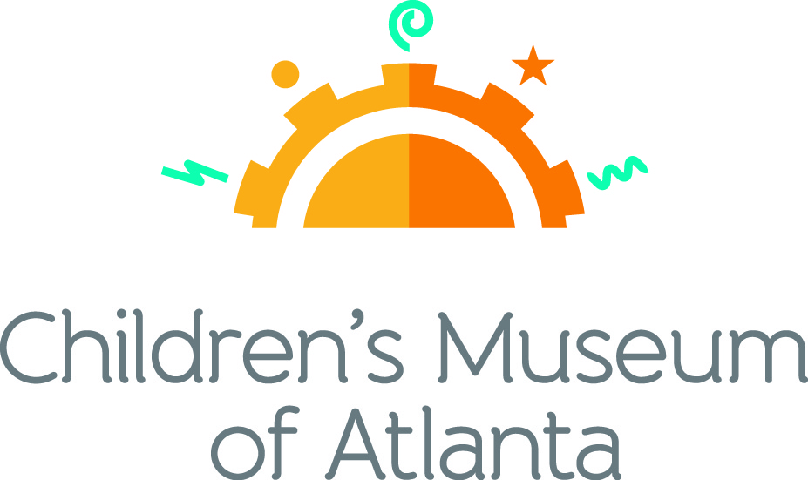

CONTACT
Becca Meyer/Jennifer Walker
BRAVE PR, 404.233.3993
bmeyer@bravepublicrelations.com/
jwalker@bravepublicrelations.com
FOR IMMEDIATE RELEASE

Children’s Museum of Atlanta announces new science educator
Kate Sherrill to lead educational activities as Professor Labcoat

ATLANTA (January 22, 2018) – The Children’s Museum of Atlanta is proud to announce Kate Sherrill as the science educator for the Museum’s STEM programming. Sherrill will serve as the renowned Professor Labcoat, hosting the Museum’s daily Super Spectacular Science Show. She will help kids explore various aspects of the Science Bar which features interactive exhibits about light, robotics and how the human body works.

“Kate brings an incredible wealth of scientific knowledge to the table, and we’re thrilled to have her join our team,” said Jane Turner, executive director of Children’s Museum of Atlanta. “Her spunk and enthusiasm for sharing the world of science with children align with our Museum’s focus on teaching children through the power of play.”

As a science educator for young audiences, Children’s Museum of Atlanta made an effort to choose someone who exuded creativity, passion and a playful attitude. Sherrill’s personality is not only portrayed in her entertaining teaching methods, but also in her custom-made scientific themed clothing which includes a planet covered dress, among many others.

"I think of science as creative problem-solving. Children are natural explorers, and play is the perfect medium for learning to think outside the box,” said Kate Sherrill. “The Super Spectacular Science Show On Ice is one of my favorite activities (not only because the whole audience twirls around with me in their socks on a pretend ice rink) because it encapsulates the ideas I want to impart on our guests: science is everywhere, it’s fun and sometimes we fall down – but we always learn from it!"

Sherrill attended Georgia State University, where she received both a Bachelor of Arts and Master of Arts degree in Anthropology. She will be defending her thesis on the paleodemography of the European Neolithic in spring of 2018.

###

About Children’s Museum of Atlanta:
Children’s Museum of Atlanta is the only educational venue of its kind in Atlanta, presenting educational programs and exhibits designed for young children ages 0-9. The Museum’s mission is to spark imagination and inspire discovery and learning for all children through the power of play. With six permanent learning zones consisting of bright, creative and hands-on exhibits, the Museum supports inventive play-based exploration and experiential learning focused on the whole child. Core competencies for literacy, math and science are promoted throughout all exhibits and programming in alignment with the state and national Core Performance Standards. Children’s Museum of Atlanta also offers parties, memberships, field trips, summer camp and private events. For more information or to support Children's Museum of Atlanta, visit childrensmuseumatlanta.org or call 404.659.KIDS [5437].

Museum Admission: Plan ahead and save! Families can purchase timed tickets online in advance to save money and guarantee entry to the Museum. Babies under 12 months and members are admitted for free. All daily programs are included in price of admission. Group rates and military discounts are available. For more information regarding ticket and membership options, visit childrensmuseumatlanta.org.
Museum Hours: Monday, Tuesday, Thursday and Friday 10 a.m. – 4 p.m.; Saturday and Sunday 10 a.m. – 5 p.m.; Closed on Wednesdays. Please check the Museum website to confirm hours of operation.

Facebook: https://www.facebook.com/childrensmuseumatlanta
Twitter: https://twitter.com/ChildMuseumATL
Instagram: https://www.instagram.com/childrensmuseumatlanta
Pinterest: http://pinterest.com/cmatlanta

