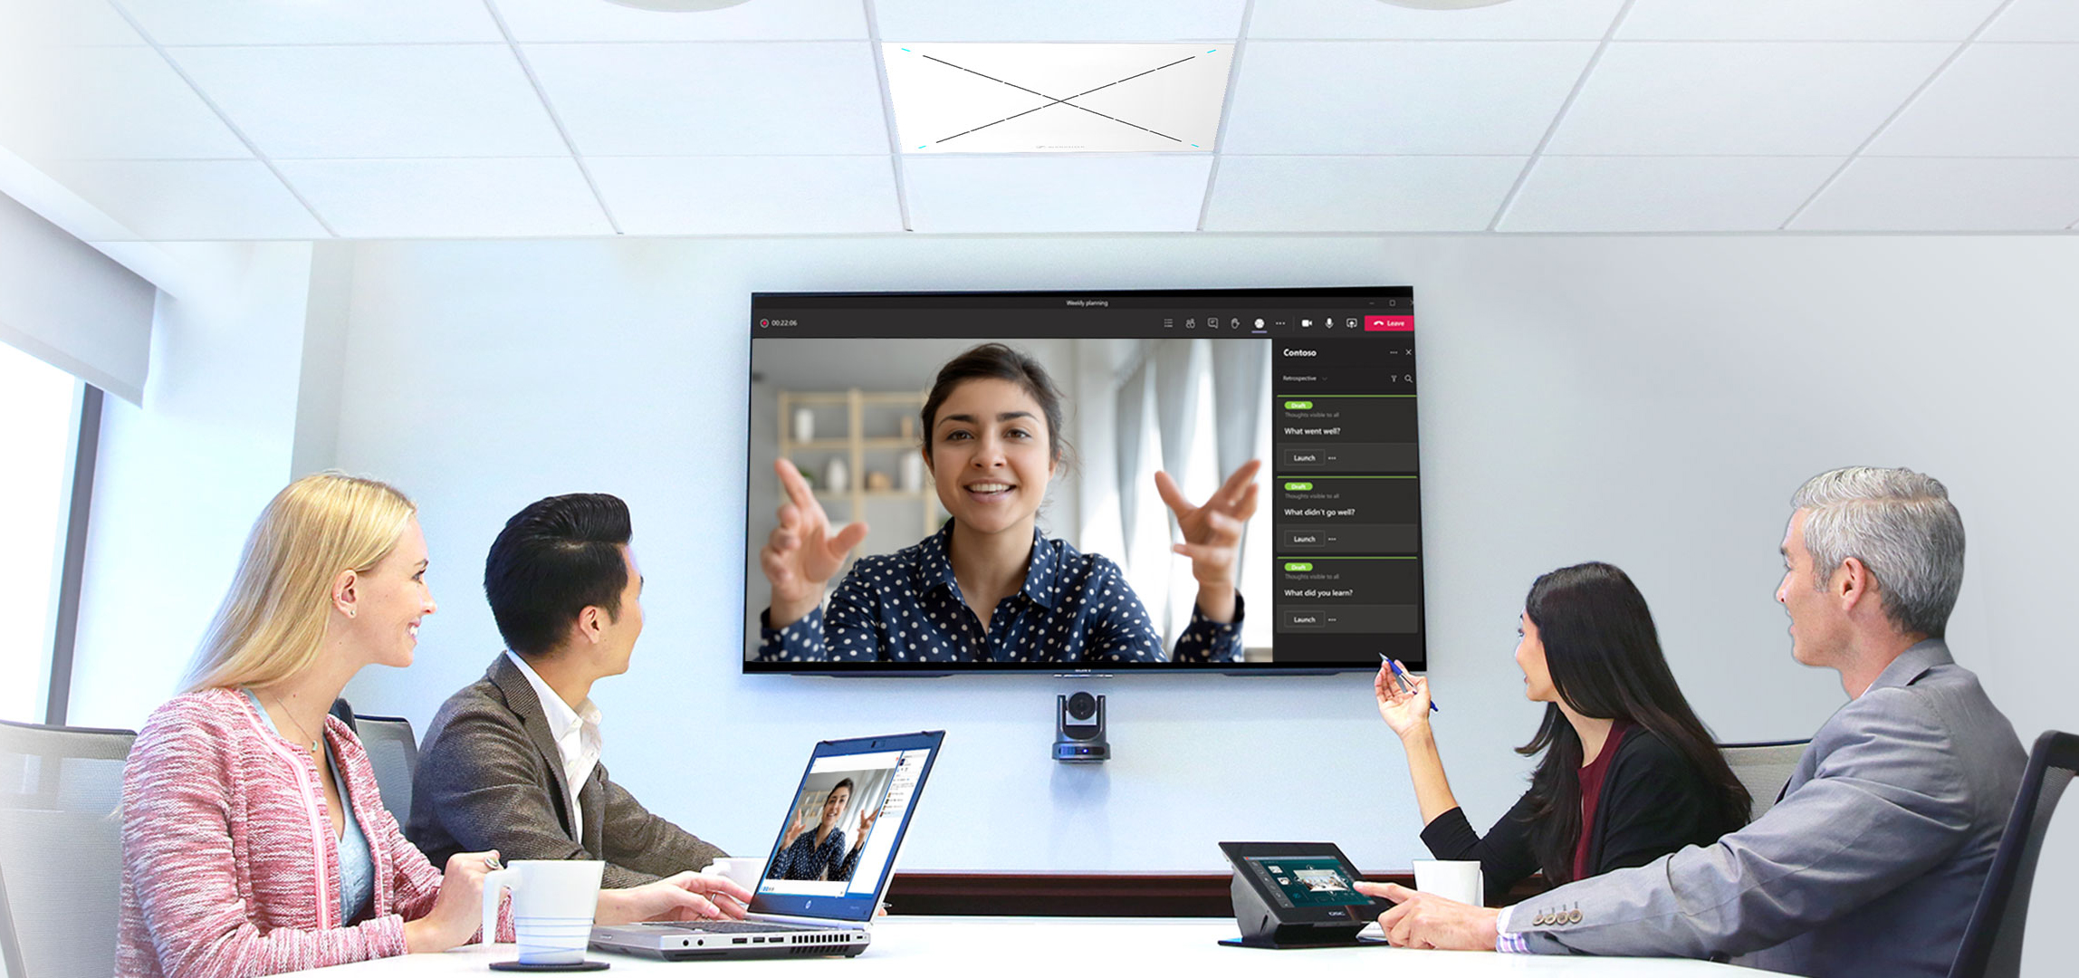
Video conferencing: Sennheiser and QSC help to make the experience more engaging
Register for free online seminars and earn CTS credits

Wedemark, June 7, 2021 – Today’s businesses are ever more reliant on video conferencing, and although the technology has been a true blessing during the pandemic, many participants feel that the whole experience could be a little more natural. In a joint online seminar, Sennheiser and QSC show how interactive technology can help to reduce the perception of distance and increase engagement from remote participants, and the important role that Microphone-Based Camera Steering can play in achieving this. Visit www.sennheiser.com/followme to register and learn more about the combined solution that brings together Sennheiser’s touchless TeamConnect Ceiling 2 microphone and the QSC Q-SYS Ecosystem to make video conferences more natural and dynamic. The AVIXA-certified seminars are available in English and German through June and July. In addition, private demonstrations are possible too.

Two team players to build the optimal audio design for meeting rooms
Both the Q-SYS Ecosystem and TeamConnect Ceiling 2 are IT-friendly solutions that work together seamlessly. Q-SYS is a software-based audio, video and control platform that is scalable, reduces the need for dedicated hardware and eliminates complex integration workarounds.
Sennheiser’s TeamConnect Ceiling 2 is ideal for conferencing and – thanks to its new TruVoicelift feature – for in-room audio amplification, too.

To make virtual meetings even more lifelike, Sennheiser and QSC recommend the Automatic Camera Preset Recall plugin, available for download in Q-SYS Designer Asset Manager within Q-SYS Designer Software. It enlists the TeamConnect Ceiling 2 (TCC2) to deliver signal presence and positioning data from the active talker and in turn, automatically switches the video stream to the appropriate camera in the room and triggers specific camera position presets, resulting in more natural interaction and dialogue for diverse spaces.

Furthermore, Q-SYS allows the plugin to take full advantage of multiple Q-SYS cameras and multiple TCC2 microphones in the room to accommodate even more complex spaces. Lastly, since the camera movement is triggered solely by the presence of the audio signal, the system also offers privacy/security advantages over other solutions that rely on facial or other physical tags. This way, no personal data is collected.

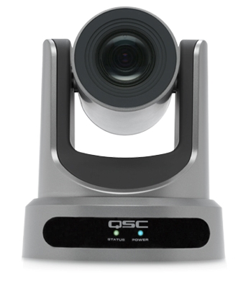
The TeamConnect Ceiling 2 microphone delivers the audio signal to control the camera direction

Seminar details
During this AVIXA-certified seminar, participants will learn more about the Sennheiser TeamConnect Ceiling 2 microphone and Q-SYS by QSC. They can learn how to establish pre-determined preset zones within the space via Q-SYS and use the participant’s proximity to the microphone to trigger the appropriate preset.

Completion of this online seminar is worth 0.5 CTS RUs.

Seminar dates
English seminars will be offered at 10am and 3pm UK time (11am and 4pm CEST) on the following dates:
- June 30
- July 14
Registration for the morning sessions is open at https://zoom.us/webinar/register/WN_SyFk2p_3TtmJE3X6QudD7Q

Registration for the afternoon sessions:
https://zoom.us/webinar/register/WN_NE00e4YLTdCJLGfZvEzr-A

German seminars will be offered at 10am (CEST) on the following dates:
- June 8
- June 22
- July 6
Registration is open at https://zoom.us/webinar/register/WN_OEOdaLSBRSeFtFcvjosQSA

To register or learn more about the solution you can also visit www.sennheiser.com/followme.

In addition to these seminars, customers can also register for a private demonstration to experience the system first-hand.

About Sennheiser
Shaping the future of audio and creating unique sound experiences for customers – this aim unites Sennheiser employees and partners worldwide. Founded in 1945, Sennheiser is one of the world’s leading manufacturers of headphones, loudspeakers, microphones and wireless transmission systems. Since 2013, Sennheiser has been managed by Daniel Sennheiser and Dr. Andreas Sennheiser, the third generation of the family to run the company. In 2019, the Sennheiser Group generated turnover totaling €756.7 million. www.sennheiser.com

Local Press Contacts

Sarah James Maik Robbe
sarahj@gasolinemedia.com maik.robbe@sennheiser.com
+44 (0) 1483 223333 +44 (0) 7393 462484

