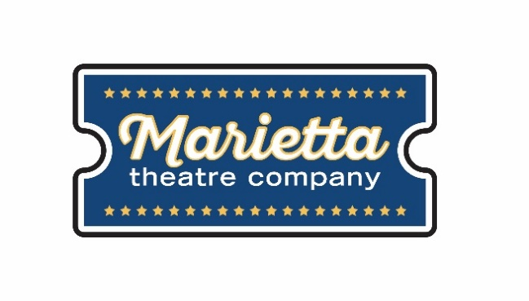

For more information:
Laurel Haislip
BRAVE Public Relations
404.233.3993
lhaislip@emailbrave.com
FOR IMMEDIATE RELEASE

Marietta Theatre Company opens second season with Nunsense, August 17 – September 1
Spectators invited to downtown Marietta for laughs about five spunky sisters!

Marietta, GA (August 6, 2018) – Following a successful inaugural season, Marietta Theatre Company is kicking off its second season with Nunsense, a comedic, over-the-top musical that tells the story of five of the 19 surviving Little Sisters of Hoboken: a one-time missionary order that ran a leper colony on an island south of France. Nunsense, set to run August 17 through September 1 at the Lyric Studio on the Square, is a hysterical comedy written and produced by Dan Goggin, who received the 1986 Outer Critics’ Circle Award for Best Musical, Best Book and Best Music.

“What better way to open our second season than with a production that will have audiences laughing hysterically?” said Blaine Clotfelter, president and co-founder of Marietta Theatre Company. “As an emerging theater company in Atlanta’s bustling arts scene, we are honored and humbled to have received nearly 20 Metropolitan Atlanta Theatre Award nominations for our inaugural season – more than any other theater in the region - and hope this show will set the tone for continued momentum in the year ahead.”

The hilarious musical follows five nuns who discover that, while they were off playing bingo with a group of Maryknolls, their cook Sister Julia accidentally killed the other fifty-two residents of the convent with her tainted vichyssoise. Things go from bad to worse when they forget about four of the nuns and need additional funds for a proper burial. With the deceased nuns on ice in the deep freeze and desperate to raise the necessary amount, they decide to stage a variety show in the Mount Saint Helen’s School auditorium on the set of the eighth-grade production of “Grease” and hilarity ensues all around.

Featuring star turns, tap and ballet dancing along with an interactive audience quiz and comic surprises, this show has made waves as a rip-roaring international phenomenon. The cast is full of comedic characters that audiences will come to know and love, including Reverend Mother Regina (Kelsey South), a former circus performer; Sister Mary Hubert (Hannah Craton), the Mistress of Novices; a streetwise nun from Brooklyn named Sister Robert Anne (Kate Metroka); Sister Mary Leo (Megan Wartell), a novice who is a wannabe ballerina; and the delightfully wacky Sister Mary Amnesia (Sophia Decker), the nun who lost her memory when a crucifix fell on her head.

Nunsense will play at the Lyric Studio on the Square from August 17 through September 1 with shows at 8 p.m. Thursday – Saturday and 3 p.m. on Sunday. Individual tickets ($25) and VIP tables for four which include a bottle of wine ($125) are on sale now at www.mariettatheatre.tix.com. Audiences are also invited to purchase a season subscription and save 20 percent, equivalent to the price of a single show, to enjoy all five shows in Marietta Theatre Company's 2018-19 season, including Nunsense, The Toxic Avenger, I Love You Because, You're a Good Man Charlie Brown and Altar Boyz.

For more information on Marietta Theatre Company and to stay up to date on upcoming season information, please visit mariettatheatre.com or follow along on Facebook and Instagram.

About Marietta Theatre Company:
Marietta Theatre Company (MTC Players, Inc.) is a domestic 501(c)(3) and recipient of 19 2018 Metropolitan Atlanta Theater Award nominations in its inaugural season. The theater is proud of its mission to provide an atmosphere for the community to experience life together and introduce patrons to outstanding local talent all while supporting local charities. To stay updated on Marietta Theatre Company's latest news and performance schedule, join their email list by visiting www.mariettatheatre.com/join-our-email-list/.

###

