SENNHEISER PRESENTS 2019 RESULTS AND ANNOUNCES JOB CUTS
The audio specialist reacts to strong dynamics in the headphone market and the effects of the COVID-19 crisis

Wedemark, July 1, 2020 – The Sennheiser Group has presented its financial results for the fiscal year 2019. The family-owned company generated turnover of €756.7 million; earnings before interest and taxes (EBIT) of €18.5 million were slightly down compared to the previous year. For the 2020 fiscal year, however, the audio specialist expects a significant decline in turnover and earnings and announces that it will cut around 650 jobs by the end of 2022, about 300 of them in Germany. The reasons for the decline are the accelerated dynamics of the headphone market and the long-term effects of the COVID-19 crisis in the consumer and professional business.

“We look back on a rather mixed fiscal year 2019. In addition, we face major challenges this year due to massive changes in the consumer market and the declining demand for audio products because of the COVID-19 crisis. In order to position the company for a successful future, we will adapt our organizational structure to the changing conditions and align it with the new requirements,“ said Daniel Sennheiser, co-CEO of Sennheiser.

“We will continue to focus on our core competencies and further strengthen both our consumer and professional divisions by transferring operational responsibility completely to these two business areas. Sennheiser has always stood for excellent sound quality and extraordinary audio experiences since its foundation 75 years ago – this is what we will continue to stand for in the future,“ added Dr. Andreas Sennheiser, co-CEO of the company.

The adjustment of the organizational structure will result in job cuts throughout the company, particularly in corporate functions such as Supply Chain and Operations. Overall, Sennheiser plans to cut up to 650 jobs worldwide by the end of 2022. The reduction is to be implemented in the most socially responsible manner possible. Measures under consideration include not filling open positions, a voluntary redundancy scheme and severance options in addition to opportunities for partial and early retirement. “We are a family-owned company and every single one of our employees is part of the team. Together we share a passion for audio. With this in mind, these have been very difficult decisions to make and it is important to us primarily to avoid redundancies and to find individual solutions together with employees,” said Dr. Andreas Sennheiser, co-CEO.
Effects of the COVID-19 crisis on the audio market
Since the beginning of 2020, the global effects of the COVID-19 pandemic have also presented Sennheiser with major challenges. "With the cancellation of live events all over the world, the entire event and music industry has been practically brought to a standstill and is only slowly getting back on track. The future of many rental companies, and other service providers is under threat. This is having a significant impact on sales of microphones, which will continue to be reflected in our business performance next year. Exceptions are studio microphones,“ explained Daniel Sennheiser. The effects are also being noticed in Sennheiser’s consumer division: the global headphone market has declined by 30 to 40 percent in recent months, particularly as sales in bricks and mortar retail outlets in many countries were no longer possible at all or only to a very limited extent. Sales of Sennheiser headphones also decreased to the same extent. In order to mitigate the negative effects, Sennheiser had already taken measures in March by starting comprehensive cost reductions and introducing reduced working hours in Germany. Measures to reduce personnel costs and material costs were implemented to the same extent at Sennheiser's international locations.
Review Fiscal Year 2019
Sennheiser looks back on a rather mixed fiscal year 2019: Although the audio specialist was able to achieve strong growth in the professional division, it was below expectations in the consumer business. In total, the Sennheiser Group generated turnover of €756.7 million, which is €46.0 million or 6.5 percent more than in 2018, while EBIT of €18.5 million was slightly below the previous year’s level of €21.2 million.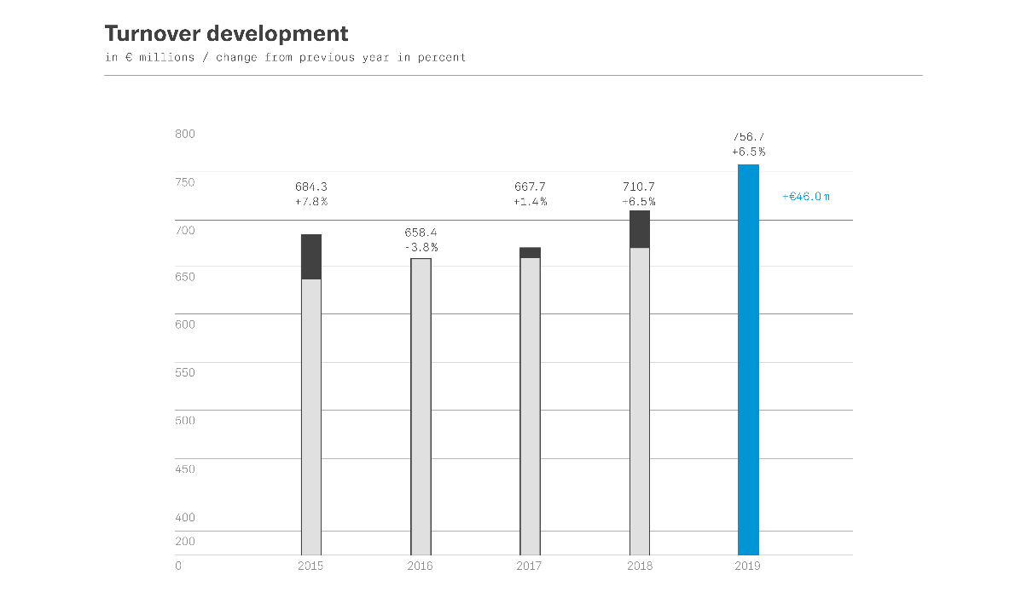
In the fiscal year 2019, the professional division generated turnover of €363.3 million, an increase of 9.2 percent over the previous year. Growth was driven in particular by the product categories of live music, studio recording and business communication. The consumer division generated turnover of €393.4 million. Although turnover increased by 4.1 percent, or €15.4 million, this was significantly below the growth of the headphone market as a whole. Despite the successful launch of new headphone models in the premium segment, the acceleration of market dynamics and increasing competition in the headphone market had a negative impact.

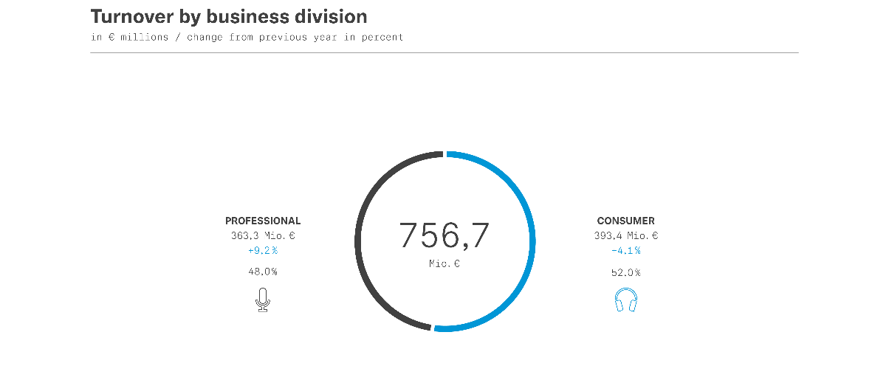

Taking a global view of the markets, EMEA continued to be the region with the highest turnover in 2019 with €382.7 million. This corresponds to an increase in turnover of 6.4 percent or €22.9 million. In its home market Germany, Sennheiser was able to increase turnover by 1.8 percent, or €1.9 million, for a total of €103.1 million. The APAC region recorded the highest increase in percentage terms with 10.6 percent. Total turnover here amounted to €175.3 million. This is €16.8 million more than in the previous year. Growth was driven in particular by the markets in China, Japan and South Korea. In the Americas region, turnover increased by €6.3 million, or 3.3 percent, year on year to €198.7 million.

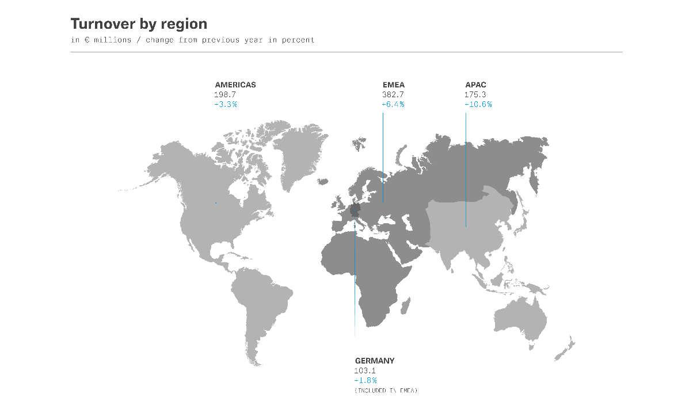

Strengthening development
“To create innovative audio experiences for our customers and to shape the future of the audio industry, we are continuously investing in our development activities,“ said Dr. Andreas Sennheiser. Sennheiser Group's investments in 2019 increased by 4.1 percent to €63 million compared to the previous year, which corresponds to 8.3 percent of turnover. “We will continue to invest in development in the coming years and work closely with our customers and partners.” Sennheiser's technology program AMBEO remains an important strategic component of the consumer and professional divisions.

about Sennheiser
Founded in 1945, Sennheiser is celebrating its 75th anniversary this year. Shaping the future of audio and creating unique sound experiences for customers – this aim unites Sennheiser employees and partners worldwide. The independent family company, which is managed in the third generation by Dr. Andreas Sennheiser and Daniel Sennheiser, is today one of the world’s leading manufacturers of headphones, loudspeakers, microphones and wireless transmission systems. In 2019, the Sennheiser Group generated turnover totaling €756.7 million. www.sennheiser.com
Press Contact
Sennheiser electronic GmbH & Co. KG
Mareike Oer
Head of Corporate Communications
T +49 (0)5130 600-1719
mareike.oer@sennheiser.com

