Neumann Monitors in the Krauthausen Recording Studio: 3D Audio in Reference Quality
13 Neumann monitors ensure reliable evaluation of 3D audio mixes

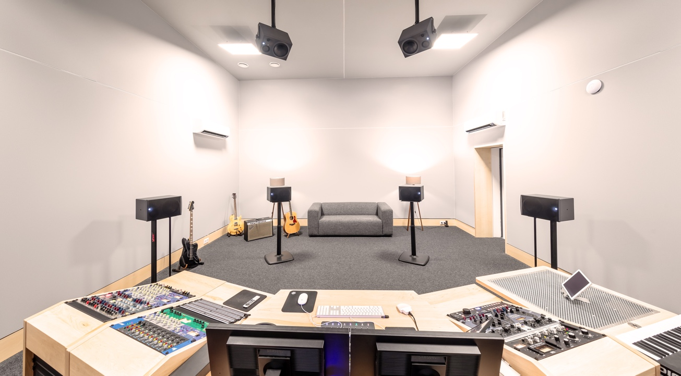

Cologne, Germany, May 4th, 2023 - Since the beginning of the year, the Krauthausen recording studio has enriched the German studio landscape. On the premises of the widely known Media Centre Cologne East, several recording and control rooms designed by the acoustics office Krämer & Stegmaier offer space for recording and mixing projects of many different kinds. In the largest of the three control rooms, 13 (!) Neumann monitors enable a reliable assessment of mixes in 3D audio formats.

Loudspeaker Positioning With Millimeter Precision
A highlight in the newly built sound studio complex is Studio 1 with its 45 sqm control room, in which productions are made not only in stereo, but also in surround sound (5.2) as well as in 3D audio (7.2.4). Speakers of choice for Dolby Atmos and other multi-channel formats are eleven Neumann KH 310 A three-way monitors and two Neumann KH 810 G subwoofers with long-throw 10“-drivers. In the actual setting, the subs are configured as LFE (.2) and are responsible for reproducing low frequencies below 80 Hertz. The electronics integrated into the Neumann woofers take care of signal management in the Krauthausen recording studio: the „7.1 High Definition Bass Manager“ supports formats ranging from mono to surround to 3D audio and is connected to the studio environment via eight inputs and outputs.
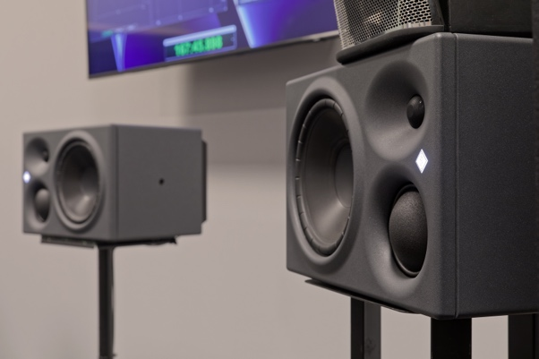
Seven tri-amplified KH 310 A are placed at ear level in the control room using stands. A 3/2 setup according to ITU-775 recommendation (L/C/R//LS/RS with 0/30/110 degrees) is complemented by two rear speakers.
The drivers of the KH 310 A located in the „audience area“ of the control room are protected from unwanted mechanical damage by Neumann GKH 310 metal grilles.

A 16-channel SPL MC16 Mastering Monitor Controller with 120V technology serves as a high-quality control center in control room 1, with the help of which, among other things, individual playback channels can be conveniently switched to solo mode. Nils Dreyer (3ER Professionelle Audiotechnik) was responsible for the analog cabling of the loudspeakers and the other studio electronics. in the digital domain, the Krauthausen recording studio meets audiophile demands with sampling rates of 96 kHz or more.

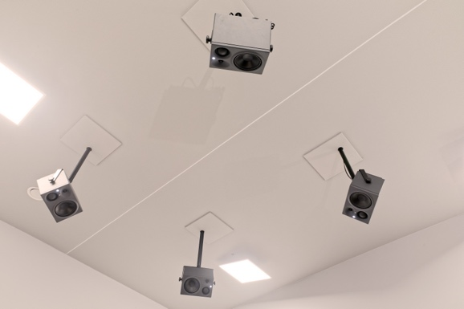
A view towards the ceiling in control room 1 shows four more KH 310 A speakers attached to Neumann LH 46 telescopic ceiling mounts and LH 25 brackets. The circular positioning was chosen so that the overall construction of all Neumann monitors forms an imaginary hemisphere.

The Dolby Atmos specification is met with millimeter precision. In the Krauthausen recording studio, there is no need to electronically set delays, which is necessary elsewhere due to unfavorable spatial conditions.

The studio is prepared for all developments in 3D audio: Invisibly hidden behind the acoustically treated ceiling in control room 1 are additional mounting positions for even more loudspeakers. In the future, these may be used to mix in the Auro-3D format, which competes with Dolby Atmos.

„First the Speakers, Then the Space Around Them!“
Dieter Krauthausen points out that in his new control room 1 the positioning of the loudspeakers was determined before the planning for the surrounding space took place to match: „First the speakers, then the space around them!“ is how the sound engineer succinctly summarises his approach. This approach was made possible because the studio is integrated into a historic industrial hall, which forms the outer shell for the sound production landscape integrated into it. During the calibration of the Neumann loudspeaker ensemble in control room 1, the Dolby consultant was enthusiastic about the acoustics of the perfectly designed control room.
Dieter Krauthausen chose Neumann loudspeakers based on a recommendation from Peter Brandt (Zyrkle GmbH, see below): „For test purposes, I set up two KH 310 A in a stereo configuration, and I was impressed right away“, the sound engineer recalls. „My staff were initially rather skeptical, as they are attuned to other loudspeakers. However, upon trial listening, they immediately accepted the KH 310 A as a first-class alternative to the systems they were familiar with. The Neumann KH 310 A can easily compete with our nearfield monitors from an English manufacturer that we have been using for years.“

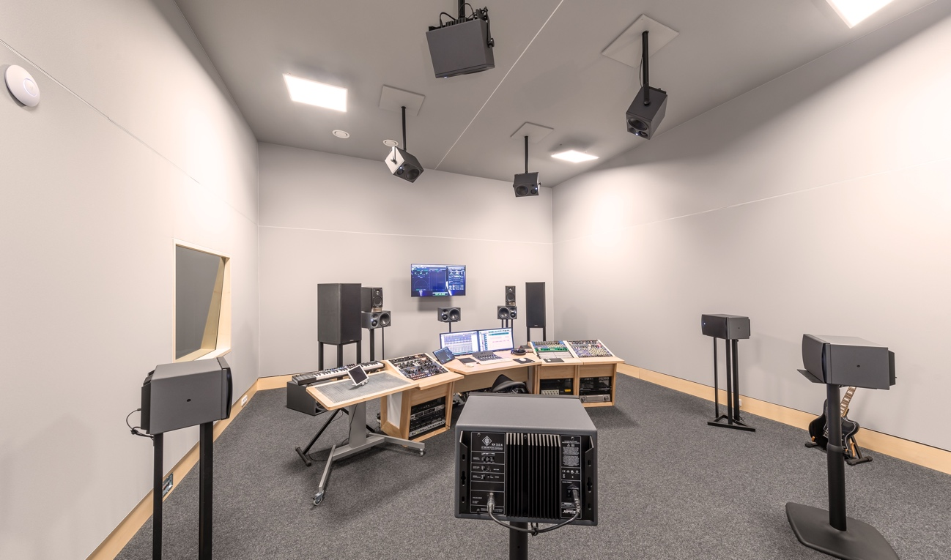

Immersive Sound Experience: Room and Space for the Music
„For me, it was clear from the beginning that 3D audio would be an integral part of my new studio“, says Dieter Krauthausen. „I've been a confirmed fan of 3D audio since I heard such a recording for the first time. Music has much more room to breathe when played back in 3D audio, partly because signals are not limited as harshly as stereo recordings often are these days. Of course, due to compression and hard limiting, the stereo mix is quite a bit louder than a multi-channel 3D mix, but then again, the stereo version usually sounds unpleasantly squeezed. If you think the 3D version is too quiet, you can just turn the volume control ...“

Dieter Krauthausen is certain that 3D audio will be commercially successful in the music context: „When it became obvious that 3D audio would be supported by Apple Music and Amazon Music HD, it was clear to me that the format would now find its way to broad listener groups thanks to relatively authentic playback via Apple's AirPods. Such an exploitation chain without elaborate loudspeaker setups simply didn't exist before, which may have been one reason why SACD and DVD-Audio couldn't establish themselves in the consumer segment.“

Peppermint for the Ears
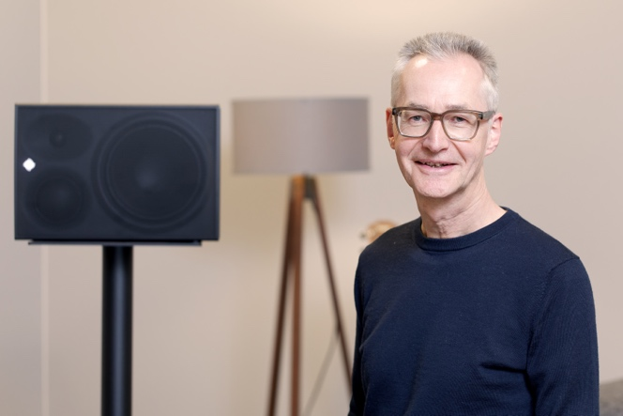
Dieter Krauthausen is always in lively contact with artists of different musical genres and tries to convince them of the advantages of three-dimensional sound reproduction with elevated loudspeaker levels. „Sometimes I almost feel a bit like a preacher in the process“, the experienced audio professional notes with a smile. „It takes time, but I can feel my enthusiasm slowly but surely transferring to the artists, their management, and their record companies. I believe that 3D audio has a great future in the music field!“
If you want to experience a 3D mix by Dieter Krauthausen, you can listen to the sound of the videos for the album „Das Pfefferminz-Experiment“ (to be found on the Blu-ray of the „Deluxe Edition Box Set“) by German rockstar Marius Müller-Westernhagen, which was recorded in Woodstock - among other things, a Decca Tree was used for the recording in an old church.

Remote Revolution: Cooperation With Zyrkle
Dieter Krauthausen works closely with Zyrkle GmbH (www.zyrkle.com), which has also recently found a home on the industrial site east of Cologne. Peter Brandt is the head of Zyrkle - with his new company, the audio entrepreneur has set his sights on nothing less than revolutionizing the live industry and live event broadcasts. Brandt is known in the pro-audio community in particular for his remote recording activities as well as his marketing ideas (keyword: „remote taxi“). Since 2011, Brandt has been, in his own words, a „permanent guest“ in Dieter Krauthausen's studio, which was formerly located in another part of Cologne. The audio liaison is to be continued and intensified in the new premises.

„We have chosen the new recording studio in the Cologne East Media Park as the hub for our future audio activities“, explains Peter Brandt. „In control room 1, we can produce stereo, surround and 3D mixes. Here we can mix live events remotely worldwide! As a first step, we will tackle broadcast mixes, making the audio OB vans otherwise parked outside the venues obsolete. Already this year, we will realize the mixes for the live streams for some renowned festivals in the Krauthausen recording studio. At the concert venue, there will then only be one container with core technology, from which signals will be transmitted directly to the studio's technical room in Cologne. In the future, we also want to produce multi-channel 3D sound live with Neumann monitors in the controlled acoustic environment of control room 1.“

Premium Microphones From Neumann and Sennheiser
It goes without saying that in a studio with the highest quality standards, various Neumann premium microphones are to be found: Three Neumann U 87, two Neumann TLM 170 and two Neumann TLM 103 shape the character of numerous recordings in the Krauthausen recording studio with their unmistakable sound signatures.
Among Dieter Krauthausen's favorites are two phantom-powered Neumann KM 86i small-diaphragm condenser microphones: these not-so-common transducers have comparatively large baskets in which two independent capsules do their work. The directional pattern (omnidirectional/cardioid/eight) is set via a switch below the basket. A worn engraving indicates that at least one of the two vintage microphones once belonged to the legendary English Manor Studio. „I am totally thrilled with the KM 86i!“, states Dieter Krauthausen. „With acoustic instruments, for example, they sound fantastic as a stereo pair; the imaging is just wow!“

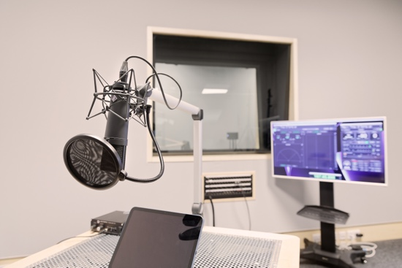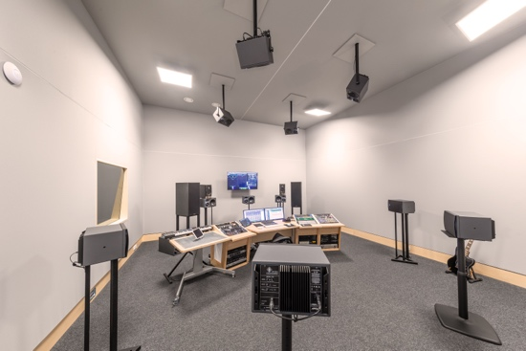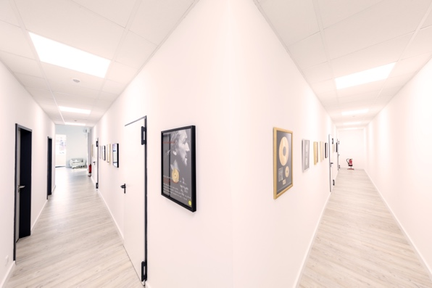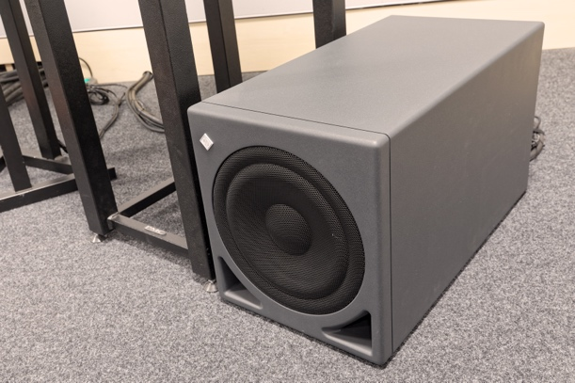

From the Sennheiser portfolio, the MKH 40, MKH 50, two Sennheiser K6, a Sennheiser MD 409 U3, four Sennheiser MD 421, and two Sennheiser MD 441 are used in the Krauthausen recording studio. „During my time with Conny Plank and in the CAN studio, I got to know and love the MD 421 for miking the bass drum“, Dieter Krauthausen reports.
For 3D recordings, Dieter Krauthausen particularly appreciates the Sennheiser MKH 800 TWIN: „The TWIN would be my first choice for the proverbial desert island“, says the experienced sound engineer. „This mic is an absolute dream and is ideal for 3D recordings!“
Neumann and Sennheiser microphones are valued and regularly used in the Krauthausen recording studio as artistic design tools.

Mehr Updates über Neumann auf: FACEBOOK I INSTAGRAM I YOUTUBE

About Neumann
​Georg Neumann GmbH, known as “Neumann.Berlin”, is one of the world’s leading manufacturers of studio-grade audio equipment and the creator of recording microphone legends such as the U 47, M 49, U 67, and U 87.
Founded in 1928, the company has been recognized with numerous international awards for its technological innovations. Since 2010, Neumann.Berlin has expanded its expertise in electro-acoustic transducer design to also include the studio monitor market, mainly targeting TV and radio broadcasting, recording, and audio production. The first Neumann studio headphones were introduced in 2019, and since 2022, the company has increased its focus on reference solutions for live audio. With the introduction of the first audio interface MT 48, and its revolutionary converter technology, Neumann now offers all the necessary technologies needed to capture and deliver sound at
the highest level. Georg Neumann GmbH has been part of the Sennheiser Group since 1991 and is represented worldwide by the Sennheiser network of subsidiaries and long-standing trading partners. www.neumann.

Press Contact Neumann:
Andreas Sablotny
andreas.sablotny@neumann.com
T +49 (030) 417724-19

Raphael Tschernuth
raphael.tschernuth@neumann.com
T +49 (030) 417724-67

