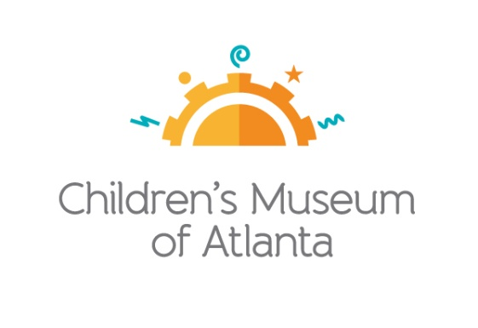

CONTACT
Becca Meyer/Jennifer Walker
BRAVE Public Relations, 404.233.3993
bmeyer@bravepublicrelations.com/
jwalker@bravepublicrelations.com

*MEDIA ADVISORY*
Celebrate Children’s Museum of Atlanta’s inaugural TinyCON, September 2
Families invited for a fun-filled day of Jedi training, Mario Kart races and more!

ATLANTA (August 9, 2017) – Calling all little wizards, superheroes and princesses! Children’s Museum of Atlanta welcomes families for the inaugural TinyCON, celebrating kid-friendly comic books and fantasy world adventures. On Saturday, September 2, little ones can catch ‘em all during the Pokémon Hokey Pokey, build a lightsaber to prepare for galactic adventure during Jedi training, enter the wizarding world to learn the science behind potions from Harry Potter and more! Visitors are encouraged to arrive in costume.

WHAT: TinyCON
Children can celebrate Labor Day weekend with the Museum’s own Tiny Convention!

WHEN: Saturday, September 2 from 10:30 a.m.-4:30 p.m.
The run of schedule is as follows:
- Mario Kart Races: 11 a.m. and 2 p.m.
- Science Bar with Harry Potter potions: 11 a.m.-3:30 p.m.
- Art Studio: Cartooning: 11 a.m.-4:30 p.m.
- Build It Lab: Light Sabers: 11 a.m.-4:30 p.m.
- Pokémon Hokey Pokey: noon
- Star Wars Jedi Training Academy: 1 p.m. and 3 p.m.
- Super Spectacular Science Show: 4 p.m.

WHERE: Children’s Museum of Atlanta
275 Centennial Olympic Park Drive, NW
Atlanta, GA 30313

HOW: General Admission is $15.95 (plus tax) for anyone 1 – 100 years old. Babies and members are admitted for free.

MORE INFO: To learn more or to register, visit bit.ly/TinyCON

For more information or to support Children's Museum of Atlanta, visit childrensmuseumatlanta.org
or call 404.659.KIDS [5437]

###

