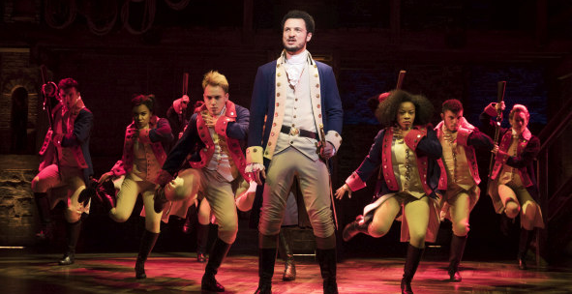Welcome back my friends – Sennheiser’s Digital 6000 Series at the heart of a resurgent West End
Autograph Sound are supplying close to 300 channels of Sennheiser’s 6000 Series as London’s legendary West End theatre scene recovers

London, 6 December 2021 – The “ghost lights” are gradually disappearing from London’s theatres as the world learns to live with COVID-19. One by one, the household-name shows which bring so much joy, colour and revenue into the most vibrant theatre scene on earth are returning, and the audiences with them. As ever, Sennheiser wireless technology takes centre stage, with Hamilton, Les Misérables, Phantom Of The Opera and Disney’s latest production Frozen just some of the shows currently relying on Sennheiser’s Digital 6000 wireless systems.
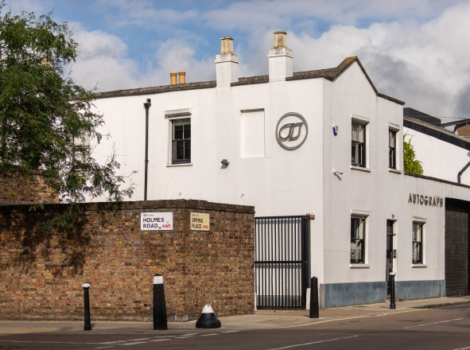 | Autograph’s headquarters in North London

The association between Autograph and Sennheiser is a long one, reaching back to 1984 when the former first used the famous MKE sub-miniature microphone on Starlight Express to help deal with the high levels of on-stage noise. Autograph’s first purchase of complete Sennheiser wireless systems was for another Lloyd Webber musical, Aspects Of Love in 1989, a 21-channel system of EM 1036 receivers with SK 2012 transmitters. In the intervening years, Autograph’s Sennheiser inventory has kept pace both with evolving technology and continuing demand from leading sound designers – now, in late 2021 where the entertainment industry is very much in a recovery phase after the unimagined devastation of COVID, Autograph’s commercial partnership with Sennheiser continues to develop.
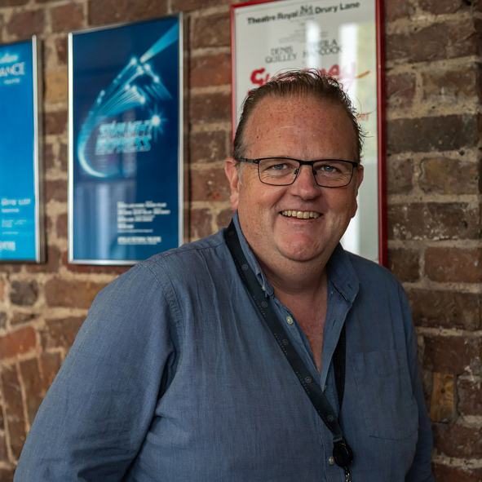 | Scott George, Autograph’s Operations Manager

Autograph’s Operations Manager Scott George comments, “In recent years Autograph has developed into a true full-service operation, providing sound design, equipment rental and sales, event supply, technical support, consultancy, infrastructure design and installation, training, product development and more. In terms of our sound rental operation however, our first objective is always to provide what sound designers specify.
“The designers for the eight London shows currently using our 6000 Series inventory specified that system in preference to anything else. The calibre of the designers we work with and the shows they deliver speaks volumes about the high regard in which Sennheiser’s wireless systems are held within top-end theatre.”
The sheer numbers of channels in simultaneous use on the current roster of shows is breathtaking, especially when compared to Autograph’s first use of wireless in 1981, when the Andrew Lloyd Webber / Cameron Mackintosh production of Cats used just six, for the principals only. Frozen, Les Misérables, Phantom and Tina are all using over 40 channels each, while Hamilton, Pretty Woman and Wicked are all 30 or more. Dear Evan Hansen features a relatively modest 12 channels while, away from London, the current touring production of Beauty And The Beast uses no less than 50 channels of the Digital 6000 Series.
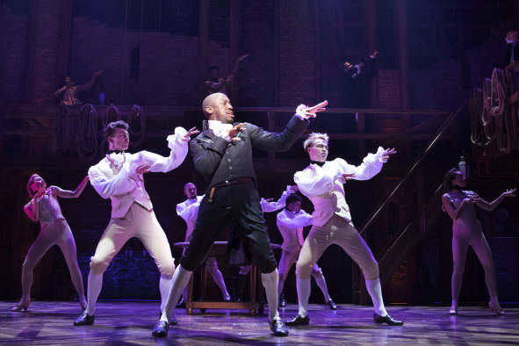 | The West End production of Hamilton uses over 30 channels of Sennheiser’s Digital 6000 Photo credit: Matthew Murphy

“As a long-standing partner of Sennheiser, Autograph have certainly been instrumental to the success of Digital 6000 in the theatre market over the past few years,” concludes Kevin Gwyther-Brown, Business Development Manager Pro Audio at Sennheiser. “It’s great to see Autograph’s level of support to their customers is resulting in more shows using our technology going their way. Long may this strong relationship continue.”

(Ends)

The high-resolution images accompanying this press release can be downloaded here.

About Sennheiser
Shaping the future of audio and creating unique sound experiences for customers – this aim unites Sennheiser employees and partners worldwide. The independent family company, which is managed in the third generation by Dr Andreas Sennheiser and Daniel Sennheiser, is today one of the world’s leading manufacturers of headphones, microphones and wireless transmission systems. In 2020, the Sennheiser Group generated turnover totaling €573.5 million. www.sennheiser.com

