Sennheiser and PXL reimagine Synrise with GOOSE
Belgium band celebrates second album’s tenth anniversary with new development in immersive mixing

Kortrijk, Belgium, November 24, 2020 – Belgium electronic rock band, GOOSE, has a fanbase that spans Europe. They have produced four albums and headlined at major festivals including Rock Werchter, Pukkelpop and Tomorrowland. 2020 marks two decades of success and also sees them celebrate the tenth anniversary of their second album, Synrise, the cover of which, interestingly, was designed by British graphic designer, Storm Thorgerson, well-known for producing many of the legendary Pink Floyd album covers. To mark the occasion, and to give their fans something special in these strange and challenging times, GOOSE collaborated with Sennheiser and the Music Research Expertise Unit of Belgium’s PXL University of Applied Sciences and Arts to produce an extraordinary binaural recording and mix of the album’s title track, which was released on 22nd October.

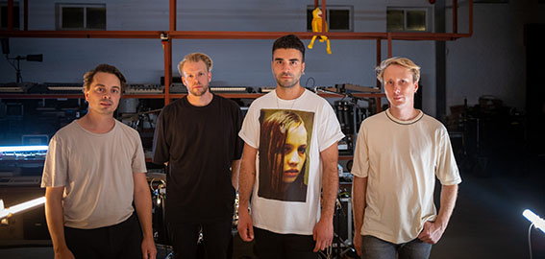
GOOSE, left to right: Dave Martijn, Bert Libeert, Mickael Karkousse and Tom Coghe

Picture courtesy of Universal Music Belgium

GOOSE - Mickael Karkousse (vocals/synth), Tom Coghe (synth), Dave Martijn (synth) and Bert Libeert (drums) - is never afraid to think outside of the box when it comes to developing new ideas in terms of music production and live shows. When the idea came to record an immersive version of Synrise, both Sennheiser and PXL, known for pushing the boundaries of innovation in audio technology, saw an opportunity to deliver something new and significant in the development of immersive audio.

“A couple of years ago, we were introduced to immersive sound for multiple applications; such as a new way of live mixing and of experiencing live music in a room, or by using the technology as musicians in our IEMs,” says GOOSE. “To be honest, none of these applications seemed useful to us. We love the simplicity of a good old rock ’n roll show; speakers left and right and a crowd jumping up and down. But now that this is all gone for an uncertain amount of time, we were looking for ways to engage with our fans. And suddenly the immersive technology made complete sense. Not as an effect or as a geeky experiment, but to help us to tell our story.

“It’s our answer to all the streaming shows; the way we have always looked to build a real connection with our fans. And streaming in poor video and audio quality wasn’t up to both our fans’ and our own standard. So integrating immersive sound in a live recording shot in one take by one of our best Directors of Photography, Maximiliaan Dierickx, was the only way forward.”

Working with GOOSE was, according to PXL’s Tom Van Achte and Arthur Moelants, a natural process. Deciding on a binaural mix, which filters the sound, tricking the brain to believe a source comes from any given direction, the team at PXL partnered with Sennheiser for the project, knowing the audio experts’ AMBEO 3D immersive recording solutions, particularly the AMBEO VR Mic, would be ideal for delivering the results they were looking for.

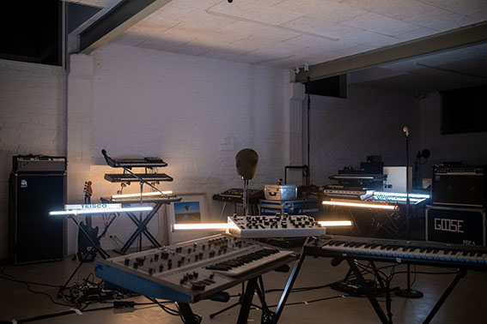 | The GOOSE set-up in the Safari Studios  Picture courtesy of Universal Music Belgium

“At PXL, we are researchers in immersive audio, so we know the recording set up is always the starting point, and you have to be aware of what the output will be,” says Van Achte. “For Synrise, we made the decision to record many sources and use many mics. The position of the band in the room was crucial, but by fortune that’s also how they rehearse, so it was a good starting point. We were in the lucky position where Sennheiser and Neumann supplied everything we asked for, along with some additional options such a Neumann KU 100 Dummy Head mic, which we used as a reference for the video editor, but in essence was a research tool for us.”

“In ‘normal’ live circumstances, we would use a stereo PA to amplify our sound,” explains GOOSE. “This means that all our instruments would come from only two directions: left and right. For the recording, we set up amps behind each musician and made an organic mix that was perfect in the centre of the room as a reference point, but it was crucial that it also sounded great at any point in the room. This has the advantage that when the camera travels in the room, it records the sound of the exact spot the cameraman finds himself in. Adding to that, PXL set up microphones in each corner of the room to record the full spectrum of sounds, giving us the opportunity to record the room completely. All these tracks were used in the final mix to give you an optimal sensation of being in the room with us.”

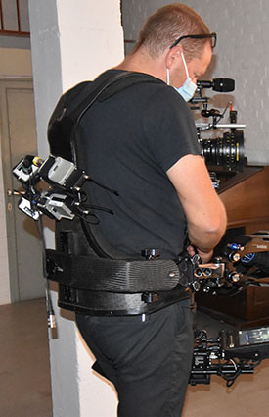 | The camera mounted AMBEO VR Mic with four SK 6000 bodypack transmitters for wireless operation

Whilst spot mics were used in the mix to ensure the audio came from the correct place relative to the position of the camera, making for a more natural experience, a Sennheiser AMBEO VR Mic was also mounted on the camera, using four SK 6000 bodypack transmitters for wireless operation to allow the cameraman free movement around the room. The drum kit was close-miked using two Neumann TLM 103s for overheads, a Neumann KM 184 for the hi-hat and two Sennheiser e 904s for toms, with electronic samples used for kick and snare. A Sennheiser e 935 was used for the drummer’s vocal and two Neumann KMS 105s were deployed for additional vocals. Four overhead Sennheiser MKH 8020 omni mics were also used in the mix, as the camera did not only move horizontally around the room, but also vertically, so these opened up the overhead layer.

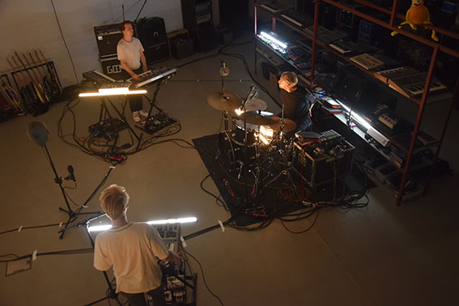 | A mixture of spot microphones picked up the band, while Sennheiser AMBEO VR Mics were used as main microphones for immersive audio. The Neumann KU 100 binaural head served as a reference for the video editor

The final result is a combination of the AMBEO VR Mic mixed using the dearVR Ambi Micro plugin, with direct lines from the synths and mics, giving a balance between AMBEO and the multitrack recording. All sources, with the exception of the AMBEO VR Mic, were automated in a DAW according the movement of the camera, the movement of the video being a vital component in being able to follow where the sound is coming from.

“It’s more our overall vision and the position of the mics that’s important,” Van Achte explains. “With the help of Frank Voet, GOOSE’s FOH engineer, we took a day to get the sound we wanted into the mics. We did it ‘old school’, just by listening. It sounds logical, but people forget. The choice of mics also determines part of the sound and there were not many alternatives to the VR mic on the camera.”

“The result was exactly what we had hoped for,” concludes GOOSE. “The camera invites you in the room with us and as a listener/viewer you really have the impression that you are hearing the sound of the room. When you stand closer to Dave you will hear his parts more upfront than when standing in front of Bert’s drums. Really like you were in the room with us walking around in the studio room.

“We are particularly proud that we used this technology from a musician's/producer’s point of view. We love live instruments and love to record them in the most organic way. And this is exactly what we did.”

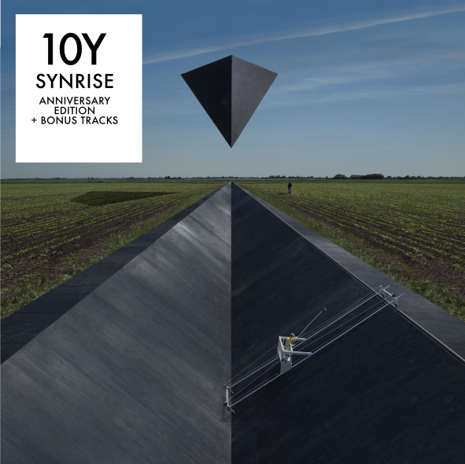 | Cover of the 10Y SYNRISE album

Watch the YouTube recording here or listen on Spotify.
Goose on Instagram: https://www.instagram.com/wearegoose/

ENGINEERED AND MIXED BY
PXL

EXECUTIVE PRODUCERS
Universal Music Belgium
Safari Studios

SUPPORTED BY
Sennheiser
PXL

The high-resolution images accompanying this press release can be downloaded at https://sennheiser-brandzone.com/c/181/G3gkdhQr.

About Sennheiser
Founded in 1945, Sennheiser is celebrating its 75th anniversary this year. Shaping the future of audio and creating unique sound experiences for customers – this aim unites Sennheiser employees and partners worldwide. The independent family company, which is managed in the third generation by Dr. Andreas Sennheiser and Daniel Sennheiser, is today one of the world’s leading manufacturers of headphones, loudspeakers, microphones and wireless transmission systems. In 2019, the Sennheiser Group generated turnover totaling €756.7 million. www.sennheiser.com

Local Press Contact

Ann Vermont
ann.vermont@sennheiser.com
+33 (0) 1 49 87 44 20

