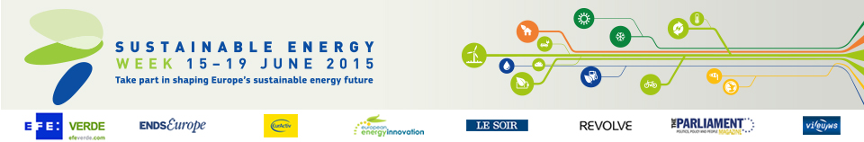

Energy Days in the Netherlands (7)

- Smart City Event
Date: 02/06/2015 - 05/06/2015
Time: From 8:00 to 20:00
Location: Amsterdam

- An Innovative Truth VII - Sustainable ICT & Energy Conference
Date: 15/06/2015
Time: From 12:30 to 19:00
Location: Eindhoven

- Warffum@Work
Date: 15/06/2015
Time: From 19:30 to 22:30
Location: Warffum

- Energy Day - ERAC
Date: 16/06/2015
Time: From 12:30 to 18:00
Location: 's-Hertogenbosch

- Ways of balancing decentralised energy supply
Date: 17/06/2015
Time: From 14:00 to 17:40
Location: Groningen

- Erasmus Energy Forum
Date: 18/06/2015 - 19/06/2015
Time: From 8:30 to 16:10
Location: Rotterdam

- African Energy Day in Bergen - Holland
Date: 18/06/2015
Time: From 19:00 to 21:00
Location: Bergen N-H

