The True Spirit of Giving: Sonarworks Offers 40% Black Friday Discount on True-Fi,
to also Include NEW Mobile App ‘Early Access’
With over 250 headphone models supported, Award-Winning True-Fi software is poised to be
the ultimate gift for music lovers this holiday season
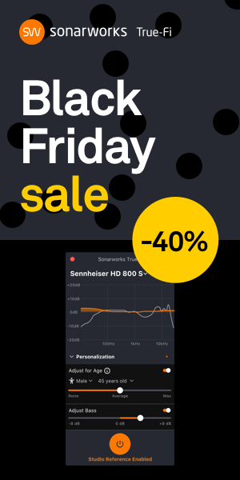
Riga, November 14, 2018 – Innovative European audio software developer Sonarworks announced that it will offer a spectacular 40% Black Friday discount off of its groundbreaking True-Fi headphone calibration software. For four days only, between November 23 and November 26 on Shopify, music lovers will be able to access the full desktop version of True-Fi, and also gain ‘early access’ to the company’s forthcoming mobile application at no additional charge on November 29th.

Having made its U.S. debut at the 2018 Consumer Electronics Show, True-Fi enables fans to listen to music exactly as it was intended by the artist. By using a patented calibration system and advanced filtering algorithms, True-Fi is able to align the frequency response of more than 250 supported headphones — including models from AKG, Beyerdynamic, Focal, Sennheiser and many others. The new mobile app, which is scheduled to launch at CES 2019, makes True-Fi the ultimate application for listening to music anytime, anywhere — without compromise.

“There is no better time to become a True-Fi customer,” commented Janis Spogis, VP and Partner, Sonarworks. “Our Black Friday promotion — which is here just in time for the holidays — not only offers a significant discount on our groundbreaking True-Fi platform, but a lifetime of listening pleasure.”

Sonarworks will be offering early access to the trial version of the True-Fi mobile application to encourage community feedback as it reaches the important milestone for version 1.0 release — to occur during CES 2019. The mobile application — which is the ultimate gift for travelers — will run natively on iOS and Android devices and promises to redefine the mobile listening experience. The new application will support a range of file popular audio file formats. It will also support and manually sync local content sources including iTunes local music library and Spotify (Premium account required).

Both the desktop application and the forthcoming mobile application offer support of personalized listening preferences, so users can apply age-related hearing loss compensation and gender-based adjustments, as well as create customized sound preferences.

During the Black Friday promotion between November 23 and 26, customers will get a 40% discount during checkout on Shopify.com. For more information about Sonarworks' True-Fi, please visit https://www.sonarworks.com/truefi. For a list of supported headphones, please see https://www.sonarworks.com/truefi/headphones.

About Sonarworks
Sonarworks is a Europe-based audio software development company specializing in acoustic calibration and DAW plugins. The company was founded in 2013 and entered the pro audio market in 2015. Sonarworks software, which has received several prestigious industry awards, is relied on by many Grammy winning artists and engineers, and its software is present in more than 30,000 studios around the world.

Media Contact:
Jeff Touzeau
Hummingbird Media
+1 (914) 602-2913
jeff@hummingbirdmedia.com

