1 September, 2022

**APPRENTICESHIP ACADEMY TAKES THE LEAD**

**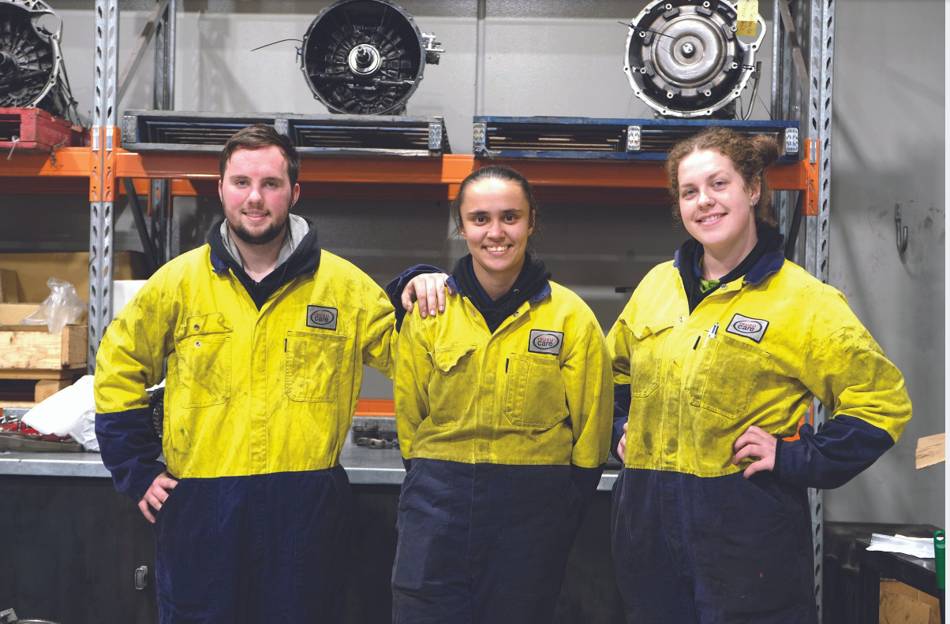***Image: Dandenong apprentices Thomas Moorman, Kristen DaSilva and Madeleine Sutton*

Doing their bit to combat the startling rate of apprenticeship dropouts and skills retention across Australia, two innovative Melbourne-based Isuzu truck dealerships have teamed-up to establish their own training academy.

A group of 12 apprentices are now more than halfway through their first year at the [Westar and Patterson Cheney Apprentice Academy](https://www.westar.com.au/apprentice/).

Westar and Patterson Cheney Truck Group Training Coordinator Peter Sherry said the response to the academy had been resoundingly positive, with more than 30 applications received for the first 12 apprenticeships positions.

Under the Academy program, apprentices partake in a range of paid work and training and attend TAFE together every two months.

Mr Sherry said the aim was to build a strong camaraderie among the participants to help them feel more committed to finishing their apprenticeships.

For a range of reasons, many Australian trades currently experience high levels of apprentices not completing of their training.

**High Dropout Rate**

According to the latest research by National Centre for Vocational Education Research (NCVER), one third of all first-year apprentices and trainees do not complete.

In its [Completion and Attrition Rates for Apprentices and Trainees 2021 report](https://ncver.edu.au/research-and-statistics/publications/all-publications/completion-and-attrition-rates-for-apprentices-and-trainees-2021), released on August 11, the NCVER said that less than half of the apprenticeships begun in Australia in 2017 had been completed.

Mr Sherry said the combined dealership initiative decided to take the bull by the horns to encourage young people to consider a career as a truck mechanic. The group works with training and government organisations to reach out to young people who might be interested.

“We actually put some of them into our dealership one or two days a week so they can see whether they like it before they commit,” he said.

Through the Apprenticeship Academy, an apprentice can become a qualified heavy commercial vehicle technician or an auto electrician, with training in all areas of the service and pre-delivery areas.

During the four-year program, the apprentices will complete a Certificate III in Heavy Commercial Vehicle Mechanical Technology (AUR31120) or Certificate III in Automotive Electrical Technology (AUR30320) through the Kangan Institute at the Automotive Centre of Excellence in Melbourne’s Docklands.

The apprentices will also have the opportunity to obtain a forklift licence, first aid qualifications, a truck licence, Certificate II Automotive Air Conditioning and Arctic A/C refrigerant handling licence.

**Free Toolkit**

To sweeten the deal, everyone accepted into the Patterson Cheney Apprenticeship Academy is also given a starter toolkit worth $4,000.

“We place the apprentices in our three dealerships,” Mr Sherry said. “We have five participants in Dandenong, six at Westar in Derrimut and two in Campbellfield, which is now expanding and doubling its workshop size.”

The first intake in the Patterson Cheney Apprenticeship Academy range in age from 16 to late-20s and include a mix of male and female apprentices.

As part of their training this year, the group visited the Isuzu Australia Limited (IAL) head office to watch the final of the [Isuzu National Technical Skills Training Competition](https://content.isuzu.com.au/news-media/isuzu-techs-set-to-take-on-the-world/) to get an idea of the training opportunities for Australian truck mechanics.

“The opportunity came for them to observe the competition, to see what goes and obviously we hope they’d be involved with it one day,” Mr Sherry said.

“It’s also important for them to see the level of professionalism of the IAL guys so they can replicate that in the dealerships.

“It’s not just bringing dirty old trucks into workshops and getting oil changed and getting themselves dirty as well. There’s quite a lot of nous that goes into diagnosing. Hopefully they can take some hints back to the workshop.**”**

**Women in Trucking**

Kristen Da Silva, a first-year apprentice at the Patterson Cheney dealership in Dandenong, said she was enjoying her training as a truck technician.

“As a kid I was always fiddling with things and putting them together.

“Eventually I decided I wanted to be a truck mechanic.”

Kirsten encouraged other young women to consider a trade as a career.

“If anyone says don’t do it, it’s a man’s job, don’t listen to them,” she said.

Madeleine Sutton is also a first-year apprentice at the Patterson Cheney dealership in Dandenong.

Previously a restaurant manager, Madeleine was looking for a career change when she found the Patterson Cheney Apprenticeship Academy advertised on Seek.com.au.

“I did want to be a truck driver when I was little, so I’ve revolved back to the truck aspect,” she said.

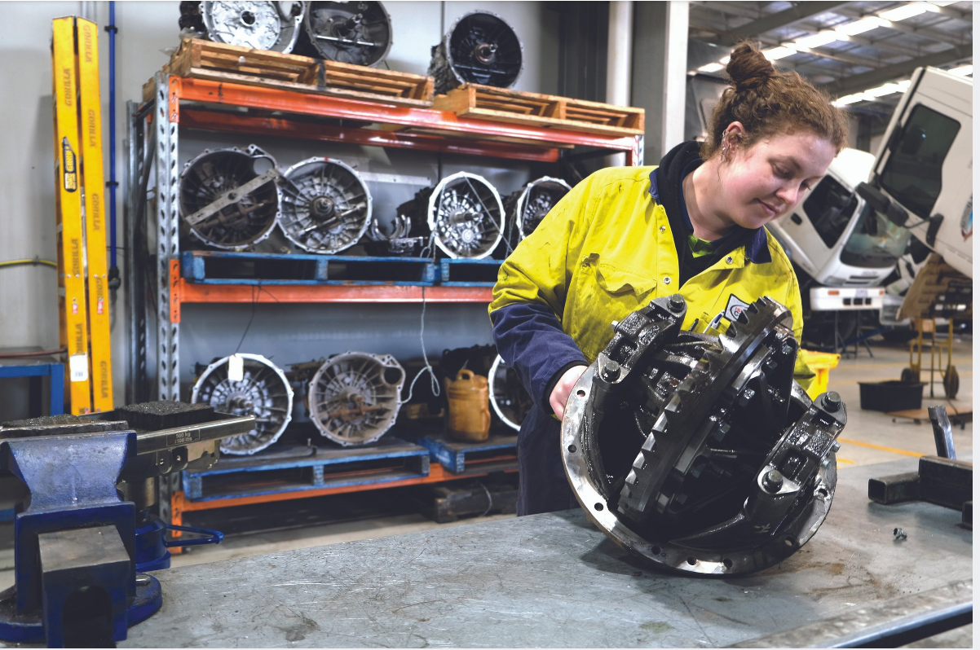

Madeleine had some automotive experience from working on her own car.

“It turns out it’s a bit cheaper to be able to work on it yourself.”

Patterson Cheney is planning another intake of 12 to the Apprenticeship Academy next year, and possibly even a mid-year intake.

“It’s a way of helping the Service Managers pick the right candidates for technician positions,” Mr Sherry said.

“Trucking is one of the most stable industries for people to start their careers.

“As was really hammered home during the last few years of covid, trucks are vital to the transport and service industries and to the Australian economy.”

**ends**

**For further information, please contact:    For Isuzu Trucks releases and photos:**

Sam Gangemi                                                      Arkajon Communications

Isuzu Australia Limited                                       Phone: 03 9867 5611

Phone: 03 9644 6666                                           Email: [isuzu@arkajon.com.au](mailto:isuzu@arkajon.com.au)