For more information, please contact Marta de Paco
On +34 670 780 664 or email press@comunicahair.com

Important:
These images are only available for editorial content.
Credits must be included.
Notification of their publication is expected.

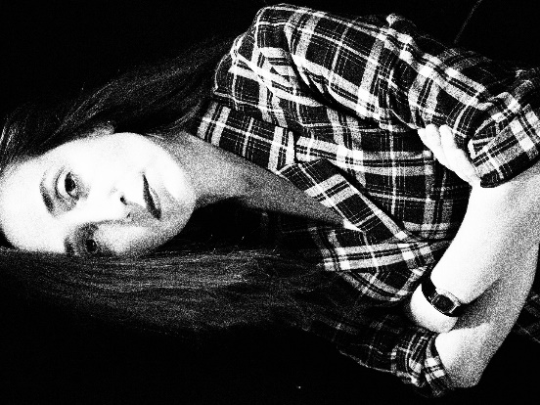
PELSYNERA
CON Collection

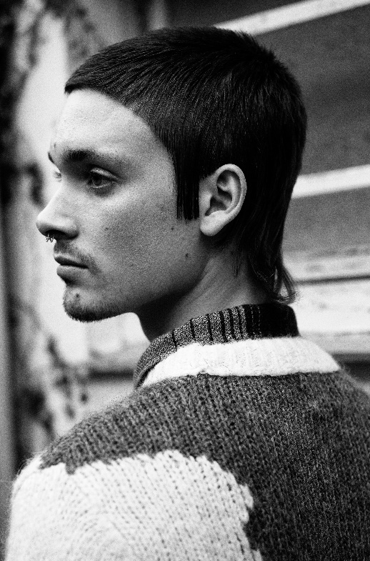
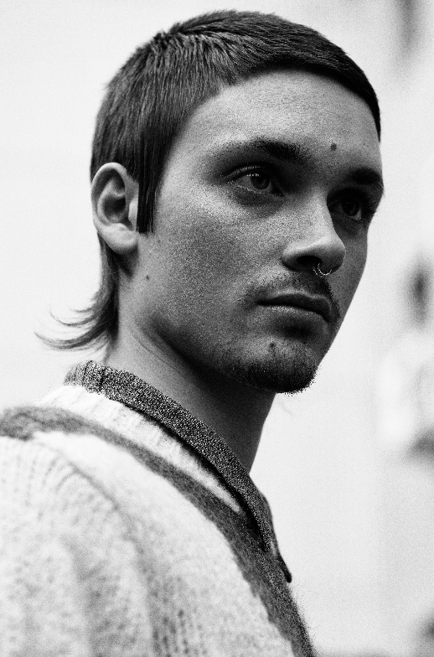
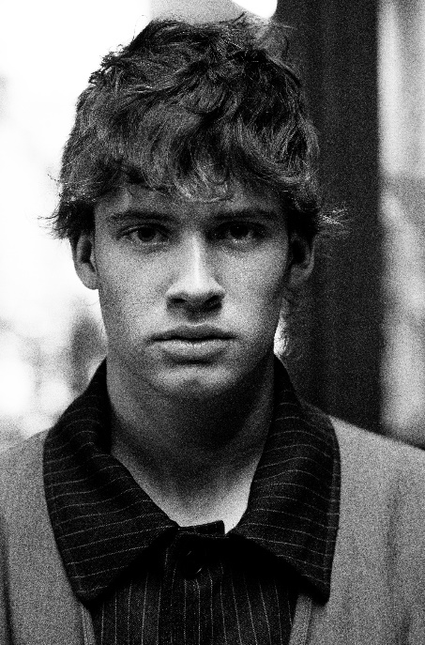

Hair: Sonia Neri @ Pelsynera
Instagram: @Pelsynera
Photographer: David Arnal Instagram: @Davidarnalteam
Make up: De Maria Instagram: @de_maria

PELSYNERA
CON Collection

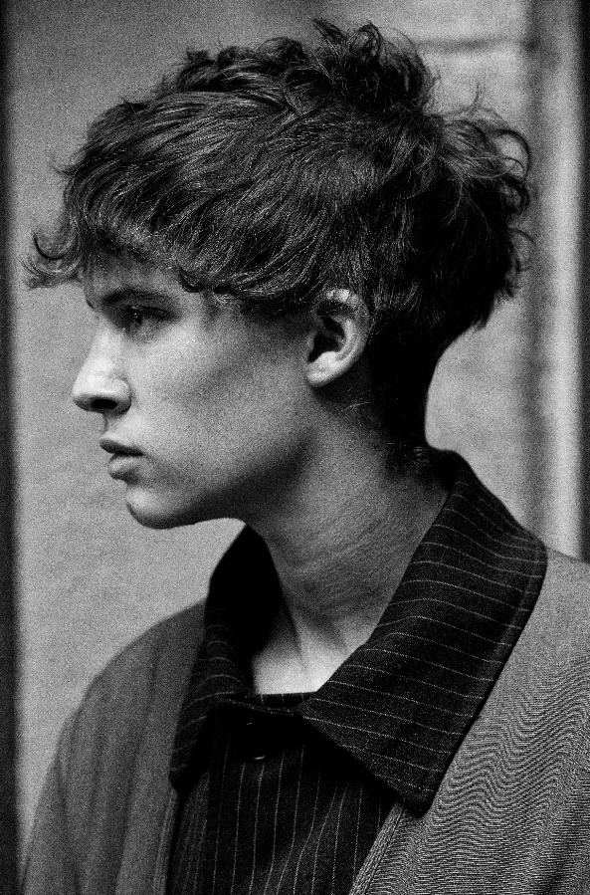

This collection is like a game of perspectives, a dance of adverbs that invites us to change our thoughts depending on the point of view from which we observe. Perfect and polished contours that become longer strands on the nape, rich textures that are combined with lighter ones. It is all about believing in a surprising reality that deserves to be known from all its nuances.

