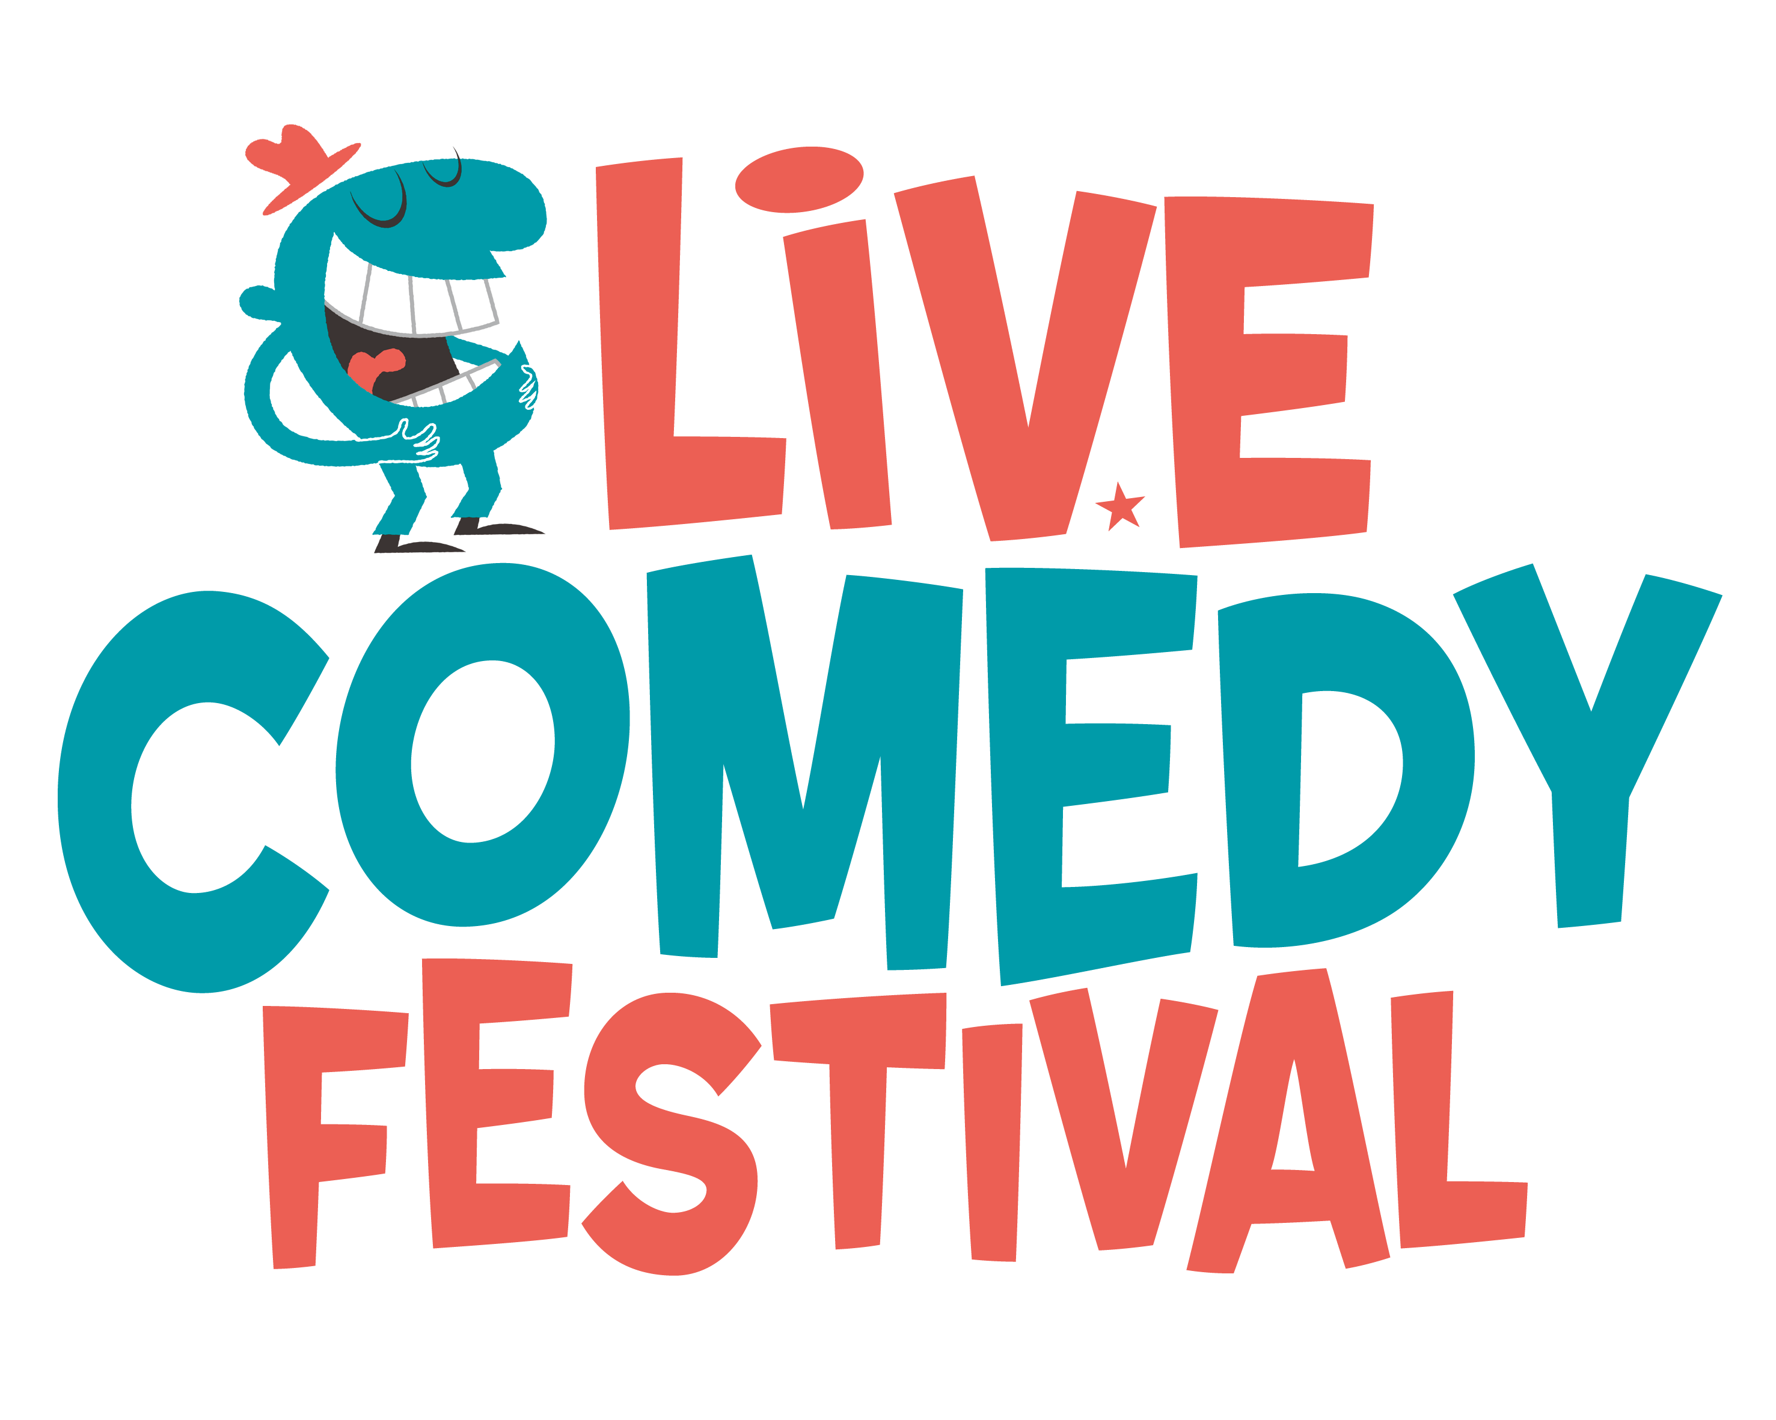

JIMMY CARR headlines
International Live Comedy Festival in Antwerp

Live Comedy Festival is an international comedy festival that will take place from 26th September in four theatres in Antwerp for two weeks. New names are:

JIMMY CARR (UK)
DANIEL SLOSS (UK)
JEROEN LEENDERS (B)

With Stephen Merchant, Jack Dee, Hans Teeuwen & The Painkillers, William Boeva, Begijn Le bleu and Jan Jaap Van der Wal, the festival bill is impressive.

More names will be added soon. All events are on sale from today.

Live comedy.be, founded by Tom Bertels, is a promoter of Flemish, Dutch and English comedy events in Belgium.

Why the need for this festival?

A lot of big cities in the world have their own comedy festival. In Flanders that is not yet the case and we would like to change that. The focus is on international comedy, but you can also see Flemish and Dutch stand-up comedians.

The Flemish people are ready to go to comedy events in English. A lot of Flemish people can understand English and have already discovered comedy in English via YouTube and television. There are also people with different nationalities who live here or who spend their holiday in Flanders and speak English as a second or third language. A lot of them also really like comedy, so they will be very excited to hear about this.

Jimmy Carr
Jimmy Carr, one of the most original and distinctive stars of television, radio and the stage, is bringing his show to Belgium for the first time. This is part of a 250-date tour where he will perform in the UK and Ireland as well as playing three arena shows in South Africa.
On top of his mammoth touring schedule Jimmy has been the host of Channel 4’s 8 Out of 10 Cats, has performed three times in front of His Royal Highness the Prince of Wales, sold 1.2 million copies of his DVDs and 1.5 million tickets for his live shows. He has won awards as Funniest Comic, Funniest DVD, Funniest Man, Best Stand Up Tour, Best Stand Up....
“The show will be packed with one-liners, stories & jokes. Some clever, some rude & a few totally unacceptable.Everybody’s welcome. Just leave your conscience, sense of common decency & moral compass at home & come out for a laugh".

Daniel Sloss
The smash-hit, hilarious LIVE! show from comedy’s internationally acclaimed and award-winning half-man-half-Xbox, Daniel Sloss!
Daniel started writing and performing stand-up aged 16. He has appeared on the major UK TV shows including Michael McIntyre’s Comedy Roadshow, Mock The Week, Set List and Russell Howard’s Good News. He also starred in his own BBC show, The Adventures Of Daniel, gave a prestigious Tedx Talk and released his debut DVD - all by the time he was 22. In February 2014 he became the first comedian ever to perform twice within two months on the USA’s Conan O’Brien Show when he was asked to return straight after his incredible first set which just about blew the roof off the studio. In 2012 (aged just 21) he performed a prestigious solo season at Montreal’s Just For Laughs Comedy festival. In Oct 2014 Daniel will perform in 16 different countries during his first European Tour.

For more information, please visit http://www.livecomedyfestival.be/
Text & visual on our press server : http://pers.livecomedy.be
