Podcast Production Company Resonate Recordings Embraces RME ADI-2 for Clean Conversion, Better Volume Control
The RME converter provides Resonate’s lead mixing engineer with added headroom, fidelity

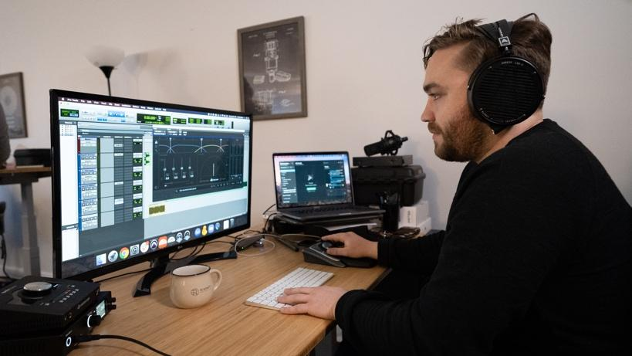
Louisville, KY, April 20, 2020 — Resonate Recordings is the ultimate one-stop shop for podcasters. The full-service podcasting production company covers everything from pre-production and script editing to post-production and hosting — even handling a podcast’s social media content. Mixing engineer Pat Kicklighter handles all quality control of podcasting clients’ audio for the Louisville, Kentucky-based firm. He recently incorporated an RME’s ADI-2 two-channel converter into his arsenal to help with clean conversion.
“I really needed 0.5 or 1-dB increments on my volume control with a digital readout so I know where I am when I’m mastering,” he said. “I’ve used other interfaces for that, but you don’t have as much control of your monitoring levels like you do with the RME unit.”
More of Everything
With a variety of clients ranging from podcasting giant Tenderfoot TV, to major universities like Brown University and Stanford University to home hobbyists, Resonate Recordings services a wide range of podcasters.
“We’re Tenderfoot TV’s main post team,” Kicklighter explained. “And we’ve also been finding that businesses and universities have a lot of need for internal communications which they are now using podcasting for. Anyone that wants to record a podcast is someone we work with.”
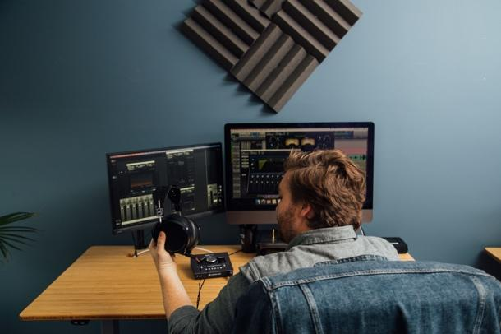
Kicklighter has his ADI-2 coming out of his laptop which is “stuffed full of USB cables,” as he puts it. One of those goes straight into his ADI-2 and another port feeds into to another interface. Kicklighter said the ADI-2 provides him with more headroom, fidelity and bandwidth.
“A lot of the affordable interfaces have limited dynamic range and produce a fairly mid-rangey sound” he explained. “They often have a lot of power — like even if you just plug your headphones into a laptop you can get a lot of output but it’s sort of a closed down midrange sound.”
“But the RME is different,” he continued. “The ADI-2 has a ton more headroom, more fidelity, more bandwidth, more high-end and more low-end.”
Kicklighter added that RME also offers additional output power options. “I use the high output option for my Audeze headphones, but for my Sennheisers, I can use the low power option, so it accommodates the best of both worlds,” he said.
Kicklighter explained that the ADI-2’s broad and general EQ can tweak a headphone’s sound, ideal for when a producer or showrunner is listening to playback.
“If I’m having someone listen in like a producer, they tend to be more used to a bass-heavy sound like listening in a playback room, so the ADI-2 allows me to turn that bass range up and I can then give them a familiar sound.”
For more on RME, visit rme-usa.com

About Synthax, Incorporated
Synthax Inc. is the exclusive USA distributor for RME digital audio solutions, Digigram broadcast audio systems, Appsys digital audio tools, Ferrofish advanced audio applications, myMix personal monitoring systems and ALVA cableware. We supply a nationwide network of dealers with these products for professional audio, broadcast, music industry, commercial audio, theater, military and government applications. For additional information, visit the company online at http://www.synthax.com.

Media Contacts:
Katie Kailus
Public Relations
Hummingbird Media
+1 (630) 319-5226
katie@hummingbirdmedia.com

Jeff Touzeau
Public Relations
Hummingbird Media
+1 (914) 602 2913
jeff@hummingbirdmedia.com

