
Sennheiser ja smart mullistavat autoilun äänielämykset – Dolby Atmos -tuki nyt saatavilla smart #5 -malliin Euroopassa

Sennheiserin äänentoistojärjestelmä autossa tukee nyt ensimmäisenä Euroopassa Dolby Atmos -teknologiaa ja asettaa samalla uuden mittapuun autojen viihdejärjestelmille.

Sennheiser ja smart Europe julkaisivat tänään odotetun langattoman päivityksen, joka tuo mukaansatempaavan Dolby Atmos® -äänentoiston Amazon Music -palvelun kautta smart #5 -mallin Sennheiser Signature Sound System -järjestelmään. Kyseessä on ensimmäinen kerta Euroopassa, kun Sennheiserin äänentoistojärjestelmä autossa hyödyntää Dolby Atmos -teknologiaa ja nostaa autojen viihdejärjestelmät täysin uudelle tasolle.

Lisää alla englanniksi.
With this update, customers of a smart #5 Premium and smart #5 BRABUS across Europe can now enjoy tracks in Dolby Atmos from their favorite artists directly through the Amazon Music app integrated into the infotainment system—no smartphone connection required. By simply selecting Dolby Atmos content within Amazon Music¹, drivers and passengers can immerse themselves in the 20-speaker multidimensional Sennheiser listening experience that places them at the center of the music.
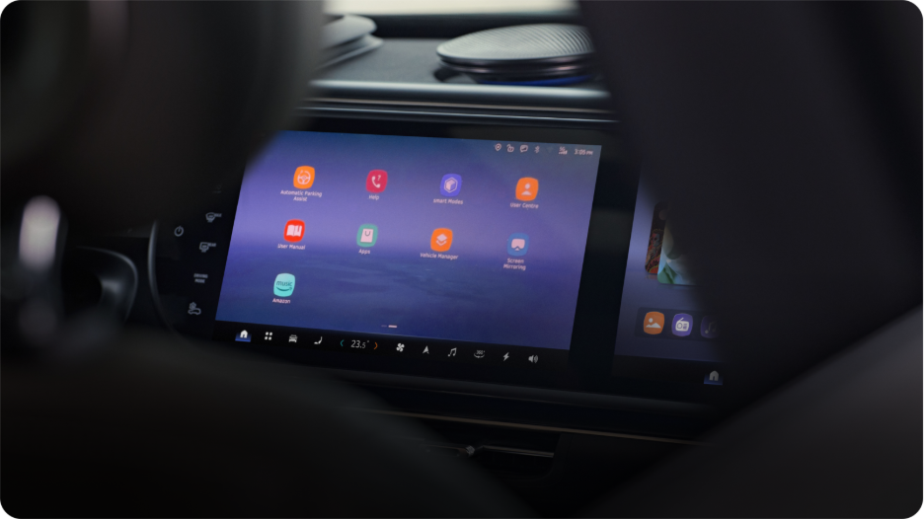
Immersive Dolby Atmos audio playback is now available through Amazon Music on the Sennheiser Signature Sound System in the smart #5.

During development, Sennheiser’s tuning engineers relied on their immersive studio in Zürich as a reference environment, ensuring that the in‑car system reproduces music in Dolby Atmos exactly as intended by its creators. This studio‑grade benchmark allowed the Sennheiser team to translate the precision and emotional impact of immersive audio into the cabin of the all-electric smart #5.

The Sennheiser Signature Sound System, available in the Premium and BRABUS editions of the smart #5, was engineered from the outset to support future-ready experiences, with a flexible architecture capable of receiving and adapting to regular and cost-free OTA updates for the customers. This capability ensures that the system continues to evolve, delivering enhanced audio innovations long after purchase. Now paired with Dolby Atmos, the system unlocks a new level of depth, clarity, and spatial precision for music lovers on the move.


By selecting Dolby Atmos content within Amazon Music, the 20-speaker multidimensional Sennheiser listening experience places passengers at the center of the music.

“Bringing Dolby Atmos through Amazon Music to the smart #5 showcases what is possible when automotive, audio, and technology leaders collaborate with a shared vision for immersive sound,” said Dr. Veronique Larcher, Managing Director of Sennheiser Mobility.

The cost-free and comprehensive OTA update for the smart #5 will be available for customers in European markets from the beginning of March. The update will be rolled out in cascades across all European markets.

Disclaimer
¹Customers will need to have an Amazon Music Unlimited membership to listen to songs in Dolby Atmos.

Amazon, Amazon Music, and all related marks are trademarks of Amazon.com, Inc. or its affiliates.

###
Information regarding Sennheiser Mobility is available at https://www.sennheiser.com/en-us/mobility

About the Sennheiser Brand – Over 80 Years of Building the Future of Audio

We live and breathe audio. We are driven by the passion to create audio solutions that make a difference. This passion has taken us from the world’s greatest stages to the quietest listening rooms – and made Sennheiser the name behind audio that doesn’t just sound good: It feels true. Since 1945, we stand for building the future of audio and bringing remarkable sound experiences to our customers.

While professional audio solutions such as microphones, meeting solutions, streaming technologies and monitoring systems are part of the business of Sennheiser electronic SE & Co. KG, the business with consumer devices such as headphones, soundbars and speech-enhanced hearables is operated by Sonova Holding AG under the license of Sennheiser.

www.sennheiser.com
www.sennheiser-hearing.com

Press Contact:
Burson Finland Oy (previously Hill and Knowlton)
sennheiser.finland@hkstrategies.com

