For immediate distribution

Steppin’ Out: Chester Thompson Records Raw New Release at Sweetwater Studios
Virtuoso Drummer Tracks Steppin’ — Live Jazz Album During Sweetwater Master Class

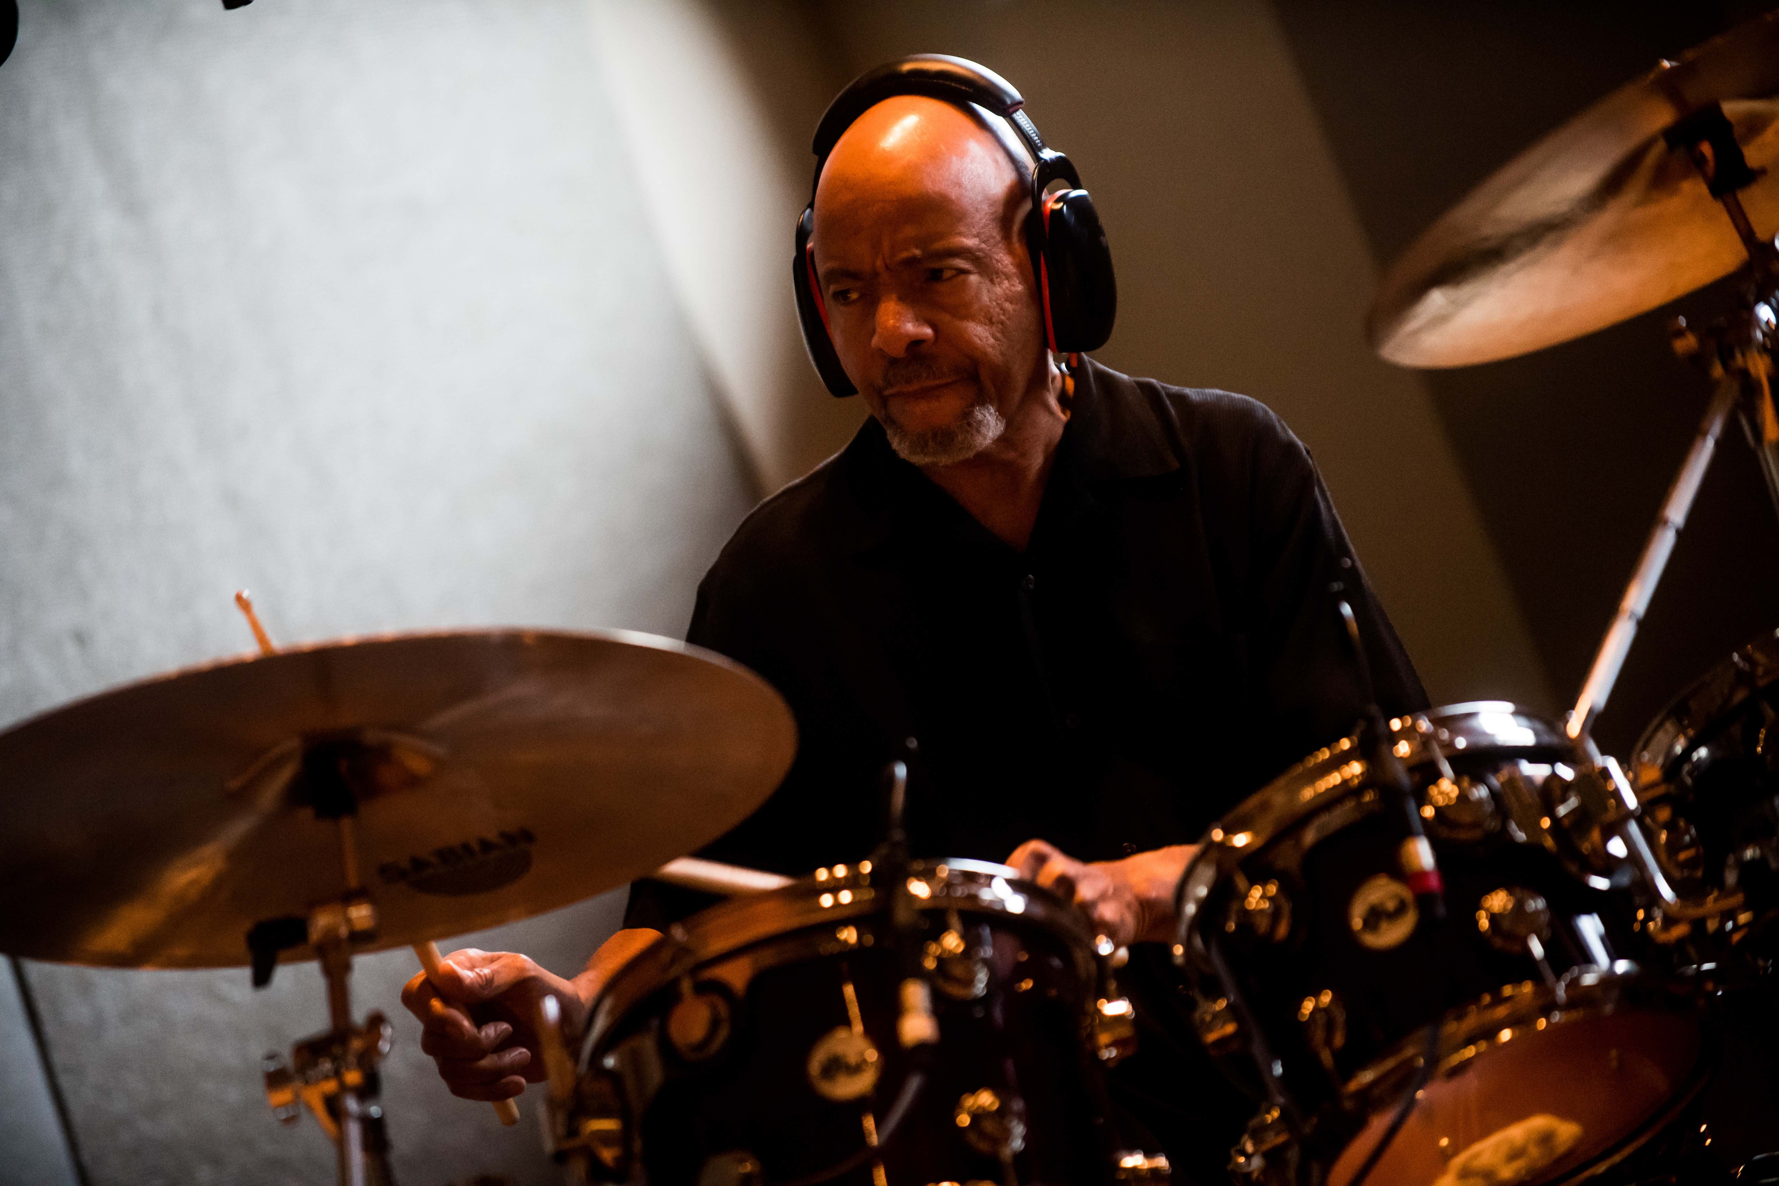
April 9, 2019, Fort Wayne, IN – Chester Thompson has spent the last forty-plus years developing a singular rhythmic resume; playing with jazz giants Weather Report, progressive auteur Frank Zappa, and touring with arena-rockers Genesis among other projects. More recently, Thompson found himself in Sweetwater Studios laying down the energetic live sessions for his latest release, Steppin’. Although Thompson is no stranger to recording with a tight jazz band in live, all-at-once takes, what made this session unique was that it took place during a sold-out session of one of Sweetwater’s Master Classes with the full participation of the attending students, supervised by Sweetwater Senior Producer/Engineer Mark Hornsby. The album is set to be released on May 1st, 2019, and will be available through CD Baby.

Class in Session
The idea to involve Thompson in the Master Class Series, Sweetwater’s unique educational offering that allows aspiring engineers to learn the art of recording alongside well-known artists, had been percolating with Hornsby for a while. “I’ve known Chester for a long time,” says Hornsby. “He’s been involved with workshops here at Sweetwater in the past and we’ve done some sessions together over the years, both here and in Nashville. Getting him involved in his own Recording Master Class was an obvious next step.” Thompson has done his fair share of teaching on his own -- having taught drums at Belmont University in Nashville for the last twenty years as well as participating in countless drum clinics -- so when Hornsby approached him about using his upcoming sessions for educational purposes with Sweetwater’s Master Class series, he was immediately intrigued. “The idea really appealed to me,” Thompson explains. “Being able to help people get further down the path of excellency in music is always something that is worthwhile to me.”

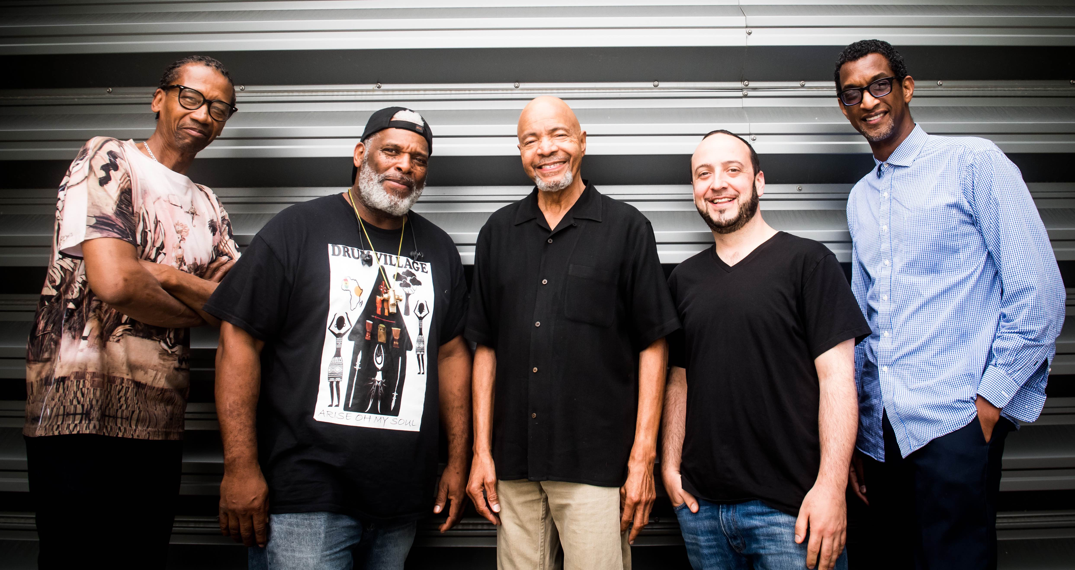
Thompson and his bandmates for the session, bassist Alphonso Johnson, pianist Joe Davidian, and percussionist Tony Carpenter, tracked live in Sweetwater’s Studio A. Once the students had been introduced to the basics of mic placement and getting sounds in the room, they spent most of the session ‘behind the glass’ with Hornsby tracking the sessions to the studio’s custom Neve 6 console. Although he says that the presence of the students was hardly noticeable during tracking, Thompson says their involvement was crucial to the recording process. “Having that enthusiasm and encouragement definitely makes a difference,” he says. “Getting to talk to them between takes and involve them in the process made it such a special experience for me.”

Real People, Real Energy
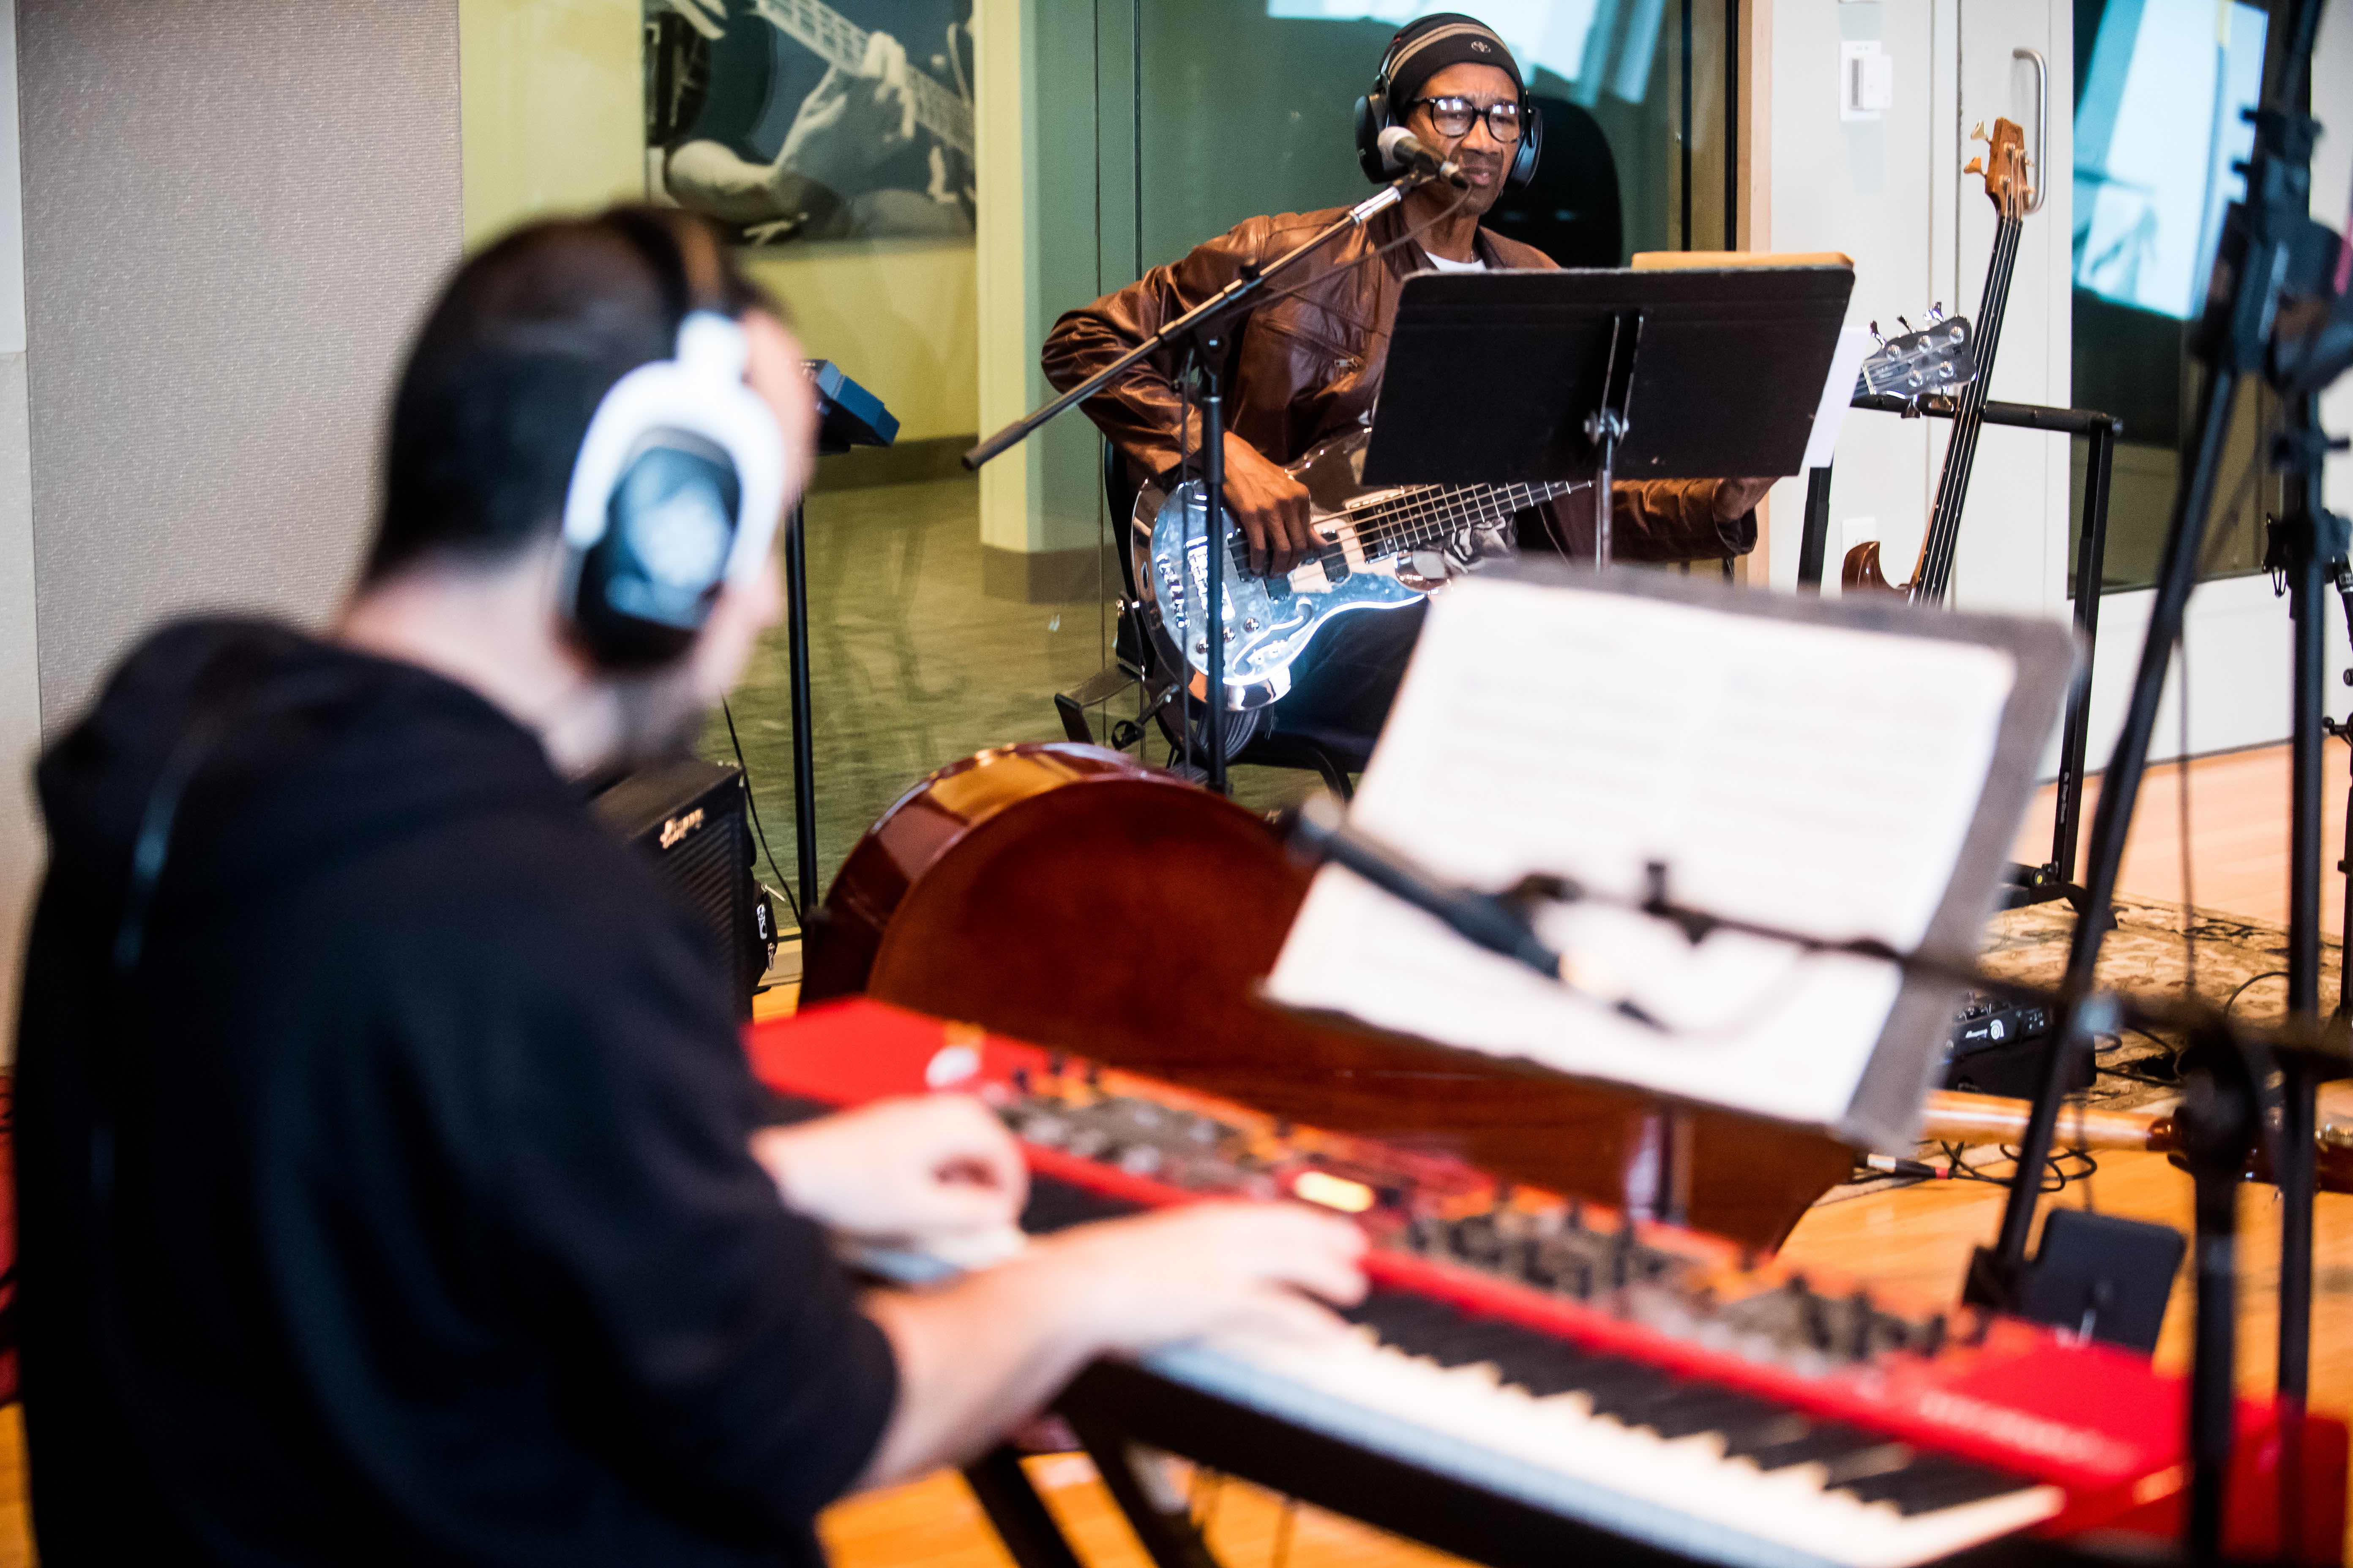
Thompson wanted a sound unfettered by excessive processing and the studio’s lively sonic profile played a key role in the sound that Thompson had in his head. “A big part of the vibe of any recording is the sound of the room itself, and [Studio A] is an amazing room,” he says. “Everything sounded so good in there that we weren’t stuck with having to ‘manufacture’ a sound.” Hornsby made sure to retain the feel that Thompson wanted by using as little post-processing as possible. “The mixing on this album was very raw, which I do like,” he says. “It was just faders up and three or four processors at the most. [Thompson] really wanted that ‘live in the studio’ feel.” Part of that attraction to that live sound comes from Thompson’s years of touring. “There’s a difference in energy when you have real people,” he says. “When I played with Genesis we never played to tracks, so I didn’t want something that couldn’t be recreated live with a real band. I wanted it to be able to be performed.”

Thompson played on the studio’s DW Cherry/Gum Jazz-series kit with Maple shells using a custom made Craviotto snare for his signature cutting sound. Hornsby had recently been favouring the kit on sessions for its versatility, and Thompson had no complaints. “Equipment-wise they’ve got everything you could want, and the way they had this kit set up felt like one of my own.” Although he only played live drums on the main tracks, Thompson also made use of a Korg Wavedrum for some of the album’s transition pieces, made up of drum and percussion jams that happened spontaneously in the studio and help to link together the tracks on the album. He’s careful to point out that he’s not anti-technology but seeks to make the best use of any tools in a given situation. “I enjoy sitting down and programming stuff, it’s just important to know when to layer it in so it’s not a distraction,” he says.

Master of Art
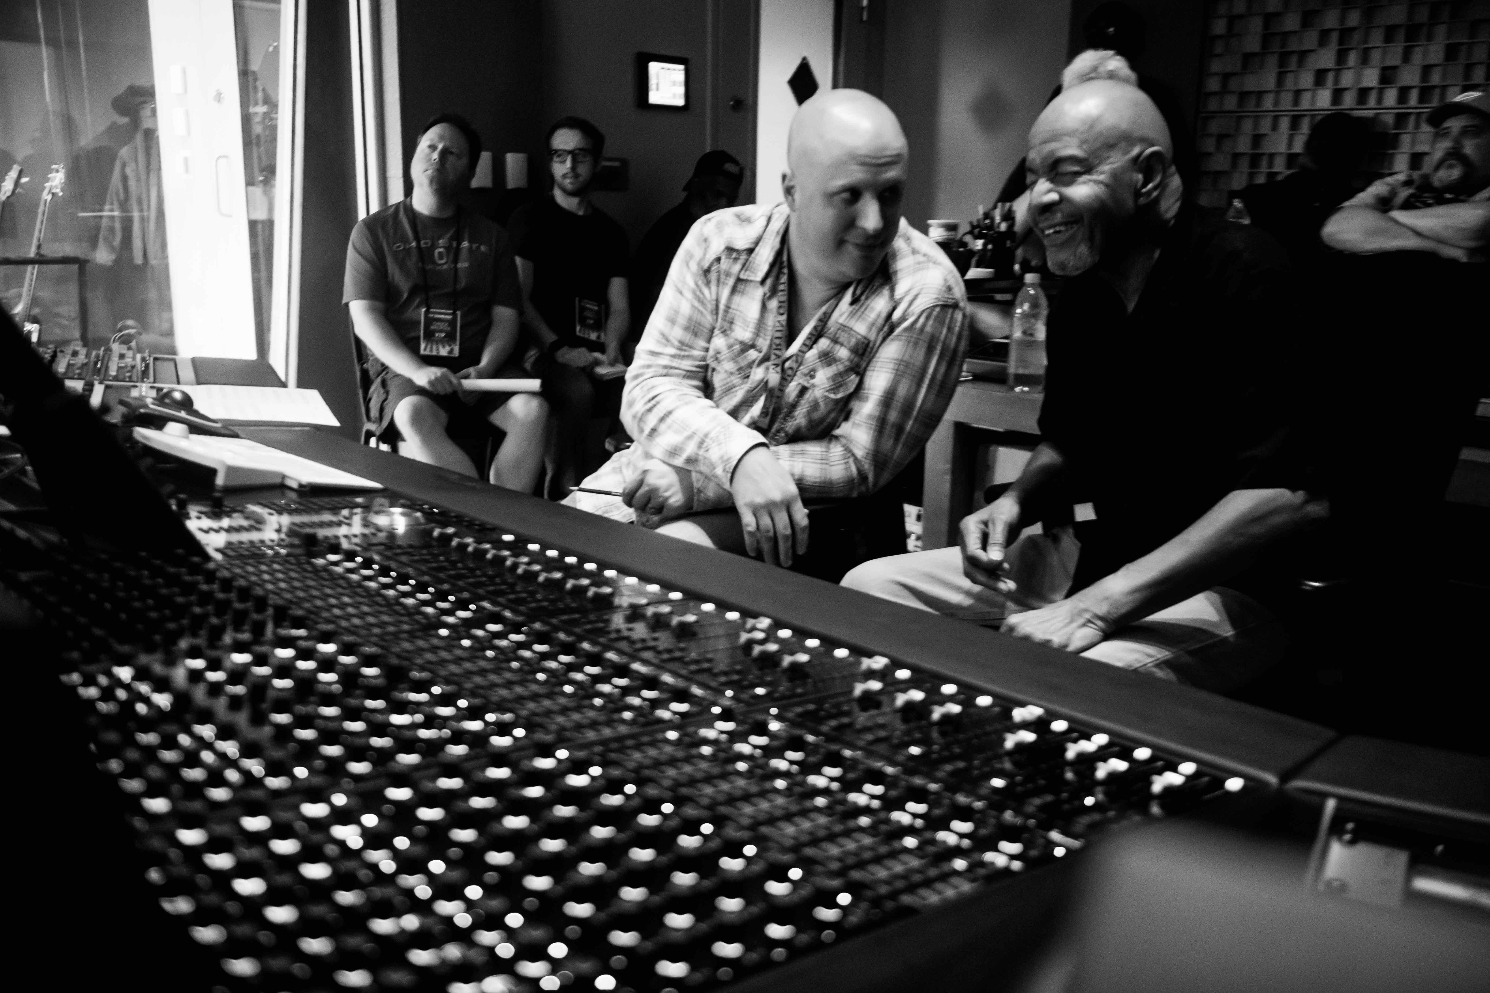
With the album finished and set to be released, Thompson is pleased with what he’s created. “I’m not trying to make a hit record at this point as an artist,” he says. “It’s all about making music that feels honest.” The experiencing of making it live in front of students is something that he says made it more memorable and special, to that point that he’d like to do another class, but this time as a student. “They get so many great artists that I admire to come in for these,” he enthuses, “I’d love to sign up for a class myself and see what I can learn!”

For more information about Sweetwater Studios, please visit: https://www.sweetwaterstudios.com/

# # #

About Sweetwater Studios
Sweetwater Studios is a wholly owned subsidiary of Sweetwater Sound, Inc., the largest online music instrument retailer in the country. With three world-class studios designed by Russ Berger and access to a greater diversity of musical equipment and professional audio gear than any other recording studio in the world, Sweetwater Studios is able to accommodate just about any recording, mixing or mastering project, no matter how simple or complex. With renowned staff producer Mark Hornsby at the helm, who has worked on many Grammy-award winning albums, Sweetwater Studios also has an exceptional staff of producers, engineers, session musicians and studio technicians. For more information on Sweetwater Studios, please visit http://www.sweetwaterstudios.com.

Media contacts
Steve Bailey
Public Relations
Hummingbird Media
+1 (508) 596 9321
steve@hummingbirdmedia.com

Jeff Touzeau
Public Relations
Hummingbird Media
+1 (914) 602 2913
jeff@hummingbirdmedia.com

