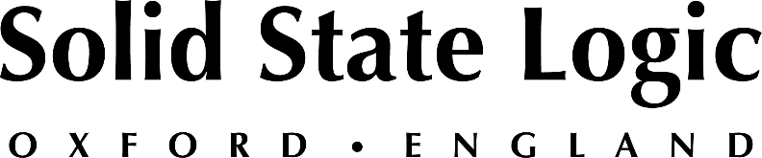

Solid State Logic Announces Free Certified SSL Live Console Training Opportunities in Nashville

Solid State Logic Live Academy to take place at Spectrum Sound on January 30th and 31st, Morris-InteRise on February 3rd and 4th and Clair Global February 5th and 6th

OXFORD ENGLAND - Solid State Logic (SSL) announces that it will be offering one-day certified training events in Nashville between January 30th and February 6th. The training sessions, which cover the SSL Live console technology, are free of charge and offered to registrants on a first-come, first-served basis.

The SSL Live series of consoles deliver the signature SSL sound, robust features and a superb operator experience. Each certified training event will enable participants to experience the impeccable sound and advanced workflow of these consoles, while becoming certified in SSL Live console technology. Training events will be held at Spectrum Sound on January 30th and 31st, Morris-InteRise on February 3rd and 4th; and Clair Global on February 5th and 6th.
Each training session will cover the following items:

- A brief history of SSL
- Basic specifications of the system
- Overview of Tempest
- Understanding the system
- Console configuration
- Layer manager
- I/O and physical connections
- Routing
- Query
- Showfile construction

Don’t miss this opportunity to participate in SSL Live certified training. For more information or to register, please visit https://www.solidstatelogic.com/events.

###

Solid State Logic is the world’s leading manufacturer of analogue and digital audio consoles and provider of creative tools for music, broadcast, live and post production professionals. For more information about our award-winning products, please visit: www.solidstatelogic.com.

###
For further information contact:
Ross Gilbert
+44 (0) 1865 842300
rossg@solidstatelogic.com

