SENNHEISER TEAMCONNECT CEILING 2 OBTAINS DINGTALK CERTIFICATION
Sennheiser TeamConnect Ceiling Solutions portfolio offers organizations premium meeting experiences with convenience

Beijing, February 13, 2023 – Sennheiser, the first choice for advanced audio technology that makes collaboration and learning easier, announced its TeamConnect Ceiling 2 (TCC2) microphone is now certified by DingTalk. TCC2 is an array microphone capable of automatically focusing on the active speaker in a room and following their voice. The combination of TCC2 with DingTalk offers users a seamless hybrid meeting experience for a variety of environments.
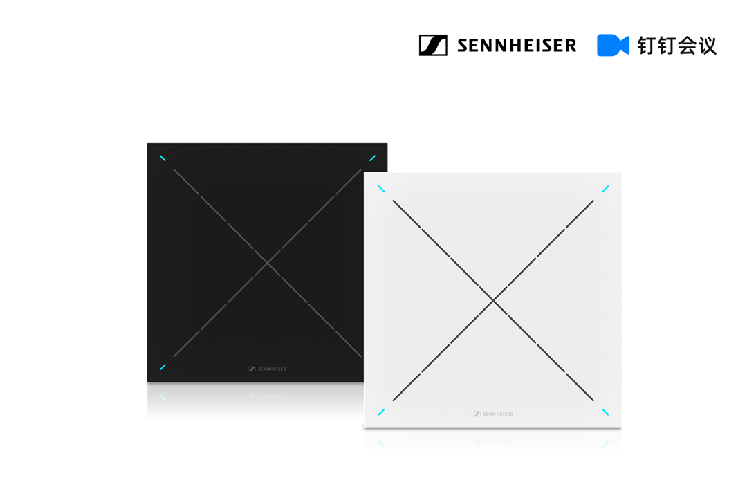
The Sennheiser TeamConnect Ceiling 2 microphone has obtained the certification by DingTalk

Due to the pandemic, remote working and online collaboration have become more important to many companies. The number of online meeting users and the amount of time they spend in online meetings have increased dramatically over the past few years. However, many users experience issues related to sound quality, such as interference from background noises, poor sound pick-up and the movement of speakers due to a microphone’s location and range restrictions. Therefore, to achieve a better hybrid working and learning experience, reliable audio equipment and excellent audio solutions are critical.

Sennheiser’s TCC2 is a revolutionary array microphone, fitted with 28 inbuilt omnidirectional microphone capsules. Its patented dynamic beamforming technology can automatically detect and follow the active speaker, allowing them to walk freely while speaking without worrying about the sound quality. This makes online meetings more flexible, efficient, easier and audibly better. Additionally, with TruVoicelift technology, TCC2 can significantly amplify the speaker’s voice. With TCC2, users can set priority zone and exclusion zones that will highlight the speaker’s voice and eliminate unwanted noise interferences to ensure what the speaker says can be heard at every corner in the room. TCC2 is also compatible with Sennheiser Control Cockpit, making remote control and supervision simple.
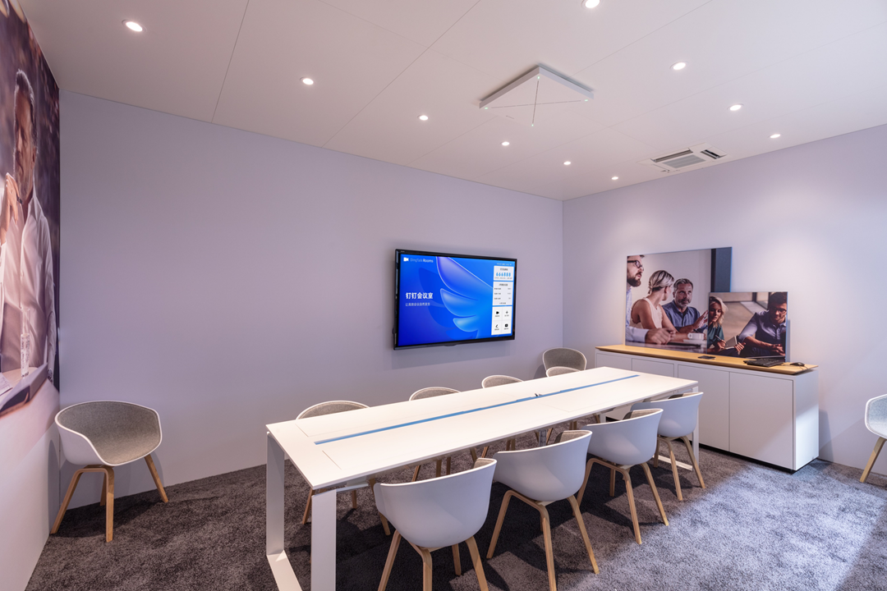
With cutting-edge technologies such as patented dynamic beamforming and TruVoicelift functionality, TCC2 makes online meetings more flexible, efficient, easier and audibly better.

Thanks to its ceiling-mounted design, TCC2 is ideal for all kinds of room layouts and configurations. It can be widely applied in various settings, such as classrooms, lecture halls and meeting rooms, making it an ideal solution for both enterprises and schools.

Having 600 million registered users in 23 million organizations, DingTalk has strong market influence and is one of the most popular online collaboration platforms in China. DingTalk, in collaboration with Sennheiser, aims to provide its users with a clearer and better audio experience. Sennheiser’s participation will also enlarge DingTalk’s ecosystem family and upgrade hybrid working and learning by delivering a superb audio experience.

“Sennheiser Business Communication always aims to support universities and corporate meeting rooms with reliable audio solutions that provide excellent sound quality. We are happy to announce that Sennheiser’s TCC2 has been certified by DingTalk, which represents the market’s recognition for our products. Meanwhile, with DingTalk’s powerful platform and strong influence, we look forward to assisting more customers achieving great success in hybrid working and learning with evolved audio quality,” said Vivian Zhao, Sales Director for Sennheiser Business Communication in the Greater China Region.

DingTalk Team considers Sennheiser as one of its most important hardware partners that provide professional audio solutions with reliable products, patented cutting-edge technologies and deep insights into the business communication industry. TCC2’s excellent long-distance sound pickup capability will further enhance users’ audio experience during meetings, which is exactly what DingTalk has always strived to do. In the future, with deep cooperation in the product, technology and channel categories, DingTalk and Sennheiser will join hands to explore more advanced audio solutions and build a better and more sustainable online meeting environment, which will further support enterprises and organizations in enhancing their remote working efficiency.

For more information about TeamConnect Ceiling 2, please visit https://en-us.sennheiser.com/

About the Sennheiser brand
We live and breathe audio. We are driven by the passion to create audio solutions that make a difference. Building the future of audio and bringing remarkable sound experiences to our customers – this is what the Sennheiser brand has represented for more than 75 years. While professional audio solutions such as microphones, meeting solutions, streaming technologies and monitoring systems are part of the business of Sennheiser electronic GmbH & Co. KG, the business with consumer devices such as headphones, soundbars and speech-enhanced hearables is operated by Sonova Holding AG under the license of Sennheiser.

www.sennheiser.com
www.sennheiser-hearing.com

