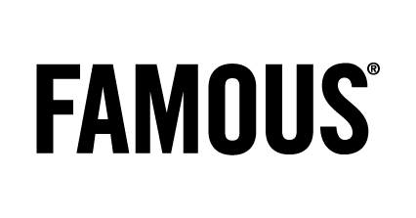
Press

Une campagne qui a du chien !

FAMOUS lance sa nouvelle campagne pour la Smart thermostat touch et Check up call d’Electrabel

CREDITS

Client: Electrabel

Benoît Crochelet, Barbara De Laet, Katrien Verbiest

Agency: Famous

Account team: Carola Michiels, Isabelle Hankard, Annick Danckers

CD: Tim Driesen

Associate CD: Jean-Marc Wachsmann, Iwein Vandevyver

Creative team: Gaëtan Gomez Garcia & Gregory Verheyleweghen

TV producer: Charlotte Mathias

Art Buyer: Sandy Leemans

PR Managers : Anne-Cécile Collignon & Liesbeth Pyck

Film:

Production company: Czar

Director: Rogier Van Der Ploeg

Executive producer: Eurydice Gysel

Producer: Nele Carlier & Saskia Verboven

Post-producer: Birgit D’Hont

Sound & Music: Sonicville

Print:

Photographer: Sven Schrader (Bransch Europe)

Producer: Eveline Vanassche (White Russian)

Radio :

Studio : Het Geluidshuis

Media:

TV commercial 20” & 10”: on air 08/10 (Smart thermostat touch)

Var 5” sponsoring Thuis/Weerbericht: on air as from 08/10 (Smart thermostat touch)

Magazines: on air as from 22/10 (Check up call)

Radio 35” : on air as from 22/10 (Check up call)

